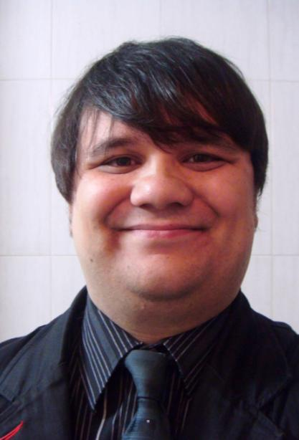

Matthew Pederson

Apt 720 Ilsan Vista Officetel – Juyeop 1 Dong 102 – Ilsan-Gu- Goyang-Si – Kyunggi-Do 411-370
Email: matthewpederson77@gmail.com * Mobile: 010-2964-2422

Birthday: 17 June 1977
Marital Status: Single
Nationality: American
Native Language: English

Objective: To teach English to elementary or middle school children at a great school in South Korea, so I can develop the skills to become a K-12 teacher.

Education
Sept 2006 - Dec 2008
University of Washington, Seattle WA
Bachelor of Science
Major: Biology

Sept 2003 – Aug 2006
Highline Community College, Des Moines WA
Associate of Arts
Major: Biology

Relevant Courses
Writing 101, Research Writing 105, Speech 100. The majority of my courses required public speaking

Relevant Work Experience
Aug 2009 - Present
International Home School, English Teacher
- Teach English and Language Arts to elementary and middle school Korean students.
- Teach writing for the school’s intensive program during the winter and summer school breaks.
- Create exams and homework assignments for students.

Jan 2005 – Aug 2009
Borelli Household, Babysitter
- Watched over children ages 5-12
- Assisted children with their reading, writing & math homework

Sep 2003 – Jun 2006
Highline Community College, Tutor
- Tutor students on writing & math

Jun 1999 – Jul 2000
Puget Sound Naval Shipyard, Master Technical Publication Librarian
- Managed a central technical publication library and trained workshops on how to maintain and update their technical publications

Work Experience
Mar 2006 - Mar 2009
Allied Barton Services, Security Guard
- Evening job while going to college
- Provide security & customer service to employees & visitors to campus
- Train new employees on worksite regulations and procedures

Oct 2000 – Sep 2005
Alaska Airlines, Executive Secretary
- Type memos, emails, awards, letters, technical manuals and general correspondence.
- Proofread documents for correct grammar, spelling & punctuation.
- Answer all incoming calls and determine the nature of the request.

Relevant Volunteering Experience
2004 - 2006
International Conversation Pals, Highline Community College
- Help international Korean students improve their English by having conversations with them.
- Introduce international students to American culture and customs.

2004 - 2006
Marine and Science Technology Dock, Redondo WA
- Educate the public on local marine organisms.
- Maintain aquarium tanks

Awards
- 2008 Employee of the Month (Twice)
- 2007 University of Washington Scholarship
- 2006 National Dean’s List
- 2006 Phi Theta Kappa
- 2006 Highline Community College Scholarship
- 2005 Vice President’s List

Language Skills
- Basic French

Travel Experience
- Canada, Mexico, Honduras, Belize, Bahamas, Philippines, Hong Kong, Singapore, Australia, United Arab Emirates, Germany, France

