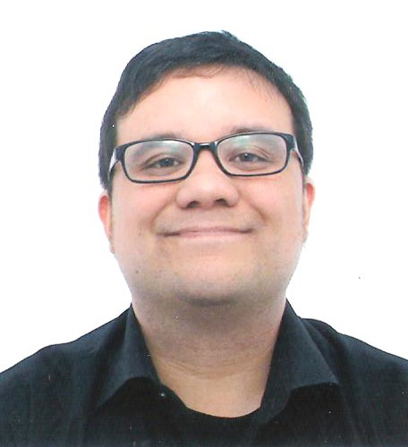

Matthew Pederson

Email: matthewpederson77@gmail.com * Mobile: 010-3616-2422
Birthday: 17 June 1977 Marital Status: Single Nationality: American Native Language: English
Education
Future: 3 Sept – 28 Sept 2012
ECC (Thailand), Bangkok, Thailand
CELTA certified (120-hour Teaching English as a Foreign Language [TEFL] certificate issued by Cambridge University)

Sept 2006 - Dec 2008
University of Washington, Seattle WA
Bachelor of Science. Major: Biology

Sept 2003 – Aug 2006
Highline Community College, Des Moines WA
Associate of Arts. Major: Biology

Teaching Experience
July 2012 – Aug 2012
37th Polyglot Day School Summer Camp, Bundang South Korea, English Teacher
- Taught intensive reading and vocabulary to elementary, middle, and high school students.
- Helped high school students prepare for the American SAT exam by teaching the critical reading and vocabulary portions of the exam.
- Prepared high school students for the integrated and independent writing portions of the TOEFL test.

Aug 2011 – July 2012
EG English School, Ilsan South Korea, English Teacher
- Teach speaking, reading, writing, and listening, to elementary Korean students.and middles school
- Teach the middle school students TOEFL, iBT speaking, listening, and writing.

Aug 2010 – Aug 2011
Cham Jeon Hagwon, Seosan South Korea, English Teacher
- Taught English to Kindergarten, elementary, middle school, and adult Korean students.
- Prepared adult students for the TOEIC exam.
- Taught TOEIC Writing and Speaking to adult students.
- Conducted English conversation classes for adult students.
Aug 2009 – Aug 2010
International Home School, Ilsan South Korea, English Teacher
- Taught English and Language Arts to elementary and middle school Korean students.
- Taught writing for the school’s intensive program during the winter and summer school breaks.
- Created exams and homework assignments for students.

Sep 2003 – Jun 2006
Highline Community College, Des Moines Washington, Tutor
- Tutored students on writing & math

Jun 1999 – Jul 2000
Puget Sound Naval Shipyard, Bremerton Washington, Master Technical Publication Librarian
- Managed a central technical publication library and trained workshops on how to maintain and update their technical publications

Work Experience
Mar 2006 - Mar 2009
Adobe Systems Incorporated, System Security, Seattle Washington
- Oversaw the security system at the Adobe campus.
- Trained new employees on worksite regulations and procedures

Oct 2000 – Sep 2005
Alaska Airlines, Executive Secretary
- Typed memos, emails, awards, letters, technical manuals and general correspondence.
- Proofread documents for correct grammar, spelling & punctuation.
- Answered all incoming calls and determine the nature of the request.

Relevant Volunteering Experience
2004 - 2006
International Conversation Pals, Highline Community College
- Help international Korean students improve their English by having conversations with them.
- Introduce international students to American culture and customs.

2004 - 2006
Marine and Science Technology Dock, Redondo WA
- Educate the public on local marine organisms.
- Maintain aquarium tanks

Awards
- 2008 Employee of the Month (Twice)
- 2007 University of Washington Scholarship
- 2006 National Dean’s List
- 2006 Phi Theta Kappa
- 2006 Highline Community College Scholarship
- 2005 Vice President’s List

Travel Experience
- Canada, Mexico, Honduras, Belize, Bahamas, Japan, Philippines, Thailand, Hong Kong, Singapore, Australia, United Arab Emirates, Germany, France

References
- Polyglot Day School, Kim See Bong, glsacademy@dreamwiz.com, 010-2321-7407
- EG School Ilsan, Mr. Park, 010-4723-2036
- Cham Jeon Hagwon, Lee Sang Yong, seelsy@naver.com, 010-6691-6635 Mr. Park, 010-3452-3219
- International Home School, Christina Shin, ew75shin@hanmail.net, 010-4723-8274

