Abby Radford

Curriculum Vitae

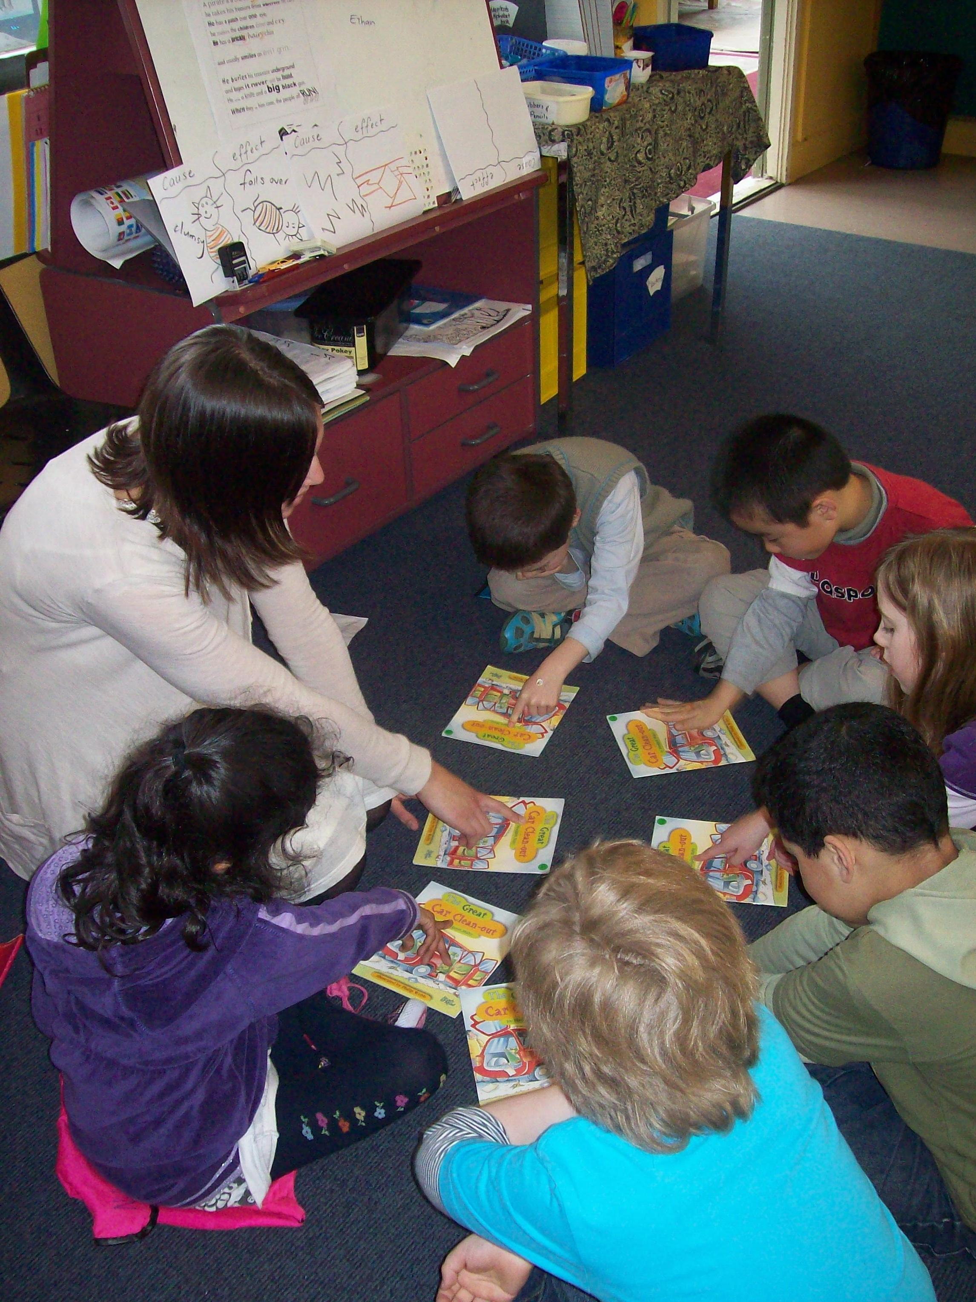

Name: Abby Radford
Address: 15 Scarborough Terrace, Mt Victoria, Wellington, 6011
New Zealand

Date of Birth: 12th September 1982

Mobile: +64 27 8719920

Health: Excellent. Non smoker

Drivers Licence: Current New Zealand Full Car Licence

Personal Statement:

I am excited about the prospect of teaching in Korea, as I wish to extend my teaching skills by teaching abroad and learning a new curriculum. I am looking forward to living and working in a different and new environment, where I will learn and share teaching skills and knowledge.

I am a passionate and hardworking teacher. I enjoy the planning and teaching process, where I consistently alter and modify my plans to meet the various social and academic needs of my students. I enjoy the relationships I develop with my students and staff members. I find working in a team with my colleagues and my students rewarding, as we help each other achieve our individual and team goals.

My strengths are as follows:
* My planning. I differentiate my plans to meet the diverse learning needs of my students and modify my plans consistently to ensure my lessons are effective and relevant for individual student learning needs.
* Effective and positive behaviour management. I use positive reinforcement to create a productive learning environment.
* Consistent and relevant assessment. I assess my students regularly to ensure that I am meeting my students’ learning needs.
* Quality learning environment: I create a safe and happy learning environment to encourage academic and social growth in the class and in each individual.
* Positive relationships with staff, students and the school community.

* Leadership skills. This year I was in charge of the School Library and Student Council at Owhiro Bay School. I also shared responsibility of the visual arts budget. I have led presentations, where I have shared skills and knowledge to colleagues and teachers in local schools.

Teaching History:

I am a fully registered Primary School Teacher and have a TESOL (Teaching English to Speakers of other Languages) qualification. I am currently relieving in Kindergartens and Primary Schools in Wellington. From 2009-2011, I worked as a Primary School Teacher at Owhiro Bay School in Wellington, New Zealand. Prior to that, I worked as a day reliever at several schools in Christchurch, New Zealand, and had a fixed term position at St Teresa’s School, Christchurch. Before training to be a teacher in New Zealand, I lived and worked in London as a Teaching Assistant at Charles Edward Brooke School in Camberwell, South London.

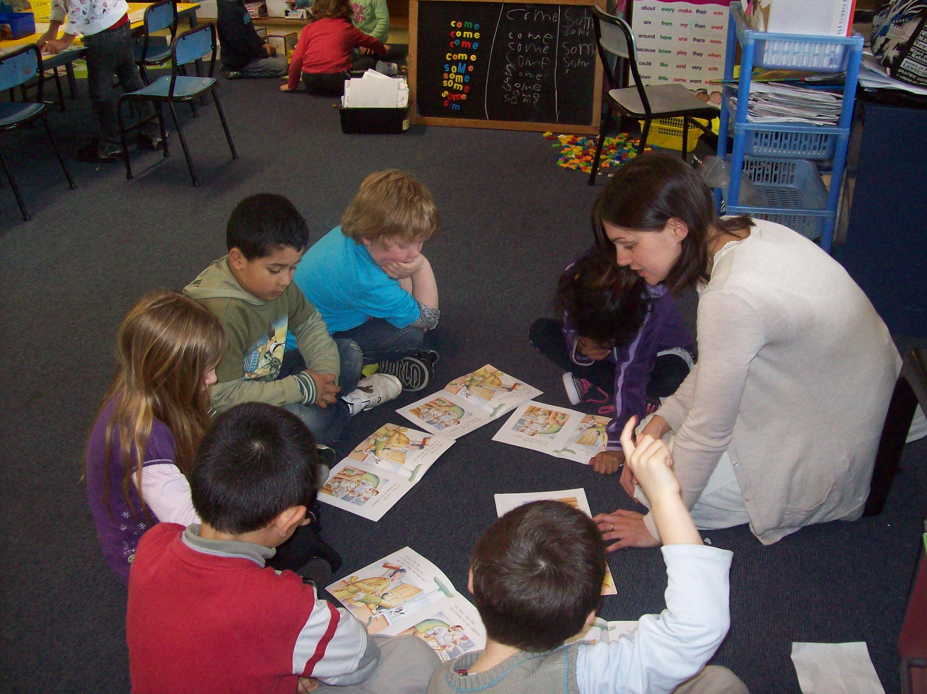

More skills and attributes:

- Gentle and warm personality
- Good sense of humour
- Organised
- Hardworking
- Caring
- Flexible and ready to adapt timetables and plans etc
- Excellent time management skills
- Eager to advance teaching practice and professional development
- Willing to share teaching knowledge and resources.

Teaching Experience:

- Kindergarten and Primary School Reliever, Welllington, 2012.
Since the beginning of this year, I have been working in many different Kindergartens and Primary Schools as a reliever. I have worked in Under 2s, toddlers, pre-school classes and Primary Schools.

- Owhiro Bay School, Wellington, 2009 – 2011, Years 1 and 2.
I taught year 1-2 children for 3 years at Owhiro Bay School. As well as being a full time teacher, I was responsible for spending the visual arts budget. I also was the teacher in charge of the Library and Student Council.

- Day Relief (relieving other teachers on a day to day basis), Years 1-8, Christchurch, Term 3, 2008: St Teresa’s School, St Martin’s Primary School, Paparoa Street School, Banks Avenue School and Clarkville Primary School.

- Fixed Term position: St Teresa’s School, Christchurch, Year 3, Term 2, 2008. Duties included – Head of Student Council and Environmental Team.

Education:

- Graduate Diploma in Teaching, New Zealand Graduate School of Education (NZGSE), Christchurch, New Zealand, January 2007 – April 2008

- TESOL Certificate (Teaching English to Speakers of Other Languages), Christchurch, New Zealand, 2005

- Post Graduate Diploma in Art History from Otago University, Dunedin, New Zealand, 2004

- Bachelor of Arts in History from Otago University, Dunedin, New Zealand, 2003

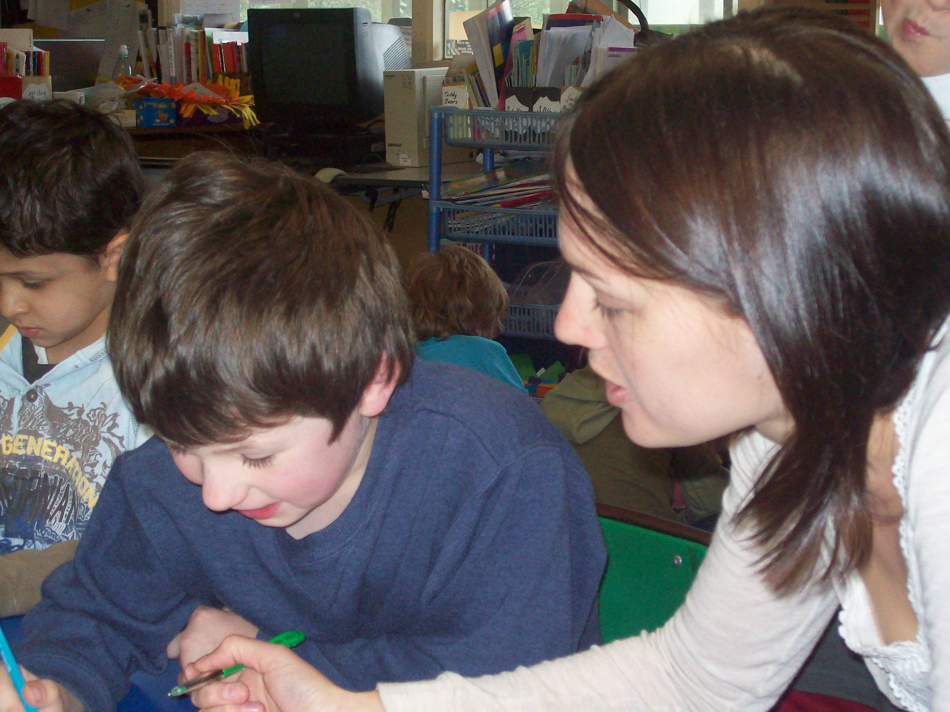

Additional qualifications and work experience:

- Glasser Foundation Course (March 2011- 5 days) – This was an introduction into Dr. William Glasser’s education theories. Glasser is a leading contemporary psychiatrist.
- Current First Aid Certificate (2009) - Order of St John First Aid Certificate, Wellington, New Zealand
- Teaching Assistant (2006) Science Department of a Secondary Girls School (Years 7 – 11) in London. This was at Charles Edward Brooke School in Camberwell, London.
- Caregiver (2005) I worked for Rest Assured We Care in Surrey. I was a live-in carer for the elderly for several months while I was living in England.
- Matron – (2005) St Margaret’s Boarding House, Christchurch, New Zealand. I supervised and tutored girls in a Boarding House after school.
- Volunteer Mentor (2003-2004) I spent several hours every week with a young girl who needed support and mentoring. This volunteer work was for the Presbyterian Support Buddy Programme in Dunedin, New Zealand.

Teaching Strategies and Philosophy:

- I use a wide range of positive behavioural strategies to correct students’ behaviour.

- I use assessment data to inform my planning and teaching. I cater for the needs of every student, extending students and giving more support when it is needed.

- I create a positive and safe learning environment by involving all students in the learning process, offering praise for effort and success, using cooperative strategies and by teaching values and social skills.

- Student’s have ownership over their own learning. I give students the chance to decide what they want to and need to learn, share their learning process with others and teach other students their skills and knowledge.

- Student’s know their next learning steps and have the opportunity to decide what their next learning steps should be.

- I state to the students what they are learning and why. I also clearly state how they will achieve the learning intention. Students share their learning intentions to students and the school community.

- I encourage good self esteem and a sense of self worth in my students. Students share their knowledge and skills to others, teach and help other classmates and view their work on display.

- Students use individual and class success criteria to measure their own learning success and form their next learning steps.

- I give students immediate and clear feedback to help them understand what they have achieved and how to progress in their learning.

- I use a combination of teacher directed and student directed learning. This gives the students a sense of ownership over their own learning and also direction and focus.

- Glasser’s Choice Theory and Reality Therapy is used as a guideline when working on and maintaining my relationships with staff and students.

Cultural and Sporting Interests:

Photography, skiing, yoga, pilates, gym, running, tramping, travel, reading, dance.

Referees:

Mrs Deanne Daysh
Teacher and Deputy Principal of Owhiro Bay School, Wellington, New Zealand
Senior Teacher during my Provisional Registration (first 2 years of teaching)
Phone: +64 4 9705394 (private)
Mobile: +64 211058566
Work: +64 4 3837189
Email: deanne@owhiro.school.nz

Miss Karen Hardie
Principal at Owhiro Bay School, Wellington, New Zealand
Work phone:
Home: +64 4 3836859
Work: +64 4 3837189
Email: karen@owhiro.school.nz

Miss Therese Young
Teacher and Deputy Principal at Owhiro Bay School, Wellington, New Zealand
Appraiser for 2011
Mobile: +64 274667866
Work: +64 4 3837189
Email: therese@owhiro.school.nz

Other referees can be contacted on request.

