Kristen Serim Hyun
kristenhyun@hotmail.com
9770 S.W. Tephra Ter.
Beaverton OR 97007
Phone: 010-7633-6252 (Korea)
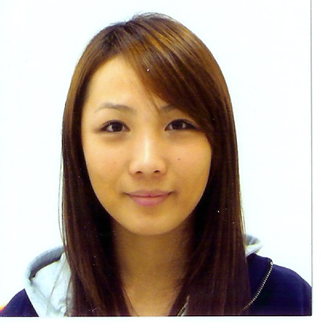

Objective | To find a position teaching English to kinder/elementary aged children while learning its culture
Education | 2007- 2009 Portland State University  Bachelors of Arts: Arts & Letters  Minor: English  2004 – 2007 Portland Community College  TESOL Certificate: 100hrs  Honors: cum laude  Coursework: English, music history.
Experience | August 2009–August 2011 Seoul Yeong-Mun Elementary School  Seoul, Yeongdeungpo South Korea  English Teacher (원어민)  -Conducted English classes in cooperation with Korean homeroom or English language teachers.  -Prepared teaching materials and activities for English language education.  -Assisted with the development of teaching materials related to English language education.  -Assisted with activities related to speech contest, voice recorded English listening comprehension tests, conducted English conversational classes in the English camp.  March 2008- July 2009 Portland State University Library USA  Circulation Desk Associate  -Circulated and renewed materials for patrons  -Processed materials on hold, notified patrons, monitored, and maintained reserved materials shelves  -Created and maintained patron financial records and database files  -Effectively responded to telephone and in-person inquiries  -Recommended library materials to patrons and refer them to various services
March 09- June 09 Highland Park Middle School USA
Teacher Assistant/Volunteer (ESL)

-Worked with students aged 11-13
-Helped students with class activities and homework
-Social interaction; exchange of cultural knowledge
-Taught basic English vocabulary

January 09-March 09 Portland Community College USA
Teacher Assistant/Volunteer (ESL)

-Taught adults from many different backgrounds and nationalities
-My job included writing and delivering lesson plans
-Helped students with class activities and homework
-Planned for the group segments of the lessons
-Taught basic English vocabulary

November 03 – November 04 Walgreens USA
Sales Associate

-Ensured that each customer received outstanding service by providing a friendly environment, which included greeting and acknowledging every customer, maintaining solid product knowledge and all other aspects of customer service.
-Maintained an awareness of all promotions and advertisements.
-Assisted in floors moves, merchandising, display maintenance, and housekeeping.
-Assisted in processing and replenishing merchandise and monitoring floor stock.
-Aided customers in locating merchandise.
-Communicated customer requests to management.
-Assisted in completing price changes within the department.
-Participated in year-end inventory and cycle counts.
-Assisted in ringing up sales at registers and/or bagging merchandise.
-Any other tasks as assigned from time to time by any manager.

September 04-November 04 Barns Elementary School USA
Teacher Assistant/Volunteer

-Helped children with reading, writing, and math
-Entertained children with different activities (sports and arts)
Additional Information | -Typing speed: 80 WPM  -Proficient at Microsoft Office Suite  -Excellent customer service and communication skills  -Extremely organized  Korean  Spoken: Advanced  Written: Advanced  Read: Advanced
References | Jeong Su Lee  Yeong-Mun Elementary School: Co-teacher 010-9171-5130  Jeong Hee Park  Yeong-Mun Elementary School: Co-teacher 010-6814-3220  Ma-Ji (Christine) Rhee  Professor (503) 725-3000  Blalock-Koral, Molly  Portland State Library: Circulation Supervisor (503) 725-4234  Ratliff, Philip  Portland State Library: Serials Maintenance Coordinator  (503) 725-5790

