Francine Krull
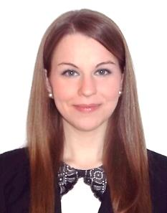

EDUCATION__________________________________________________________________
The Ohio State University Columbus, Ohio, USA
B.S. Human Development and Family Science Graduated June 2011
Specialization: Early Childhood Development and Education
• Minor: Spanish
• Honors: Magna Cum Laude

WORK EXPERIENCE______________________________________________________________________
Gangwon Provincial Office of Education Sokcho, South Korea
Guest English Teacher September 2014 – Present
• Plan and deliver lessons in elementary English classes, grades three through six
• Design and lead one-day special English classes for students grades three through six from six area schools, using interactive English language games and projects to encourage communication between students and native English teachers
• Design and lead of week-long English camps for students from grades one through six, including a variety of interesting and creative English lessons and activities each day

Community of Madrid Madrid, Spain
Language and Cultural Ambassador and Conversation Teacher October 2012 – June 2014
• Taught in bilingual English, Science, and Art classes to numerous classes, ranging from first to fourth grade, in a bilingual primary school
• Provided instruction in English in both classroom settings and small group settings
• Formulated and delivered appropriate and engaging lesson plans adapted to students and subject material
• Prepared students for external English exams: Trinity College London
• Provided English language consultation to bilingual, native Spanish-speaking teachers
• Created educational presentations, materials, and other resources for use in the classroom

Junta de Andalucía Seville, Spain
Language and Cultural Ambassador and Conversation Teacher October 2011 – May 2012
• Taught in bilingual English, Science, Social Science, and Math classes to numerous classes, ranging from seventh to twelfth grade, in a bilingual secondary school
• Formulated and delivered appropriate and engaging lesson plans adapted to students and subject material
• Provided English language consultation to bilingual, native Spanish-speaking teachers
• Created educational presentations, materials, and other resources for use in the classroom

A. Sophie Rogers Laboratory School Columbus, Ohio, USA
Assistant Early Childhood Specialist January 2009 – June 2011
• Assisted with managing seven infant/toddler and preschool classrooms at a Reggio Emilia-inspired center as a long-term substitute teacher
• Promoted cognitive, emotional, and social development of children through educational experiences
• Contributed to the creation and implementation of lesson plans based on the interests of the children and adapted to their individual needs

