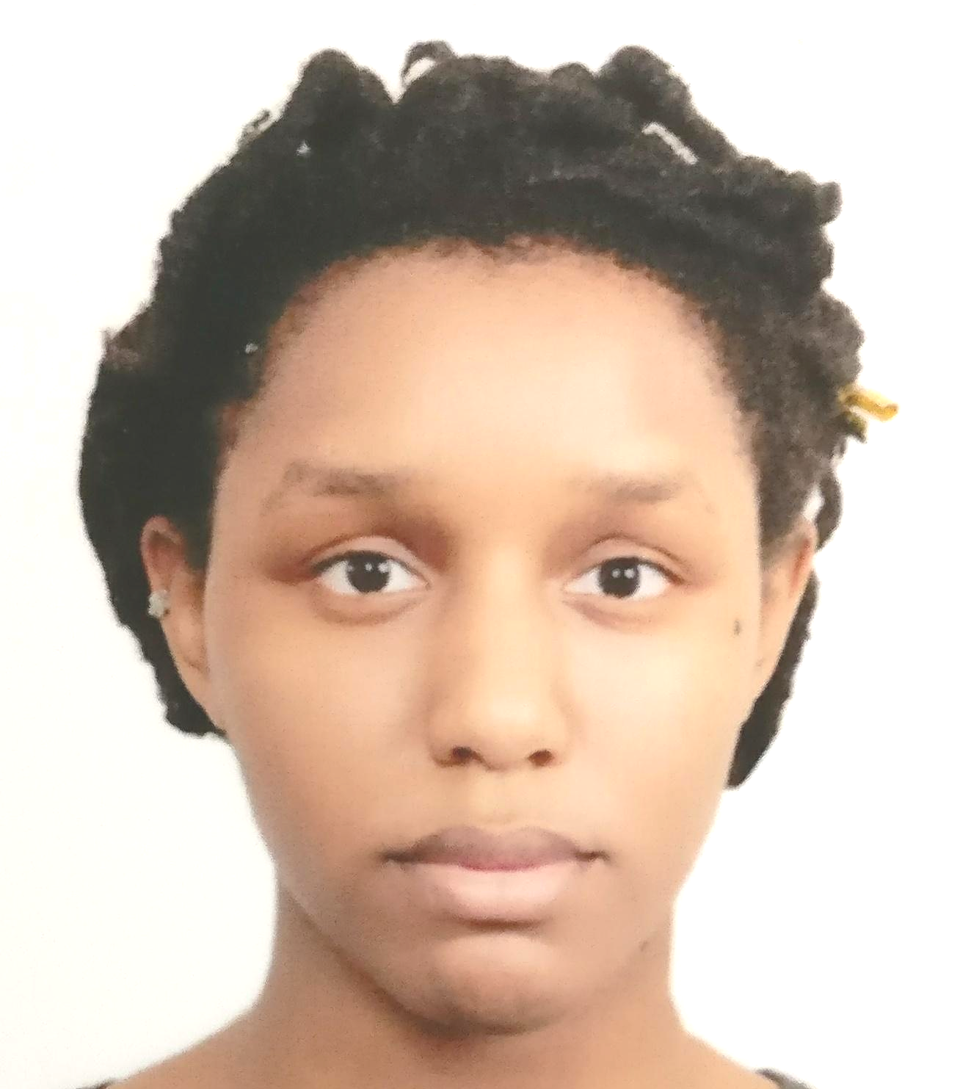

Education
Teachers College, Columbia University, New York, United States
June 2015 – August 2015
Certification in Teaching English to Speakers of Other Languages (TESOL)
- Created lesson plans and provided English language instruction to adults during course
- Utilized computers as a resource to enhance interactive learning
- Collaborated with fellow teachers in providing lesson plans tailored to target students
Yonsei University, Seodaemun-gu, Seoul, Korea
March 2014- December 2014
Study Abroad
- Completed Level 3 Korean at Yonsei’s Korean Language Institute
State University of New York at Albany, Albany, New York, United States
August 2011- May 2015
Bachelor of Arts in East Asian Studies, Minor in Korean

Work History
Korea POLY School , Guwol-dong, Namdong-gu, South Korea
August 2018 - Present
- Instructed English classes to children ages 4 - 11
- Developed knowledge and experience with Microsoft PowerPoint, Word, and Excel
- Prepared students for monthly assessments throughout the year with monthly progress and behavioral reports
- Adapted curriculum to students’ language learning needs

Skills
- Knowledge of Korean and Spanish languages
- Utilization of computer resources to supplement learning

