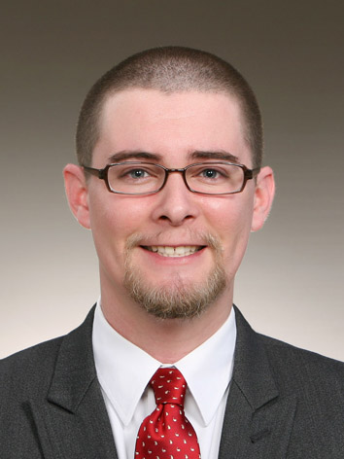
L. Austin Sharpe III
서울 도봉구 창5동
SR스타빌 904호 132-045
10/07/1981
010-4650-6116
laustinsharpeiii@gmail.com

Work Experience

- 2008-2011 – Chung Dahm Learning Dobong campus
  - Teacher
    - Taught children ages 10-17 in the CDL method of learning English reading, writing, listening and speaking
  - Head Instructor, 1½ years
    - Aided in new and current teachers’ improvement in their teaching skills through workshops as well as one on one individual training
    - Acted as liaison for the teachers and the Branch Manager and Korean staff as well as enacted and enforced any and all regulatory rules
- 2006-2007 - Freelance English tutor, Klaipeda, Lithuania
  - Independently solicited and tutored children and adults English
- 2004-2006 - RE/MAX North Associates, Dallas, Texas – Real estate firm franchise through which Realtors are able to independently run their businesses.
  - Foreclosure specialist
    - In charge of the #1 sales team in North Texas area for 2005.
    - Recovering, pricing, and selling of over 800 foreclosed properties for various government entities and banks over a two year period.
    - Developed, held, and taught classes regularly for other real estate agents on how to sell foreclosed property.
  - Office Assistant
    - While interning, handled phones, managed an office of 15 Realtors and many clients.
  - Real estate agent
    - Agent in the buying, selling, and leasing of residential property.
- 1998-2004 - Carrabba’s Italian Grill, Jacksonville & Tallahassee, Florida – Italian fine dining restaurant.
  - Busboy, host, cook, server, floor manager, and food preparer.
    - Part-time while attending high school and college.
- 1997-1998 - Wolf Technologies, Jacksonville, Florida – Geotechnical surveying firm involved in soil recovery and testing for new construction.
  - Office Manager and Secretary
  - Driller’s helper and Driller

References available upon request

Education

Florida State University – 2000-2004
  - Bachelor of Arts Degree, 2004
    - Major in History
    - Minor in Classical Literature, Art and Philosophy

Stanton College Preparatory High School – 1996-2000
  - National Honor Society all 4 years
    - Maintained above a 3.5 grade point average
  - Florida Bright Futures 100% Academic College Scholarship

Qualities
- Professional, respectful, and well mannered
- Leadership qualities
- Organized and responsible
- Computer literate
- Confident, detailed, and hard working
- Experienced traveler
- Great with people young and old

