Resume of

Sokol Larissa

–––––––––––––––––––––––––––––––––––––––––––––––––––––––––––––––
Personal Details

Birth Date: 16 October 1966

Address: D.Kovalchuk Str. 63, apartment 3, Novosibirsk, Russia, 630001

Phone: +7 383 228 24 02

Mobile: +7 913 711 75 25

email: ochotin@gmail.com

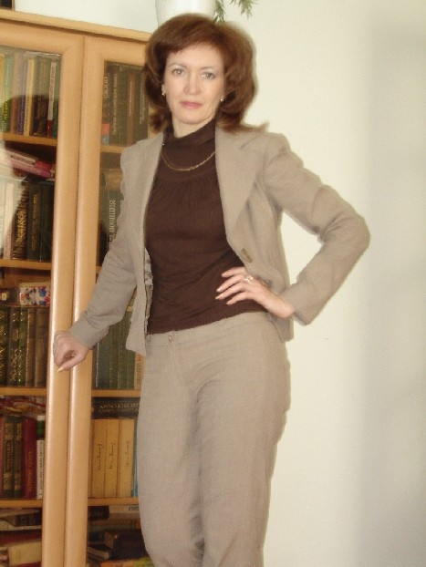

–––––––––––––––––––––––––––––––––––––––––––––––––––––––––––––––
Post School Education:

1988 -1993
Higher Education in Teaching English and German,
Novosibirsk State Pedagogical University,
Novosibirsk, Russia

2000 -2004
Diploma, Law
Tomsk State University,
Tomsk, Russia

–––––––––––––––––––––––––––––––––––––––––––––––––––––––––––––––
Employment History

September 2005 – Present

Senior English Teacher at Novosibirsk State Technical
University, of the Humanitarian Faculty, Foreign Languages
Department, Novosibirsk, Russia

February 2005 – September 2005

Specialist of International Correspondence Department at
Novosibirsk Vneshtorgbank, Novosibirsk, Russia

March 2000 – February 2005

English Teacher at Novosibirsk State Technical University
October 1995 – July 1998

English Teacher at Novosibirsk State Technical University

April 1994 – August 1995

Secretary-advisor at AOZT “GALANT”, Novosibirsk, Russia

January 1994 – April 1994

English Teacher at Novosibirsk Radio Technical College,
Novosibirsk, Russia

–––––––––––––––––––––––––––––––––––––––––––––––––––––––––––––––
Other Professional Activities:

Since 1996 - doing translation and assessment work in Russia for the German company, Kahler&Prinz (Staeder Strasse 2-4 21075 Hamburg, Germany) - this has involved business trips for orientation and liaison (to Germany and to the Czech Republic, 2 trips to Slovakia, and 1 trip to Poland)

Since 2006 - engaged in professional guide-interpreting work for Australian consultancy - undertaken in University non-teaching periods and as professional development leave for my English enhancement.

Since 2008 - engaged for English-to-Russian translation work by the English publishing company, Pink Cloud Ltd (Newton Aycliffe, Co Durham, DL56XP, UK) - this involved a business trip to the UK for orientation and liaison with them

–––––––––––
Since 2006 - I have researched and written on my personal interest in the different perceptions of Time in different cultures and languages from both linguistic and philosophical perspectives. This has entailed an in-depth comparison of Russian and English usage and literature in relation to that topic.

–––––––––––––––––––––––––––––––––––––––––––––––––––––––––––––––
Personal Interests:
Classical music
Literature
Fitness
Travelling to sites of cultural significance

–––––––––––––––––––––––––––––––––––––––––––––––––––––––––––––––

Referees

Ms Elena Melekhina
Head of the Foreign Languages Department for the Humanities
Novosibirsk State Technical University
K.Marx Prospect 20, Novosibirsk, 630092, RUSSIA
office phone +7 383 3460257
mobile +7 9039013244
email <elenam@fgo.nstu.ru>

Mr David L. Brown
Horticulture & Ecology Consultant
145 Barker Road, Subiaco, WA, 6008, AUSTRALIA
office phone +61 8 93 81 82 08
mobile +61 41 00 42 801
email <consemble@gmail.com>

–––––––––––––––––––––––––––––––––––––––––––––––––––––––––––––––

