Lane J. Mikula
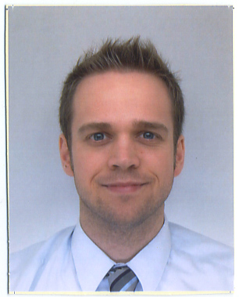
mikulalj@gmail.com
Nationality: United States of America
Place of Birth: Richmond, Virginia
Current address:
525 Kawaharagou Hidakagawa cho Hidaka gun
Wakayama Japan 6441201
Cell phone #: (80)-5630-5664
__________________________________________________________________________________________________
Career Objective: To build upon my four years of English teaching experience in South Korea. I also want to master the Korean language and have a unique understanding of Korean culture.

Work Experience:
August 2009-July 2010 JET Program Wakayama, Japan
ALT (Assistant Language Teacher) (English Teacher)
-Taught five elementary/junior high schools
-Voluntarily taught adult English classes
-Gained unique knowledge of Asian educational system
June 2007-July 2009 Virginia Commonwealth University (VCU) Richmond, VA
English Teacher
-Taught American university-level preparatory English coursework,
along with TOEFL examination preparatory English coursework
-Prepared students for college-level English test-taking
-Majority of students were college-aged South Korean students
-Taught intermediate through advanced level college English classes in five
different areas (reading, writing/grammar, listening, speaking, pronunciation)
June 2006-May 2007 El Cultural Trujillo, Perú
English Teacher
-Prepared students for Michigan ECCE (Examination for the Certificate of
Competency in English) Exam
-Taught Basic/Intermediate/Advanced/Weekend English, students aged 12 to 60
-Taught reading, writing, listening, and speaking English courses
Education:
The University of Georgia (UGA) Athens, GA
Bachelor of Arts in Journalism, GPA 3.64 Cum Laude, Class of 2006
Concentration: Broadcast Journalism (focus on writing/reporting in English), with a minor in Spanish
TESOL/TEFL ITTT
TESOL Certification, passed with an A
Business English Certification, passed with “Satisfactory”
Young Learners Certification, passed with “Satisfactory” All three received in April, 2010

Skills:
Multilingual: Spanish- Full-time fluency for six years
Japanese- Conversationally fluent
Korean- Basic level knowledge
Technology: I have frequently used computers, projectors, Smartboard, iPod, and other updated technologies in classroom settings.

Achievements/honors/awards:
Dean’s List (Fall 2002-Spring 2006): Honored as a member of the Dean’s List throughout four years of University, graduating with a 3.64 GPA and a Cum Laude degree
Acapella Group President (August 2005-May 2006): Singer with the coed collegiate acapella group With Somebody Else´s Money for three years and named President for the senior year of college

Character References:
Martha Young, Virginia Commonwealth University, 817 W. Franklin St., P.O. Box 843043, Richmond, VA 23284-3043, USA,
(804) 828-3191, mwyoung@vcu.edu
Lisse Hildebrandt, Virginia Commonwealth University, 817 W. Franklin St., P.O. Box 843043, Richmond, VA 23284-3043, USA, (804) 828-8471, lhildebr@vcu.edu

