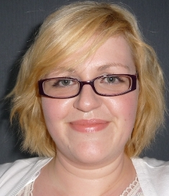
Laura Clarke
3 Arthur Avenue, Newtownabbey
BT36 7EJ, United Kingdom
Nationality: British
Marital Status: Single
Date of Birth: 28th January 1985

OBJECTIVE

University graduate who loves children and is eager for the opportunity to teach English in South Korea.

EDUCATION

B.A. English (Major) and Cultural Studies (2:1) July 2006
Queen’s University Belfast

RELEVANT EXPERIENCE

- Lived abroad in USA for 3 months
- Babysitter and tutor for young children
- Volunteered as English tutor to a foreign classmate

EMPLOYMENT HISTORY

Caregiver for Disabled 2008 – Present
- Provided assistance with reading, writing, arts and crafts
- Coordinated with therapists, doctors and caseworkers

Customer Service Advisor February 2007 – July 2008
British Telecom, Belfast
- Worked alone and as part of a team to meet deadlines and targets
- Provided some training to new staff

Audio Typist & Researcher September 2006 – February 2007
Ink Well People Ltd
- Worked with teenagers as head of a work experience programme
- Transcribed and typed interviews

SKILLS

- Proficient with Microsoft Word
- Experience with Windows operating system

