Lavon Murray
166-6 Gangnam-gu, Seoul
South Korea, 153
010-7629-7870
Jubeikibagami357@hotmail.com

PROFILE:
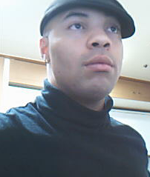
I have worked to develop myself into a highly versatile, analytical and hardworking communications expert, with a long history of working in communications based environments, as well as teaching. Able to formulate lesson plans, and extremely skilled in a wide array of areas, I also have acquired the problem solving skills of a detective. In the last two and a half years, I have created a highly developed teaching style, which incorporates 6 years of undergraduate and graduate studies, yet able to make classes engaging, even motivating to students. I am also uniquely gifted with an almost archival knowledge of subjects ranging from topics like the Kaluza Kline Theory and the Superstring formulas, to knowledge about culture, religion even philosophy. It has been my objective since my first day in college to teach at the colligate level. I have studied a huge number of communicative areas, from mass communication and public speaking, to mass media, multi-cultural communication and more. I have modeled myself after some of the best communications experts the state of New York has to offer, and have even developed the makings of a college level class structure. I am highly skilled and ready.

MAJOR ACHIEVEMENTS:

- Recipient of the American Chemistry Society Award.
- Earned Certificate of employability while participating in the 3 year Kodak Youth Apprenticeship Program.
- Organized and hosted Self Defense Seminars for women in the Buffalo, NY
gaining both radio and newspaper coverage on multiple occasions.
- Founding member of the AASO (Asian American Students Organization).
- Co-Founder and director of the WIMA (World Institute of martial arts).
- 5 time international martial arts champion.
- Recipient of the D.A.R.E. award for anti drug youths.
- Earned numerous awards over the last 15 years for academic excellence, and being a good person in general.

CAREER HISTORY:

- Pagoda/Direct English (Current)
Instructor/Teacher/Native Tutor:
This heavily communications based position has me performing all the daily tasks of a teacher/advisor/editor. I utilize many communicated tactics from visual aids to kinesthetic examples, to ensure that students are not only learning, but remaining engaged. Given the wide range of areas I assist students with while teaching them proper English skills, I am also by proxy teaching them communications, which is something I deeply enjoy and find rewarding.

- ChungDahm ESL Institute
Language, Reading and Writing Instructor (Aug 08-Sept 2010) This is another extremely communications intensive position I held, where communication and leader ship was necessary. As the branches most popular instructor, I am even on the hand out flyer/advertisement given to people walking by the school. I had very large classes in general, and in many cases my classes reached 20 or more students peaking at 30. Even in this scenario, my ability to communicate to students, parents, management and even other instructors, was exemplary. I became very popular here, and even now the students still ask the new instructors about me.

- ChungDahm ESL Institute (6 Months)
Head Instructor
For a period of approximately 6 months, I was the head instructor for the Anyang branch of CDI. During this time, I had all the responsibilities of any other teacher there, with the addition of many new obligations. One of my most important tasks, was managing the other instructors. It was my job, to ensure that all instructors were teaching properly, in addition to having proper student management. I observed CCTV videos daily of each instructor, and wrote bi-weekly evaluations of each teacher. It was then my task, to meet with each instructor individually, and discuss not only my finding, but to help instructors if there was room for improvement. I was teaching and managing at the same time, which forced me to become an even greater teacher. I had to lead by example, this is a hallmark of leadership.

- Strong Hospital & University of Rochester (Sleep Studies Center) (07-08)
Level 3 Clinical Technologist
As a clinical technologist, I used nearly all of my communicative skills, on a constant basis each and every day. I would regularly have to prepare and organize medical charts for incoming staff, then carefully explain the details of a patient's medical history. Additional communication is a necessity when caring for patients. Often it was my ability to explain the procedure to many patients which put them at ease. It was not uncommon for patients to give me amazing evaluations, and parents were often surprised at how well I was able to connect with their children through various means. A prime example of this would be an 8 year old patient of mine, who suffered from down syndrome, skin sensitivity, and severely impaired speech and hearing. This patient was partially autistic as well. Not only was the child laughing and hi-fiving me by the end of the study, but he was even trying to talk, telling his parents that I had made him into a robot. I have learned that you can communicate with anyone, and my ability to connect with this child, whom many assumed would not even make an effort to speak, let alone laugh and joke, shows my adept abilities.

- Computer Technical services (CTS), Buffalo, NY (2005-2006)
Technical Services Representative
Working in computer services was a very good opportunity to develop my computer skills, while utilizing media and interpersonal communication skills. It was my daily task to interact with clients in an effort to solve a vast array of computer related difficulties. Often people would not have the technical knowledge to explain their problems, thus requiring me to explain technical matters. It was common for me to briefly educate clients on computer related issues, leading to regular phone calls from proud clients informing us of how they had fixed a problem on their own, in large part thanks to my instructions. I made it my personal responsibility to not just fix the computer for a person, but to show that person what it was I did to correct the malfunction. This made the job not only rewarding, but gave me yet another chance to instruct others.

THE REMAINDER OF MY WORK HISTORY

I have been fortunate to have had such a wonderful chain of experiences, and would like to include some of the remaining jobs I have held through the years.

- AutoZone Corporation Customer services and Sales Representative 2006-Spring 2007
- BSC Mail Services, Buffalo, NY 2004 Distribution
- Tops Friendly Market, Rochester, NY / Buffalo, NY (Transferred) 2002-2003 Customer Service Representative
- Atkell, Incorporated, Rochester, NY 2003 Environmental Engineer
- Eastman Kodak Company 1996-1999 Research and Development Specialist
- Rochester General Hospital Fall 1995-Spring 1996 Dietary Specialist

EDUCATION AND QUALIFICATIONS:
Currently I hold a Masters Degree in communications, and have studied and experienced a huge variety of communications based scenarios, ranging from giving public speeches on the importance or learning self defense, to the intricacies of mass communication. I have learned and in fact honed the skills of communication, and have already begun developing curriculum ideas, so I have contributions to add to staff meetings. My undergraduate studies were many things under the umbrella of communications. I studied journalism, broadcasting, audio/video/photo editing, computers, various sciences, multicultural relations, media, mass communications, public speaking and even television studio production. My final project in my television class was to write, direct, produce and star in my own campus aired commercial. I got an A+ on this project, which is still available to new students as of march 2010.

ADDITIONAL INFORMATION:
As a martial arts champion/practitioner/student and teacher, I have owned and operated my own school for several years. I have taught children as young as 4, and adults as elderly as 70. I have used communications as a tool time and time again, to promote safety, through various public speeches, seminars and demonstrations. Many of these events were reported on radio stations, television stations, and even in news papers, on more than one occasion. I worked in conjunction with virtually all major campus organizations, fraternities and sororities, to ensure the safety of the campus, and even taught free classes to the student body. My classes became so popular, I had to bring in other instructors to help me, due to the sheer number of students, (Over 70 at one point). I have been striving towards a better future, and with various forms of communication bringing the world closer together each day, I know if I am given a chance to further myself professionally within your organization, I can begin to realize my full potential, and help others to do the same.

MY THANKS:
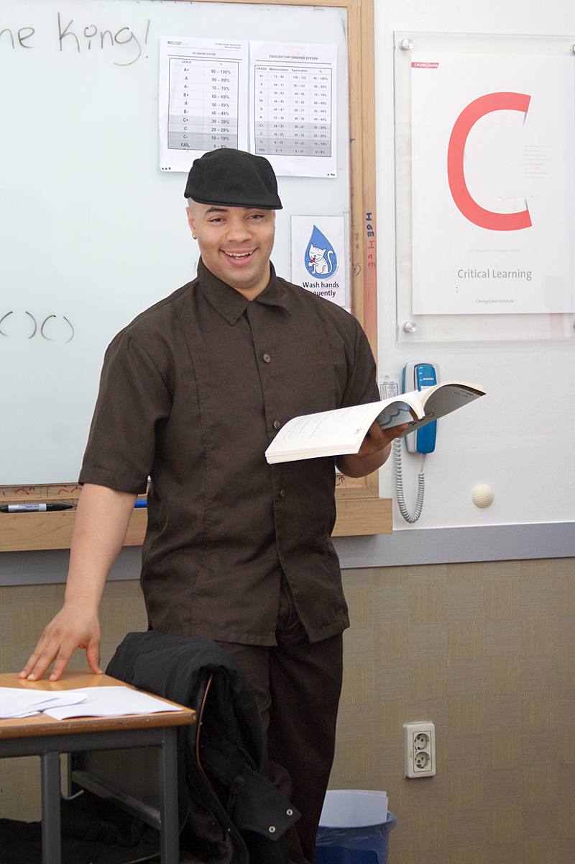
It is with my sincerest thanks that you have taken the time to read this, and I hope that you will consider giving me the chance to prove myself, through hard work and dedication. I have built a respectable amount of experience over the years, and have been told constantly that a person needs experience to teach at the colligate level, but the only true way to become excellent at anything is by doing it. I hope that after reviewing my documentation, you can see that I am both professional, and quite serious, and will give you 1000% each and every day if given the chance. I turned down an adjunct position at Bryant & Stratton in addition opting to come to South Korea, even after making it to phase 2 in the FBI agent selection process. I am determined to be a professor, it is simply all I have ever wanted to do.

Lavon M. Murray
Current Location: Gangnam, Seoul
Years Experience Teaching: 2 and a half
Objective: Teaching in a university, or colligate environment
"I am ready, If you are willing to give me a chance."

