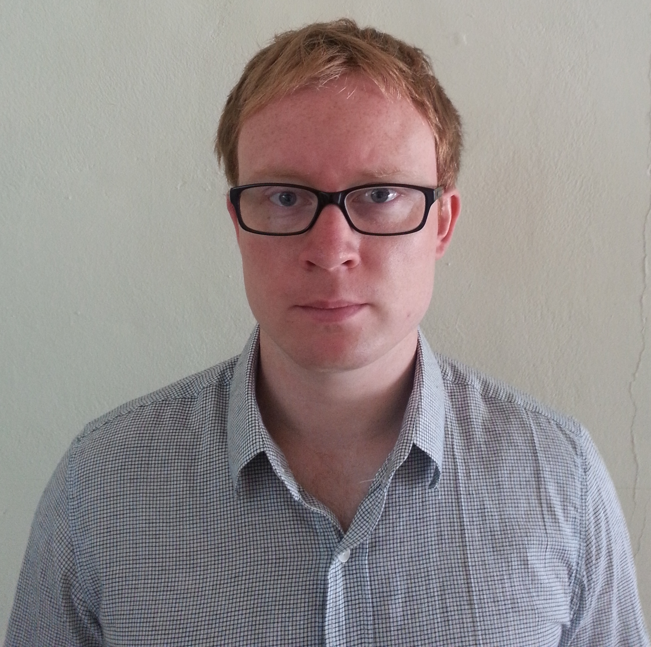

LAWRENCE DOBBS BA (Hons)

Mobile: 010-2858-3076 Email: dobbs99@hotmail.co.uk
Skype: lawrence.dobbs1

Education

2006 – 2009 University of Portsmouth, Portsmouth UK
BA Hons Film and Television Production (2:1)

2003 – 2005 South Downs College, Waterlooville, Hampshire UK
A-level: Film Studies (C)
BTEC: Media Production (Merit)

Certified TEFL Teacher: Fully qualified to teach English as a foreign language (TEFL) - 140 hours

Specialised modules: English one to one, English to young learners, audio and visual lessons and grammar awareness.

Employment History

September 2012 – current. Native English Teacher

Sujung Elementary School, 524 Beonji Chil-gap-san-Ro (Ju-jeong-Ri 283), Daechi Myeon, Cheongyang-Gun, Chungnam-do, South Korea. 345-892

- Native English teacher at Elementary level teaching English at beginner level.
- Developed excellent skills in communication and organisation
- Further developed my skills in teaching kindergarten
- Organised and planned a successful winter English camp
- Worked to develop a positive and efficient relationship with my co-teacher and colleagues
- Progressed and focused my teaching skills in conversational English
- Participated in many sporting activities with the school and the community including soccer, badminton and volleyball.
- Consistently demonstrated commitment and dependency

March 2013 – current

Cheongyang Institute of Special Education – English Teacher

- Teach beginner English to an adult class, twice a week, two hours each lesson
- Class ranges from 12 to 20 students of different levels
- Students are of Korean, Vietnamese and Filipino nationality and all reside within the community of Cheongyang.

October – May 2012 Landscape construction, New Leaf, Waltham Chase, Hampshire UK

- Continued development in landscaping skills for large construction projects and garden features

March – May 2011 Landscape construction, Haven Gardens, Shedfield, Hampshire UK

- Developed skills in Landscaping, construction and Garden maintenance

October 2009 - Editor/Camera operator, Shady Jane Productions.
‘Her Yellow Wallpaper’ Winchester University, Winchester SO22 4NR 01962 841515
- Filmed and edited a live theatre production for a drama festival in Germany

- Shot and edited the 45 minute production individually SO22 4NR

February 2009 - Music promotional video maker ‘The Pete Harris Blues Band’ filmed live at the Fat Fox in Portsmouth.
Director/producer/camera operator/editor
- Produced a promotional video for a popular southern blues band
- Used Sony Z1s and 4 directional microphones with mixer
http://www.youtube.com/watch?v=0Yx0uJ8ii24

June 2008 - Researcher/Runner
Big Wave Productions, 156 St Pancras, Chichester, West Sussex, PO19 7SH
- Assistant to the production manager
- Responsible for researching material for future and current productions
- Assisted with the edit of BBC production ‘Turtle – The ultimate Journey’
Reference – Angela Palmerton – Head of Production 01243 532531 info@bigwavetv.com

2005 – 2010 Barman/Bar Manager, The Wheatsheaf Inn, Shedfield, Hampshire UK (South Hampshire CAMRA Pub of the Year 2011) Reference – Tim Shepherd (+44) 1329 833024

- Developed excellent skills in communication and customer service.
- Responsible for the service of food and beverages and general managing of a busy public house and restaurant.
- Assisted in the promotion and organisation of music events.
- Responsible for the ordering of stock, looking after accounts, training new staff and all cellar work.

