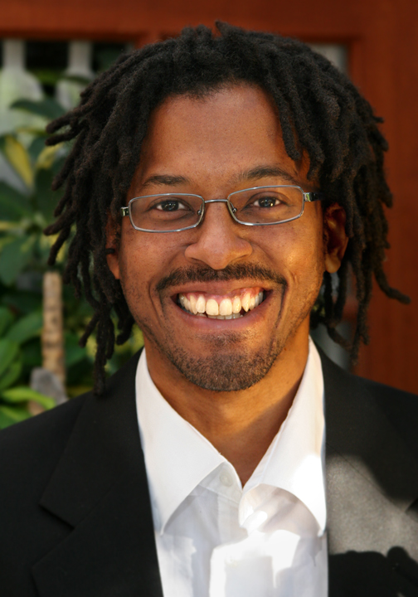

Lemuel Clarence Cabrera II
Lemuelcabrera173@gmail.com
(010)7535-6423

Education:
University of California, San Diego:
B.A. in Linguistics with Emphasis in Cognition and Language Development

Courses in:

Work Experience:
2003 - 2006: Academic Assistant
Dr. Jerry Rafiki Jenkins, Ph.D., Palomar Community College, San Marcos, CA
Responsibilities: Grading Student Essays on English Literature.

1998 - 2002: Assistant Martial Arts Instructor
Dan Tao West, San Diego, CA
Responsibilities: Assisting Students in the Qi Gong Martial Arts Practice.

2002 - 2005: Sound Production Intern
Coppercat Studios, San Diego, CA
Responsibilities: Sound Design and Editing for Music Production Studio. www.coppercat.net

1997 - 1998: Food Service Professional
Camp Pendleton Marine Base, Oceanside, CA
Responsibilities: Bussing Tables, Washing Dishes, Maintaining Sanitation for a Military Dining Facility.

2008 – 2009: English Teacher
Gajwa Girls’ Middle School, Incheon Seogu Seoknam dong, South Korea
Responsibilities: Teaching English text book lessons with the assistance of Korean co-teachers, Conducting after school English Conversation classes for middle school students, Conducting English refresher classes for Korean co-teachers, Facilitating in-school English Essay competition, Interviewing students to test English Competency.

2008 – 2009: Global Education Center Summer and Winter Camp Instructor
G.E.C. Center, Seogu Youth Center, Shinyeon Girls’ High School
Instructing students from elementary and high-school in various English lessons and activities.

References:
Fay McGrew (Dan Tao West) : 760.519.9988
Jeremy Richardson (Coppercat Studios) : 858.274.2017 or music@coppercat.net
Dr. Jerry Rafiki Jenkins, Ph.D. (Palomar College English Literature Dept.) :

