010-3625-8818
lilinoeq@hotmail.com
BD: April 1, 1979

P.O. Box 17932
Honolulu, Hawaii 96817

Objective | English Teacher Position
Education | - Chaminade University (10/03-12/06), Master in Ed, PK-3 License, 12/06  - UH-Manoa (1/01-5/03), BS in Family Resources, 5/03  - Honolulu Community College (8/99 to 12/00)  - Hawaii Community College (8/97 to 5/99), AA in LBART, 12/00  - Kamehameha School, Diploma, 1997
Experience | Teacher in South Korea  Gyeonggi, South Korea  4/08 to current  - Provide English curriculum for kindergarten & elementary students grade 1-6 students, teachers, and parents.  - Co-teach with a Korean teacher.  - Plan developmentally appropriate activities for students.  - Assess learning with monthly test.  - Communicate to families about children’s development.
Teacher Kamehameha Preschool at Waimanalo
41-235 Ilauhole Street Waimanalo, HI 96795
J. Mahealani McClellan – Regional Manager
7/16/04 to 3/08
- Provide developmentally appropriate curriculum for 4-year olds.
- Communicate to families about children’s development.
- Collect & Evaluate data for Work Sampling System.

Teacher KCAA Preschool at Wai-Kahala
1261 Pueo Street Honolulu, HI 96816
Mei Taylor -site director
6/20/03 to 6/25/04
- Provide developmentally appropriate curriculum for 3-year olds.
- Communicate to families about children’s development.
- Oversees & responsible when director is not present.

Teacher’s Aide Manoa Valley Church Preschool, HI.
9/3/99 to 6/1/00
- Assist teacher with twenty 3 year olds.
- Supervise children playing, using bathroom, and eating snacks
- Provide an activity and story for the children once a week.

Substitute Teaching Assistant Kamehameha Preschool
at Nu‘uanu and Lincoln, HI.
9/19/02 to 6/01/03
- Assist teacher in setting up daily activities for twenty 3-4 year olds.
- Encourage communication and problem-solving with preschoolers.
- Communicate with families of children’s daily activities.

Joelle Lilinoe Quindica
Experience cont’d | Mother’s Helper  Dold Family  2130 Pu‘uali‘i Place Honolulu, HI 96822  Chikako Dold - Mother  8/02 to 12/06  - Plan fun, age appropriate activities within a budget for 1-3 children.  - Responsible for feeding, cleaning, and caring for children’s basic needs.
Customer Service Associate Crazy Shirts
Outlet Store at Ward Village
1116 Auahi Street, Space D Honolulu, HI 96814
Bonnie Allen – Outlet Manager
11/7/99 to 2/02
- Greet, assist, and build rapport with customers.
- Provide product information on shrinkage, contents, and designs.
- Plan Specific, Measurable, Attainable, Realistic, Time goals monthly.
- Maintain an accurate register of $1,500 each shift.

Volunteer Work | Anuenue School, HI. (6/06 to 9/01/06)  - Assist staff and students.  - Present activities for students related to the curriculum.  - Receive feedback from Mentor teacher & University Supervisor  Lunalilo Home, HI. (3/03 to 1/06)  - Assist staff and residents.  - Talk with kupuna and engage them in activities.  Ke Ola Pono No Na Kupuna Program, HI. (1/03 to 5/03)  - Assist Elderly Services Manager.  - Learn about Native Hawaiian elderly needs and services.  - Plan activities, collect health information, & input data to be analyzed.  - Help compile information for Kupuna Cookbook.  Holy Nativity School,Keiki Co-op & Pre-K Class, HI.(10/01 to 5/02)  - Assist Teacher and Aide with group of 3-4 year olds.  - Encourage interaction and communication skills among children.  Hui Kanaka Maoli, Hawaiian Club at HawCC at Hilo, HI. (‘97-‘99)  - Committee chairperson – Waipi‘o Valley Kalo Restoration Project  - Vice President  Kamehameha Preschool, HI. (summer of ‘96)  - Assist Teacher and Aide in serving lunch, planning one group activity, and monitoring children.  Punana Leo o Kawaiha‘o - Teacher Aide, HI. (summer of ‘95)  - Gain confidence in working with Hawaiian Immersion children.
Publications | Ka Na‘i Aupuni, Kamehameha High school Yearbook, HI. (‘95-‘97)  - Co-editor in chief – Oversaw staff of 30 in completing and using Pagemaker program to create yearbook.
Skills | Fluent in Hawaiian Language. Proficient in Macintosh and Windows (Word, Powerpoint, Excel, Outlook).
References | Available upon request.  Joelle Lilinoe Quindica  Page 2 of 2

Joelle Lilinoe Quindica
P.O. Box 17932
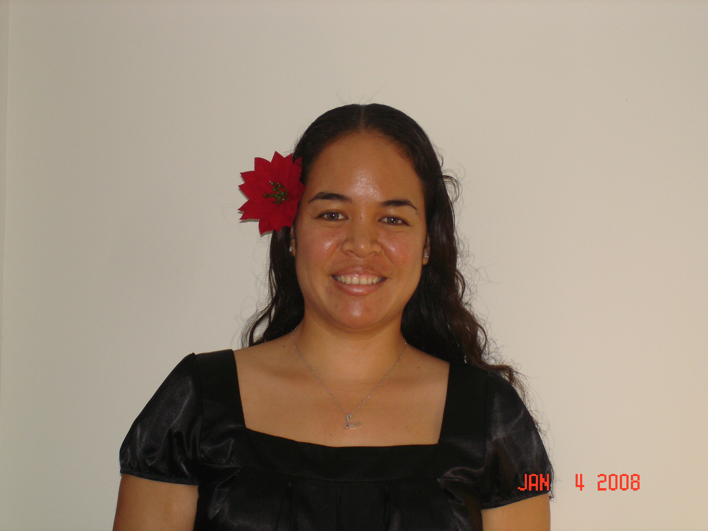
Honolulu, Hawaii 96817
Cell. 010-3625-8818
lilinoeq@hotmail.com
Birthdate: April 1, 1979

To whom it may concern:

Aloha! I am very interested in an English Teacher Position at your school.
I have over 10 years of experience working with people, especially children and families. I have good verbal skills, and am an effective communicator. As a substitute teacher’s aide at various schools, I have implemented curriculum, assisted teachers, and performed my assigned duties. In 2003 I taught at KCAA Wai Kahala, and have taught at Kamehameha Preschool Waimanalo from 2004-2008. In 2006, and 1995, I have volunteered at two Hawaiian Immersion schools where students were taught only in the Hawaiian Language, this experience and learning Hawaiian since I was young has given me skills to help others learn a second language. Since April 2008 I have worked as an Elementary & Kindergarten teacher in Gyeonggi Province, South Korea, where I taught English to kindergarten students, elementary students, parents and teachers. As a teacher I have planned, developed, and implemented curriculum, managed a budget, conducted workshops for parents, ordered supplies, collected and evaluated data, conducted conferences with parents, and supervised a teaching assistant.
I graduated in 2003 from the University of Hawaii at Manoa with a Bachelor of Science degree in Family Resources. Through my college course work I have strengthened my computer and research skills and my knowledge of using Word, Outlook, Powerpoint, and Excel. In 2006 I completed my Master’s Degree at Chaminade University of Honolulu in Education in which I was challenged to my limits of follow through, attention to detail, and efficiency.
Besides my teaching experiences I have also worked in retail and customer service positions at Crazy Shirts Inc from 1999-2002, at Thinker Toys in 1999, and Keiki O Ka Aina in 1998. Here I have learned effective customer service techniques, became knowledgeable on product information, and worked as a team member to meet the company goals.
With my above experiences, I feel that my knowledge and skills would be a great asset to creating a good foundation & nurturing the curriculum for the students at your school. I also hope to learn more about my Korean heritage since my great-grandfather was Korean, and to share about my unique Hawaiian culture.
Please call me with any questions or to set an appointment for an interview, at 010-3625-8818. Thank you for your time and consideration.
Thank you,
J. Lilinoe Quindica

