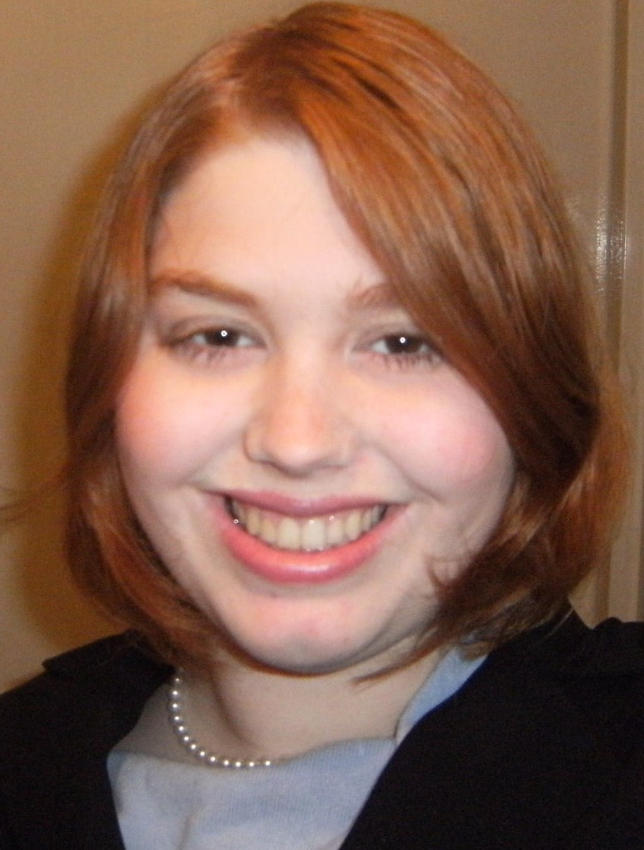

Lorena Jordan
Summary of Experience
Experienced, driven, talented, and successful young professional woman, with education and public service experience overseas in England and Japan, is seeking to continue my English instruction career with an overseas position as a English language teacher. Possessing a Bachelor of Arts, Double Honors degree in Political Science, with a focus on comparative politics of the European and Asian regions, and having conversational-level competencies in Japanese and French in addition to my native English, I currently work as a Contractor Passport Associate for the United States Department of State. In addition, my employment history, and public service record exemplifies a record of the extensive utilization of many skills crucial to being a successful Reading Specialist, including organizing and managing time and research deadlines, working with others to complete joint projects, lessons, and reports, an excellent ability to analyze ideas and/or data, perform research, synthesize information, and develop theories and proficient use of computerized applications such as Microsoft Office and Adobe software.

Education
Certificate of Educational Studies in TESOL, TEFL International, April 2012

Bachelor of Arts Magna cum laude, Political Science, University of South Carolina, 2007
Diploma, Charleston County School of the Arts, 2003.
Certifications
South Carolina Early Autism Project’s Autism Therapist training-2012
Child Abuse Laws and Practices- December 2011

Professional Accomplishments
Jordan Tours, A SC Sole Proprietorship
Charleston, S.C. 09/12-Present
Owner/Tour guide 15 Hours Per Week

Presently establishing my own business within the Charleston, South Carolina Area that will combine my skills for research and analysis with my ability and desire to teach others and explore the rich history that is in my hometown of Charleston, South Carolina.
- Using my tour guide license and expertise, I conduct personal walking tours of the famous Downtown Charleston area, providing local, native takes on events and stories that have created the city of Charleston, South Carolina. I also research new and annual events to provide clients with opportunities to enjoy their visit on a more local level.
- Promote my business venture with local vendors, establishing connections and promotions to attract new business and create partnerships.
- Constantly conduct research on Charleston’s history, architecture, politics, social customs and events to be able to express these to clients on my tours, creating a unique source of independent and extensive knowledge.

Examiner.com
North Charleston, S.C. 09/12-Present
U.S. Foreign Policy writer 10 Hours Per Week

Presently writing for the website Examiner.com, exploring and discussing current events that effect the foreign policies of the United States.
- Review, research, and determine current and relevant topics regarding the United States and its foreign relations to write and promote on my personal homepage. Recent articles have promoted understanding and analysis on the United Nations’ vote on the Palestinian Statehood, North Korea’s Rocket launch and its results, and United King-United States relations.
- On my own schedule, complete relevant, interesting, and thorough articles with accompanying pictures and reviews of materials as necessary. Currently producing over the minimum required four articles a month policy to create and successful and established profile within the Examiner.com community
- Work within independent and ever-changing deadlines to finish projects and articles as needed. Report to chief editor in a timely and efficient manner to ensure articles produced are high quality and relevant.
- Promote work among fellow writers within the site and online community; utilize popular social media outlets such as Facebook, Twitter, LinkedIn, Tumblr, and Pinterest to constantly promote my product and establish a steady readership.

U.S. Department of State/Allied Government Solutions
North Charleston, S.C. 03/12-Present
Passport Support Associate 40 Hours Per Week

Presently employed in the Charleston Passport Center’s Quality Control Division, working to maintain the integrity and security of military and civilian passport applications at all times.
- Review and handle expedited and sensitive requests from Congressional Offices on behalf of their constituents for new or renewed passports. Also handle expedited requests to complete the passport verification process from other departments, including adjudicators from the Department of State, as needed.
- Process Special Issuance Agency (SIA) passport requests from all branches of the United States military on behalf of their military personnel and designated military dependents. Responsible for the timely and efficient processing of SIA Official and Diplomatic styled passports for the military.
- Receive and amend active and valid passports by adding additional visa pages to the passport, enabling passport holders with frequent travel history to continue using their passports without the need to apply for a new one.
- Receive and examine non-expedited passport applications, processing up to 405 passport applications per day in the Mail Out division. Currently examine passport applications to ensure the final application is complete, accurate, and possessing of all necessary documentation to properly maintain a faithful record of the application in the Travel Document Issuance System (TDIS) computer system.
- Verify that the mailing address for returning evidence and personal documents to an applicant is current and correct. This includes scanning and examining all pages of provided documents for all noted addresses, notating any discrepancies in addresses given by applicants, and reporting applications that must be sent to and re-examined by an adjudicator for address correction.
- Handle complex address verification and legal clarifications needed for several passport-related applications, including the passport issuance DS-11 form, the data correction DS-5504 form, and military-related DS-82 form. In addition also use research and analysis skill set to determine proper address verification for Congressional-related expedited forms, and potentially-fraudulent passport applications.
- Work in the Image Quality Analysis division, processing up to 13,000 passport application pages per day for image review. Review individual application and supporting document pages to confirm the Travel Document Issuance System has a clear and concise image in case it is needed to be retrieved at a later date. Also confirm documentation numbers match the TDIS system number given, and that document quality and clarity are preserved at all times.

Project HERO-AmeriCorps, North Charleston, S.C. 09/11-03/12
Reading Interventionist 20 Hours Per Week

Served as a member of the initial year of the “Project HERO-Helping Enrich Reading Opportunities” Program in AmeriCorps providing literacy support within the Charleston County public school system.
- Tutored at-risk second graders in two Charleston County elementary schools. The tutoring utilized a program-sponsored reading program entitled ReadWell. In an intimate setting of 4-6 students per group, reading skills were presented in simple, sound-based and goal-based format, with students being able to practice on a more personal level with a provided tutor.
- Supported AmeriCorps and Project HERO promotion and introduction in the school district by attending events discussing the program. This included service project such as moving of supplies to schools, special events such as Charleston County community presentations, and being recognized for success at the Charleston County School Board meeting in March of 2012.
- Volunteered within the Charleston County area for AmeriCorps to serve the community and Project HERO as a Martin Luther King Jr. Parade Committee member. This was the service project for the Project HERO participants to serve on Martin Luther King Jr. Day. Coordinated the volunteer placement for my fellow Project HERO members, attended parade committee meetings, and worked with the Trident United Way and the parade committee to ensure our participation was successful and useful. In the end, 20 Project HERO members participated in the parade.

Verizon Wireless, North Charleston, S.C. 11/10-09/11
Customer Service Representative 40 Hours Per Week

Served as a Customer Service Representative, Level 1 Operator, explaining Verizon Wireless’ regulations, services, and customs to clients.
- Present, explain, and promote new products and services for customers as needed, including plan changes, home products, internet services, and functional needs to establish a more pleasant wireless experience. This included the selling of new phones, therefore “upgrading” accounts to new contracts. On average, processed 8 “upgrades” a month, when the goal was 5 upgrades per representative a month.
- Troubleshoot various device technical issues, including unresponsive servers and poor reception, for various products including Iphones, Blackberrys, Android Phones, laptops, tablets, and other issues as directed by customers.
- Resolve an average of 250 calls and extensive questions with research a week. This included potential fraud activities on established accounts, features not present that were intended to be included in customer’s plans, technical issues from technical support that were not resolved, and corporate requests to investigate complaints received from customers regarding previous customer service calls and experiences.
- Create and maintain a pleasant and positive atmosphere for customers while in real time researching, investigating, correcting, and solving issues related to their wireless experience. This included handling irate and unresponsive customers, customers that refused to explain their situation from fears stemming from previous experiences, and working with customers while on the line in step-by-step instruction to correct extensive technical issues.

Kanuma Board of Education, Kanuma Japan 09/09-03/10
English Teacher 40 Hours Per Week
1618-1 Imamiya cho Starting Salary: $ 36,000
Kanuma, Tochigi, Japan 322-0044 Ending Salary: $ 36,000
Supervisor: Michie Hosoda Phone: 0289-62-3326
May Be Contacted

Teaching English and American Culture to Japanese Junior High School Students.
- Created games, projects, worksheets, charts, and cultural presentations to instruct students in the mechanics of the English language, and the different aspects of American culture.
- In addition to expected lesson plans, created, established, and maintained several extensive and long-term programs for 1000 students in three junior high schools to allow students to practice English with myself on a personal and enjoyable basis, as well as providing opportunities to study cultures other than their own on a personal and enjoyable basis. These projects included one monthly newsletter to student classrooms at each school, a “Exploring Lorena Sensei’s Home” board at my main school, attending cultural activities and clubs with students in several capacities, a weekly radio program at my main school, and creating a card-writing system for students to write to me at my address when they desired to.
- Interviewed 25 Junior High School Students (out of 250) to determine the students qualified to visit the United States on a cultural exchange. Determined along with three other teachers which students would also enter the program on a scholarship level.
- Provided extensive training in English composition, grammatical structure, and proper enunciation and pronunciation of student-written English essays for the annual Tochigi English Speech Contest.
- Provided commentary and articles for the Kanuma Teacher’s monthly newsletter, Alternating Currents.

South Carolina State Legislature, Columbia, S.C. 03/07- 06/07
Legislative Aide 20 Hours Per Week

Serving as The Honorable Seth Whipper’s constituent contact throughout the 2007 South Carolina State Legislature’s session.

- Coordinated the distribution of district-related materials, such as the annual Legislative Manual sent to all constituents throughout the district, schedule and promotion-related materials for constituent meetings throughout the district, and information regarding Representative Whipper’s introduced legislation to those who requested it.
- Supported the public by answering constituents’ questions regarding past and current legislation sponsored and introduced by Representative Whipper, and basic positions on issues within the district and statewide-related laws and amendments.
- Coordinated on Mr. Whipper’s behalf meetings, events, personal items, and activities and prepared an extensive schedule for Mr. Whipper to maintain in both Charleston and Columbia.

South Carolina Secretary of State, Columbia, S.C. 08/03- 03/07
Clerical Assistant 25 Hours Per Week

Providing extensive knowledge of the filing processes, laws, regulations, and options for corporate entities and Notary Publics.
- Resolved an average of 100 inquiries in a given week, consistently meeting performance benchmarks in all areas (speed, accuracy, voice, volume). While creating documents including labels, Certificates of Good Standing, and applicant response letters, discussed over the phone options and legal regulations/requirements for creating, amending, and terminating corporations, partnerships and charities within the state of South Carolina. Commended officially for initiative, enthusiasm, tenacity, persuasiveness, intense customer focus and dependability in performance evaluations.
- Provided via telephone, email, and response letters extensive knowledge and explanations of the legal regulations, statutes, and necessary processes for non-South Carolina-based corporations to begin contracting business within the state of South Carolina.
- Processed applications within the Notary Public division for new Notary Publics and current commission extensions. Worked with state district offices to ensure Notary Public commission applications were completed in a legal and timely manner.
- Traveled extensively throughout the State of South Carolina to work with the Notary Public Division at Notary seminars through the Secretary of State’s Office. Provided materials to the general public on the methods to become a Notary Public, renew a current commission, and basic legal grounds to work as a Notary Public on legal documents and cases.

Long-term, non-Published Project
“My Time Abroad: Memoirs of a Student in Transition” Individualized, Senior Thesis Completed for Honors College graduation, University of South Carolina, 2007. Researched and completed with minimal supervision over eight months. Received a final grade of “A” for research and project.
Leadership and Volunteer Positions
Whipper Barony Neighborhood Vice President, November 2009-November 2010- Served in this capacity for my neighborhood committee. Arranged speakers and presentations, welcomed visitors, and worked on receiving a grant for new entertainment equipment for elderly residents.
International Order of the Rainbow for Girls, Adult Volunteer April 2009- November 2011- Served as a volunteer and alumni member supporter to my local Rainbow for Girls branch, advising the young ladies and assisting them in their community activities.
Awards
June 2012- Received recognition and $25.00 gift card for highest customer service performance rate on my assigned team.
April 2012- Recognized for highest representative resolve rate and best customer service experience at end of training. Certificates presented by manager.
May 2008- Recognized for best student performance in English speaking contests in the Tochigi area. Certificate, in Japanese, presented by school board manager.

Presentations
“The Differences between 3G and 4G, and the customer’s needs”- Presented to Verizon team North Charleston, SC July 2011
“Culture Shock: It’s Real” Presented to Current English Teachers at the Kanuma Board of Education, Kanuma Tochigi Japan, May 2008

Memberships
National Women’s Political Caucus (online member as no official South Carolina branch exists currently)- 2012-Present
Women’s Information Network- 2012-Present
Women’s National Book Association- 2012- Present
Federally Employed Women- 2012-Present
National Association for Professional Women- 2011-Present
National Organization for Women- 2010-Present
General Federation of Women’s Clubs- 2012-Present
National Association for Female Executives- 2012-Present
Women Impacting Public Policy- 2012-Present
Zonta International- 2012-Present
League of Women Voters- 2011-Present
Golden Key International Honor Society and Alumni Association- 2006-Present
Alpha Lambda Delta and Alumni Association- 2003-Present
Gamma Beta Phi and Alumni Association- 2005-Present
Japan Exchange and Teaching Programme Alumni Association- 2008-Present
Who’s Who of High School Students- 2003

