itaewon-dong seoul.
Phone:01057846115 •E-mail. loritaampofo@yahoo.com
AMPOFO ANNA LORITA
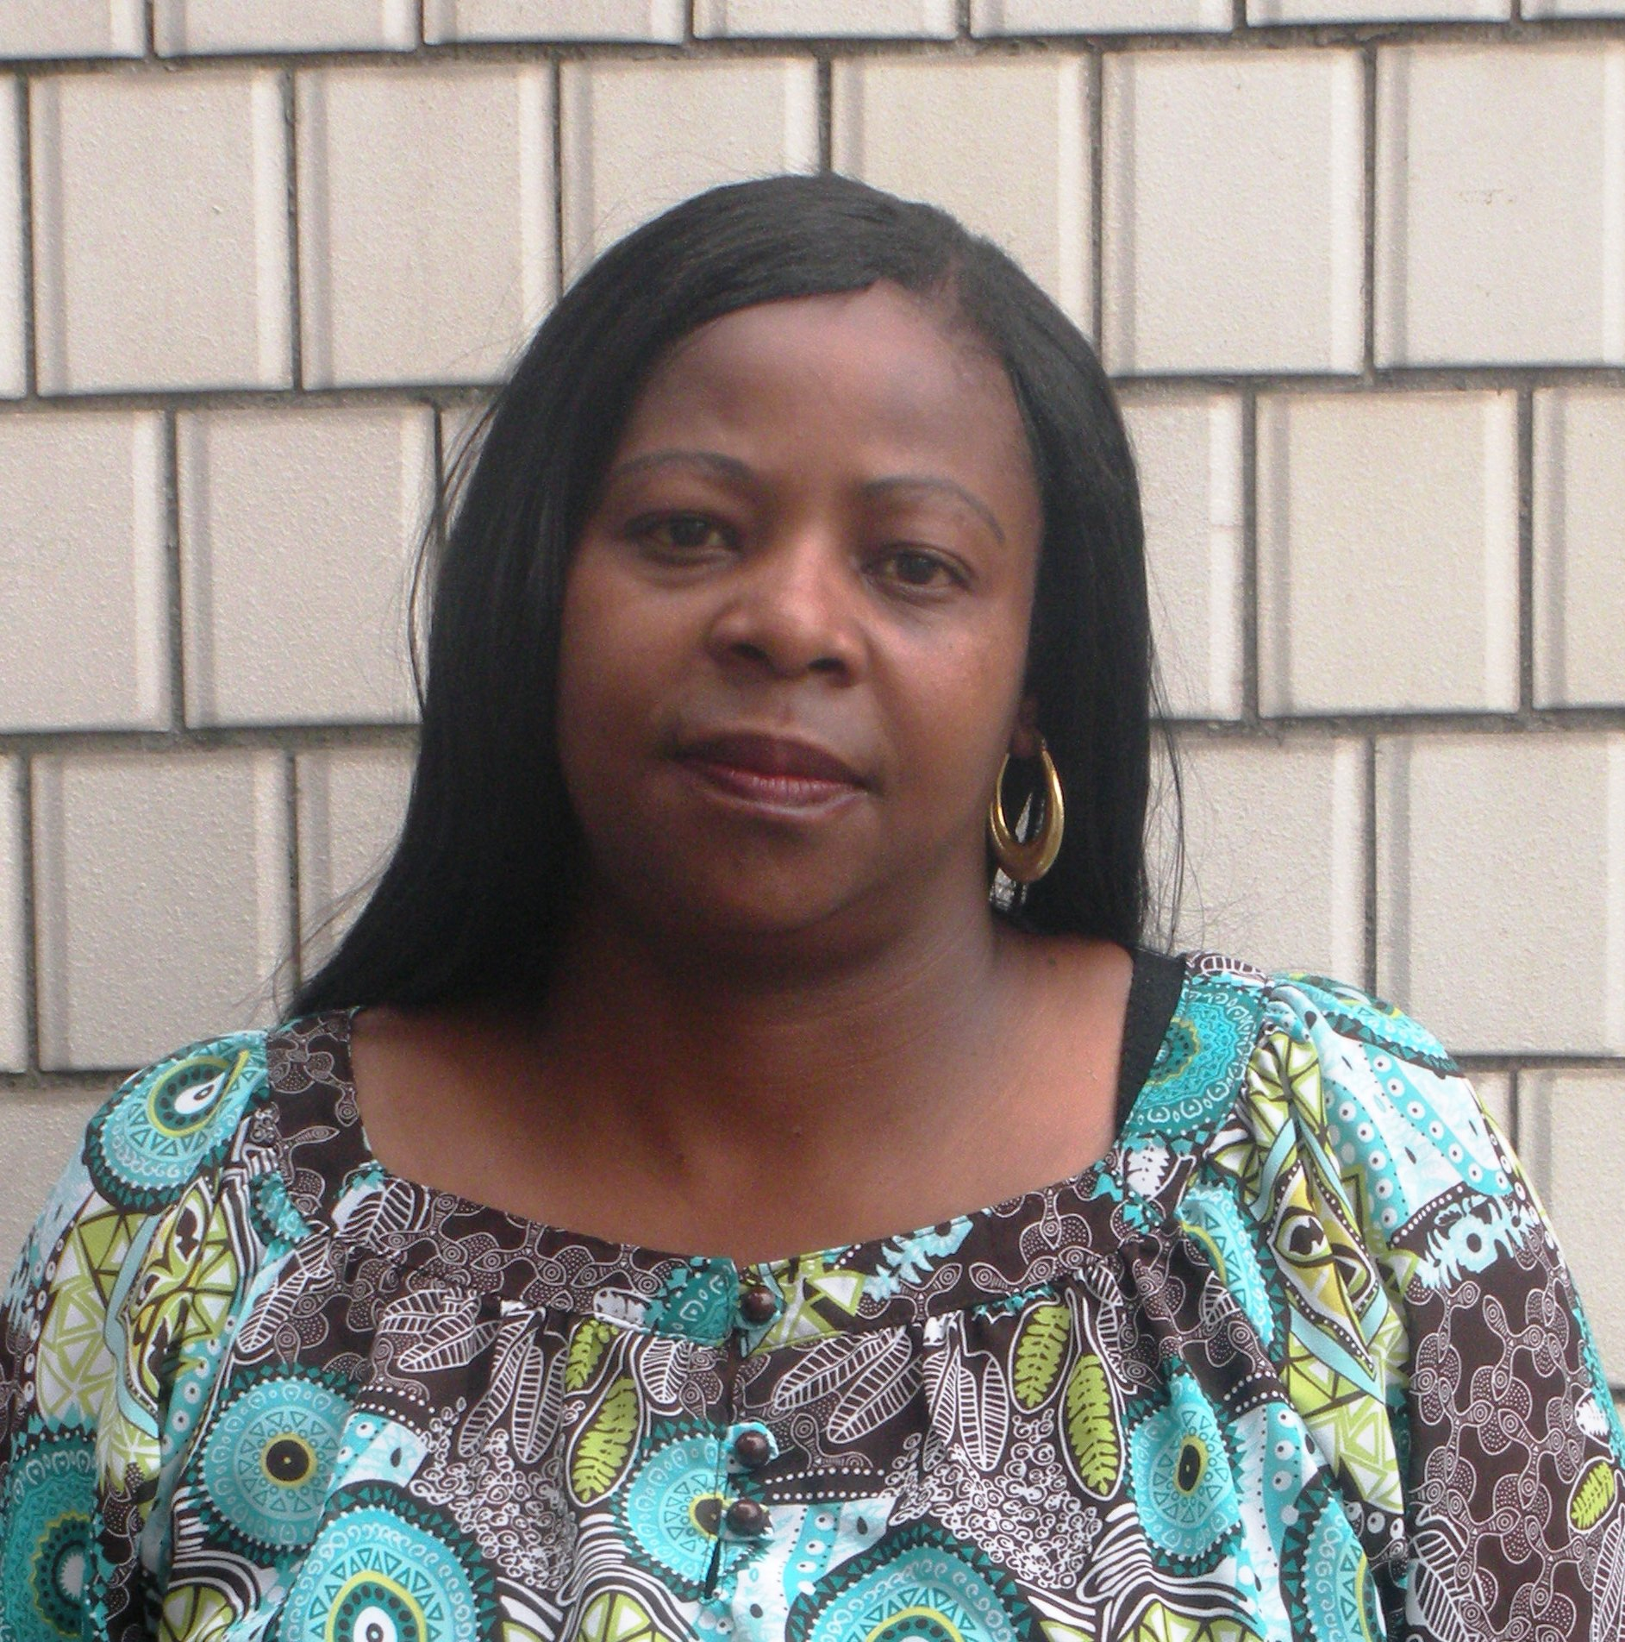
Personal Information-
Date of Birth
23rd DEC 1974
Nationality
SOUTH AFRICAN.
Marital Status-
MARRIED
Languages-
ENGLISH
EMPLOYMENT HISTORY-
TEACHING EXPERIENCE IN KOREA.
1).NIEC English Village Jangeon
2).Angel Food Academy.
3).Rira Kindergarten Balsan
EXPERIENCE IN SOUTH AFRICA.

1).Ithuseng Elementary school
Jouberton –South Africa
From-2007 to 2008

2).Tiang Elementary School
2009 to 2010
South Africa.

3). Credit manger ( Bears group of companies)

4). Kindergarten teacher. Crutze Creche’ (kinddies)

EDUCATIONAL HISTORY.
NORTH-WEST UNIVERSITY (2004-2007)
B.A (DEGREE) EDUCATION (E.D.T).
BOSKOP COLLEGE(1995)
Certificate in self Defense and Health.
Certificate in marketing.

I.B COLLEGE OF TECH/MANAGEMENT
DIPLOMA IN EDUCATION SECRETARIAL STUDIES.

MATLOSANE HIGH SCHOOL
HIGH SCHOOL LEAVING CERTIFICATE.
FURTHER EDUCATION
DAMELIN COLLEGE. (CALL-CENTER MANAGEMENT) 2000
PERSONAL SPECIFICATION
As a teacher, I hope to motivate students to do their best and to extend their own personal limits. By expanding on previous knowledge and exploring new, uncharted territory, students increase their career opportunities and future personal success greatly. In my classroom, students must commit to a level of performance that challenges them to reach their full potential. My expectations of my students are high, and by the end of the school year students realize that they can achieve any goal set before them. This a valuable lesson that they can apply to their lives beyond the classroom.

