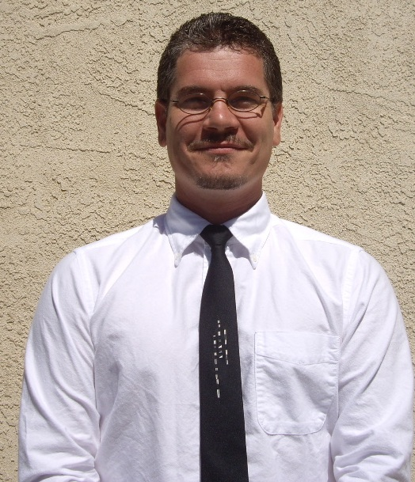

Lou Varelas

PERSONAL DATA

Country of Origin: USA
Gender: Male
Date of Birth: August 22, 1974

OBJECTIVE

I am seeking a 2 or more year teaching position with a reputable English school in Seoul, Korea. My paperwork will be finished soon and I can start work as of July 1st 2013.

EDUCATION

Seattle Central Community College, Seattle, WA TESOL Teaching Certificate, June 2007

University of Washington, Bothell, WA B.A. in Interdisciplinary Arts and Sciences, June 2006
Graduated Cum Laude; 3.86 GPA

Cascadia Community College, Bothell, WA A.A. in Integrated Studies, July 2004
Awarded multiple quarterly honors; 3.52 GPA

WORK EXPERIENCE

Feb 2013 – Present Moved to Redding, CA USA
Had to go back to take care of a death in the family.

Sep 2010 – Feb 2013 English Spot, Osaka, Japan – Lead Teacher
Worked as lead teacher for the Nagase school branch, helped to manage school affairs including: scheduling, marketing, course material design and staff management, taught students ranging from 1 year to 70 years old, also taught TOEFL and TOEIC courses to both beginners and advanced students, helped to plan, design and build all seasonal events for the school as well as direct and manage groups of volunteers who assisted in the decorations and preparations for the school events.

April 2009 – May 2010 Hitodukuri, Amakusa, Japan – English Village Coordinator
Worked closely with the Kamiamakusa government and a non-profit organization to create and develop an English Village in Kamiamakusa; responsibilities included: event creation and pricing, simple cost and revenue projections, art / graphics and marketing materials, and the creation and implementation of holiday events. (Please note that the project is still ongoing and I am still working with them via email and phone in a non-paid advisory position).

Dec 2007 – Dec 2008 Masan Foreign Language Inst., Masan, Korea – English Instructor
Taught multiple levels of English to students ranging from ages 7 to 16; up to six classes a day; was required to teach at the main school three days a week and the secondary school two days a week; responsible for creating lesson plans based upon two predetermined books given at the beginning of each month; assisted in locating and hiring new teachers when needed; helped coordinate school functions and events; performed monthly written evaluation of students; responsible for preparing and teaching all “open classes” which allowed the parents of students to observe their students English education first hand.

Jul 2006 – Aug 2007 Albert Lee Appliance, Seattle, WA – Systems Analyst
Oversaw the development and implementation of a new inventory tracking system encompassing product inventory valued at over 35 million US dollars; provided analysis and knowledge-based support on current inventory systems; initiated interdepartmental communication to assess critical system requirements and to foster teamwork and support; interacted with CEO, CFO, and buyer to devise innovative methods to increase efficiency; collaborated with product vendors to spur effective cooperation and motivation to employ new procedures; managed ongoing technology projects within the purchasing department; responsible for restructuring existing inventory processes and executed cost-saving measures which led to a decrease in 100 man-hours per week.

GENERAL SKILLS

- Excellent verbal and written communication.
- Extremely detail oriented.
- Outstanding team player.
- System analyzation.
- Behavior analyzation.
- Proven leadership abilities.
- Superb customer service skills.
- Data research and compilation.
- Intermediate Japanese ability.
- Proven ability to interact, understand and communicate in a multi-cultural setting.
- Ability to respond quickly and appropriately in crisis situations and to effectively direct others.

TECHNICAL SKILLS

- Microsoft platforms (Vista, XP, 2000, 98SE, DOS).
- Microsoft Office (Word, PowerPoint, Excel, Outlook, Publisher).
- Experience working with networks, virus software and removal.
- Experience building PC and Server systems from ground up (hardware/software).
- Experience with home and office printer installation.
- Working knowledge of 3D applications (Studio Max 3, Maya 6.0).
- Photoshop CS and older versions.

VOLUNTEER WORK

- US Forest Service – assisting with fish and wildlife projects.
- NPower Northwest – volunteered my technical skills to NPO and other institutions.
- Kamiamakusa Aikouen Kindergarten – volunteer assistant teacher.
- Kumamoto International Center – volunteer English instructor for Japanese nationals.

REFERENCES

Joe Zustak
Inland Zone Fisheries Program Manager – US Forest Service
Contact: jzustak@fs.fed.us

Athena Thomas
Graphic Designer – Freelancer
Contact: athenatt@gmail.com

Mamiko Hamamoto – Hitodukuri NPO
Lead Teacher
Contact: mamiko.1108@gmail.com

