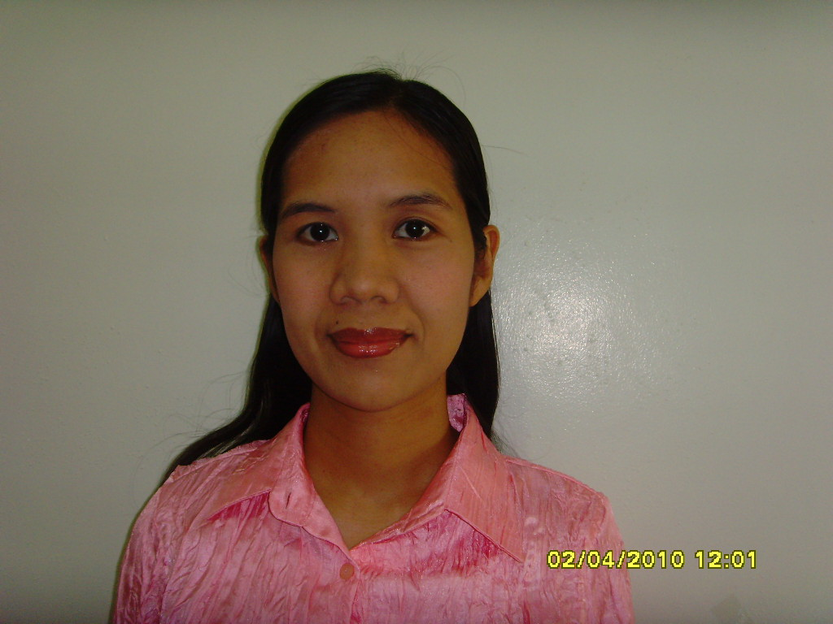

Ma. Lelanie Selerio - Kim

Contact Information
Address: Silang International Church
Silang Cavite, Philippines

Mobile #: (0919) 3941-665 / 070-7545-1240
E-mail address: lanvisele_82@yahoo.com
Skype id : juki.kim

Work Experiences

Oct. 2009 – present Position: Online Conversation Tutor
Responsibilities:
- Prepare conversational materials
- Initiate a topic for conversation
- Correct the student’s misused of words and grammatical errors
- Help the student improve his/her speaking skill

Jan. 2009 – present Position: Tutor to Korean elementary and high school students
Location : Silang Cavite, Philippines
Responsibilities:
- Teach English as Second Language (ESL) and conversational English to Koreans.
- Assist on their assignments in school, conduct review lessons for the examinations

Feb. 2008 – Dec. 2008 Position : Online English tutor
Location :Dasmarinas, Cavite Philippines
Responsibilities:
- Teach basic English grammar to advanced English to Korean students of different levels.
- Practiced them how to read properly and checked their vocabulary.

Sept.2006 – May 2007 Position : English Tutor to Korean Students
Location : Tagaytay, Cavite Philippines
Responsibilities:
- Teach English as a Second Language (ESL) to Koreans.
- Assist Korean students with their academic studies.

Jul.2005 – Aug. 2006 Company : Department of Education
Location : Cebu City, Philippines
Position : Public School Teacher
Responsibilities:
- Assigned to teach all subjects to grade 3 students.
- Tasked to give educational activities to the pupils.
- Responsible in molding the mind of the young learners to help them achieve their dreams.
- Assigned task to the pupils to help them become responsible individual

Aug. 2004 – Feb.2005 Position : English / Academic tutor
Location : Talisay Cebu City Philippines
Responsibilities:
- Teach English as a Second Language (ESL) to Koreans.
- Assist primary and secondary Korean students with their academic studies.

Other Experiences and Achievements:

- Licensure Examination for Teachers’ Board Passer with a grade of 80.40% taken last August, 2004.

Skills

Computer : MS Office (Word and Excel)
Knowledge in surfing the internet

Academic Qualifications

June 2004 – Nov. 2004 Cebu Normal University
Masters in Pre-elementary Education
Undergraduate

June 2000 – May 2004 Cebu Normal University
Bachelor of Elementary Education
Graduate

1996 - 2000 Dalaguete National High School
Secondary Education- High School Diploma
1990 - 1996 Dalaguete Central Elementary School
Primary Education

Personal Background

Born on November 07, 1982 in Poblacion, Dalaguete, Cebu, Philippines. I’m 27 years old, female and married to a Korean national with two adorable children. I’m holding a Korean visa (F2-1,this is a visa given to first time applicant and can be renewed and changed to F2). I love reading, learning on new things and being with family and friends. I’m excellent in English communication and writing skills and people skills. Flexible, friendly, hard-working, punctual, honest and above all, loves God.

