ma zarni htun
106 Thurston, Apt 8,
Somerville, MA 02145 USA
Tel. (617) 764 5327 and (917) 301 4944 (cell)
htun.ycz@gmail.com

PERSONAL DETAILS
Birth: Myanmar, 1981
Citizenship: Myanmar (Burmese)
Mother Tongue: Burmese
Strongest Language: English
Marital Status: Single
Health: Excellent

EDUCATION
2009-2010: Master of Science - Global Studies and International Affairs
Northeastern University Massachusetts, USA
2010: TESOL/TESL/TEFL Certification
Oxford Seminars
2006-2008: Master of Arts - English Massachusetts, USA
Northeastern University
2000-2005: Bachelor of Arts in English
Bard College New York, USA

1994-2000 Grades 7-12 Yangon, Myanmar
International School Yangon (ISY)
1991-1994 Grades 4-6 Sana’a, Yemen
Sana’a International School (SIS)
1990-1991 Grade 3 Phnom Penh, Cambodia
International School of Phnom Penh (ISPP)
1988-1990 Grades 1-2 Bangkok, Thailand
International School of Bangkok (ISB)

WORK EXPERIENCE
2009: Assistant Grant Writer/Fundraiser, Interlock Media Inc. Massachusetts, USA
• Wrote and edited documents
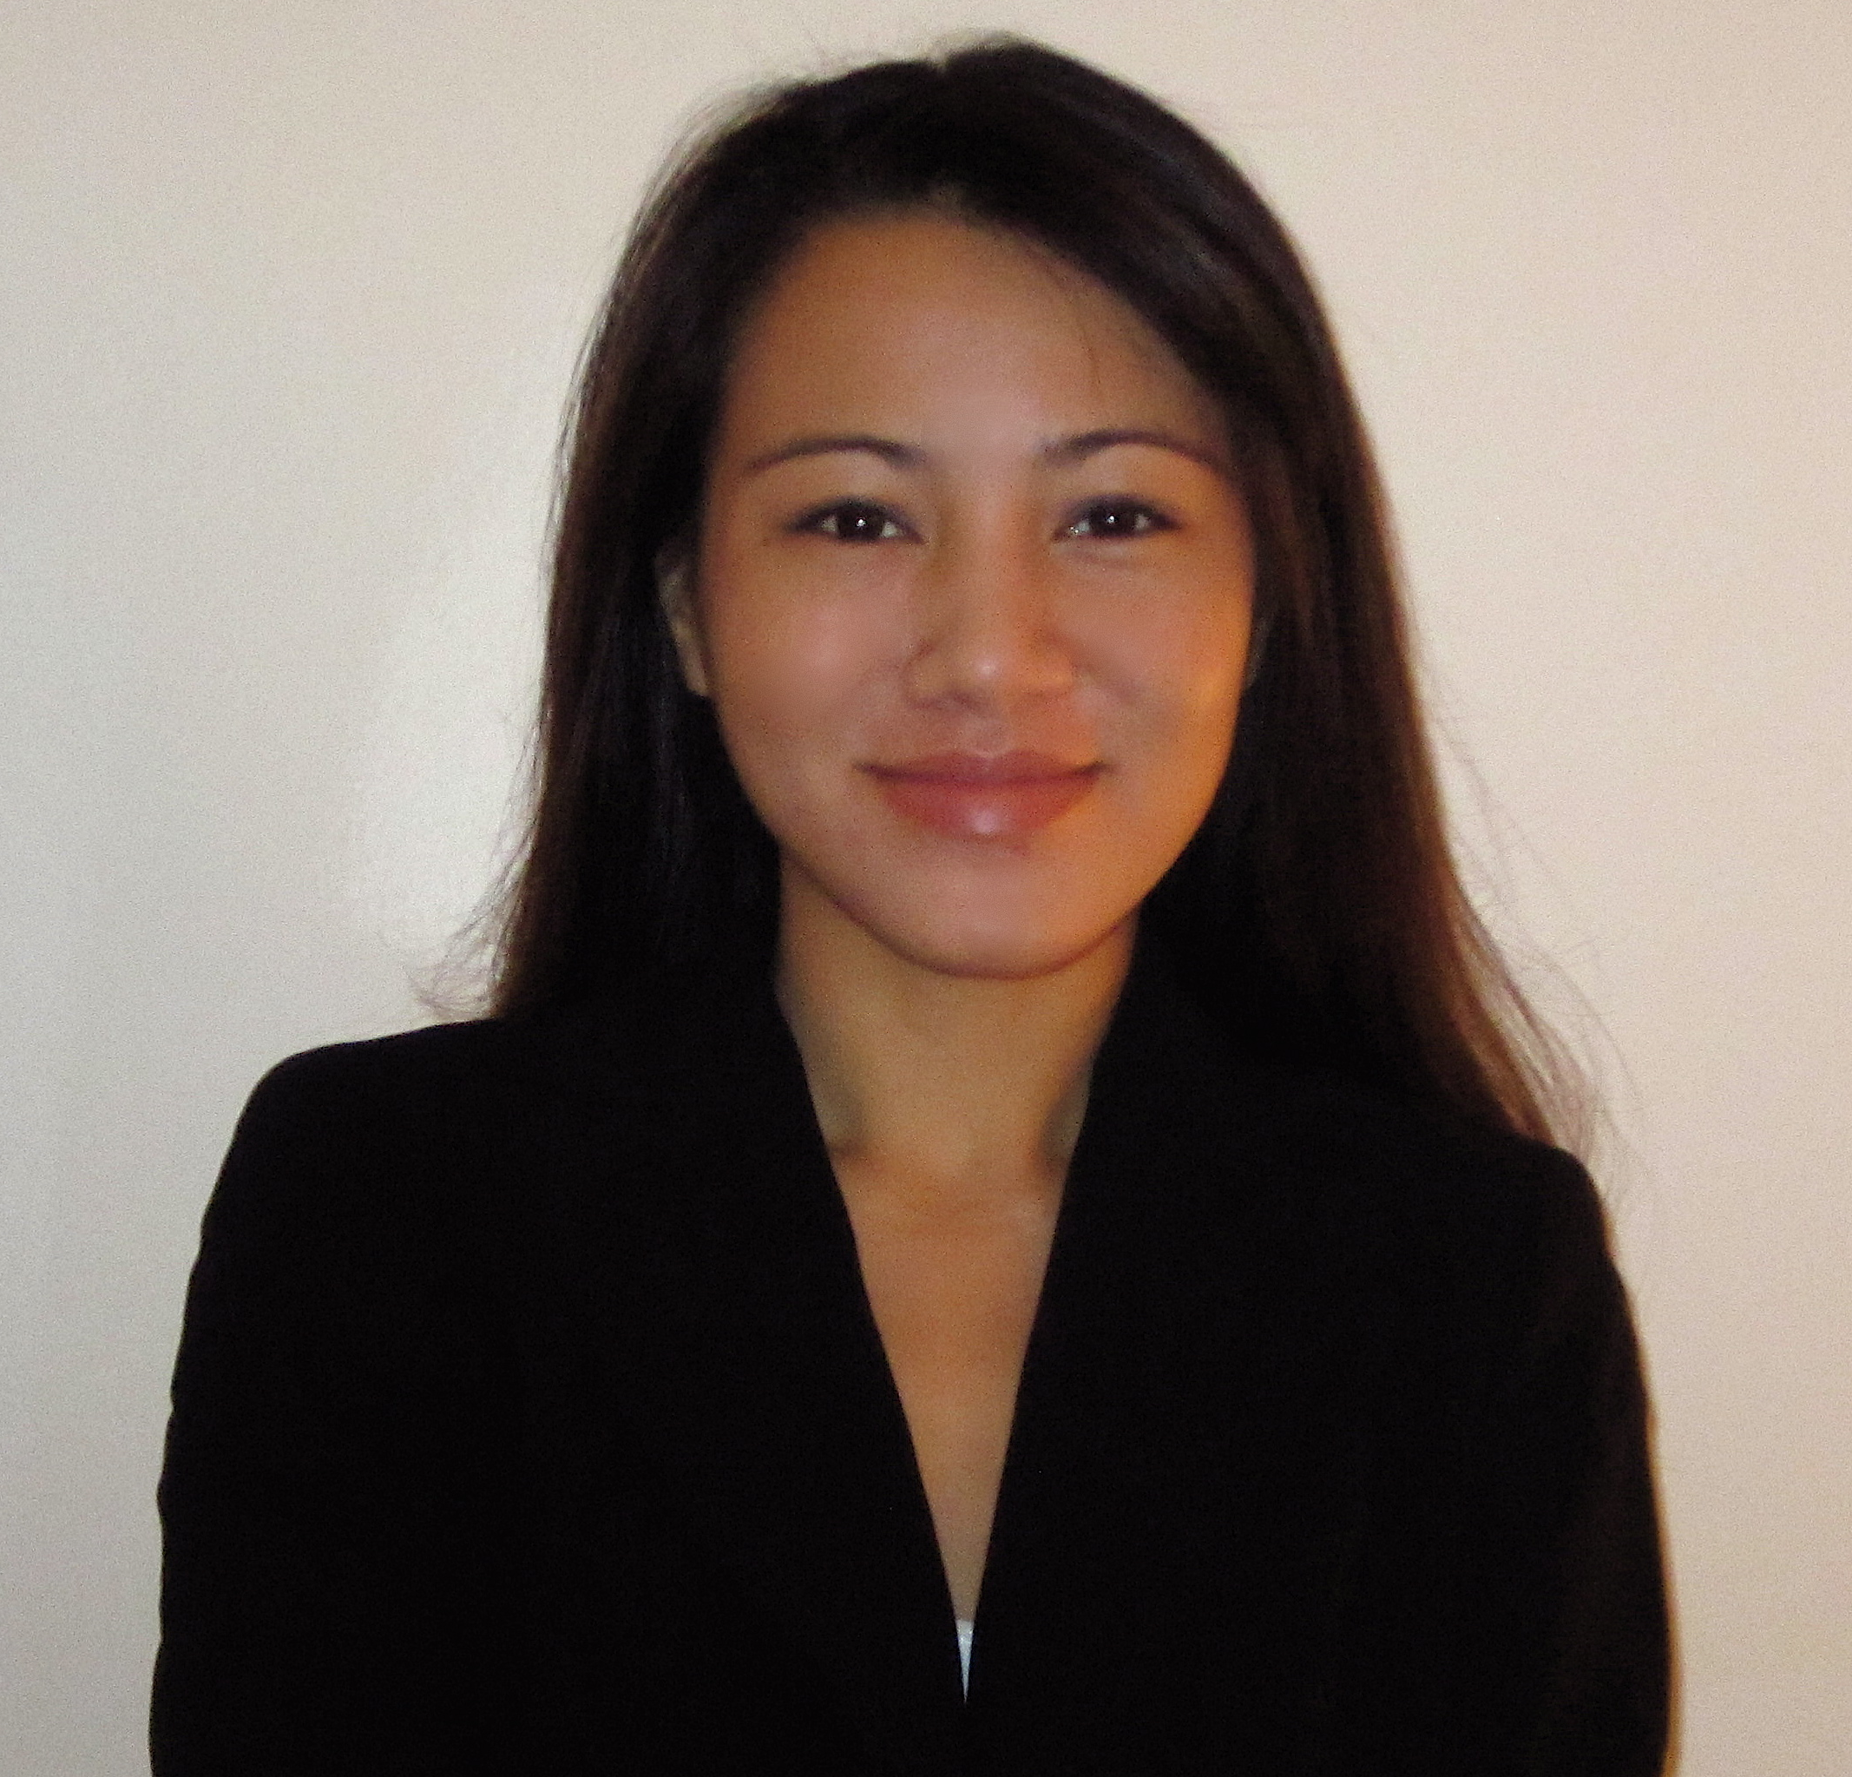
• Recruited volunteers and interns by posting work opportunities on websites and corresponding with qualified applicants

2008-2009: Administrative Assistant, Pearson Education Massachusetts, USA
• Helped editors prepare a prototype for a new grammar handbook
• Facilitated the flow of materials and texts to outside vendors or to in-house staff
• Helped edit material to be included in a prototype, sent scanned text to an outside vendor and acted as the point person for that vendor during the absence of a supervising editor
• Assisted editors in preparing material to be included in a new grammar/writing database
• Helped editorial director monitor our budget

2007: Writing Tutor, OWL Writing Center at Northeastern University Massachusetts, USA
• Instructed over 20 undergraduate and graduate students per week on a variety of writing assignments
• Instructed students on essential points of grammar and style
• Utilized MLA, APA and Chicago Manual of Style in tutoring students
• Helped students better access university resources and ask peers, professors, and administrative staff for assistance

2005 & 2006: Editorial Assistant, McPherson & Company New York, USA
• Proofread manuscripts and made recommendations to the senior editor on the quality, style, and content of manuscripts
• Communicated with libraries and bookstores
• Facilitated communication between the publisher and authors regarding manuscripts and company-related events
• Created indexes for texts and assisted in designing headings, epigraphs, tables of contents, and title pages

2006: Administrative Assistant, Alumni/ae Affairs Office at Bard College New York, USA
• Contacted alumni to solicit donations, inform them about alumni events and resources and update contact information
• Assisted alumni/ae, administrative staff, and faculty with requests, questions, and problems
• Coordinated annual commencement activities by arranging housing and transportation for attendees
• Prepared and wrote alumni updates to be published in the alumni/ae publication, Bardians

ACTIVITIES/INVOLVEMENT
2010: Member of the Golden Key International Honour Society.
2004-2005: Associate Editor at The Bard Observer, a newspaper at Bard College.
2005: Member of the Poetry Group at Bard College.
2000-2003: Member of the International Student Organization, (ISO) at Bard College
2000-2002: Member of the Asian American Student Organization (AASO)

SKILLS & EXPERIENCE
Languages: Fluent in English and Burmese; basic speaking, reading and writing abilities in French, beginner level in Japanese.
Travel: Thailand, Cambodia, Laos, Vietnam, Australia, USA, Singapore, Indonesia, France, England, Italy, The Netherlands, Belgium, Switzerland, and Austria
Interests: Volleyball, softball, swimming, reading, writing, cooking, painting, travel and dance

REFERENCES
Available upon request

