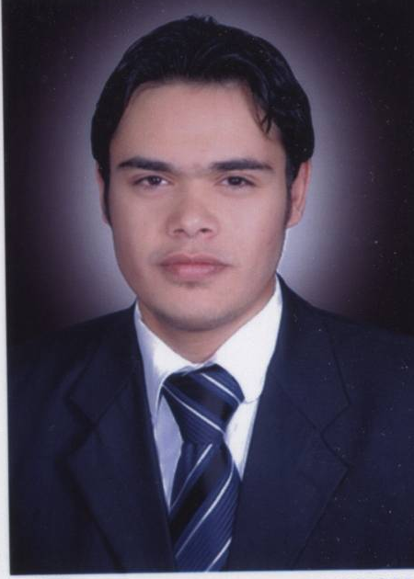

Cv

1-personal data

Name Mahmoud Hamdy Mohamed Bakr

Address 2 Mohamed Ta'lab St, Shebien El-Koom – Minoufya – Egypt

Phone Number : (002) 048 2322385
Mobile Number : (002) 010 4770218
E-mail : mahmoudhb@yahoo.com

Birth : 7th of February 1985
Nationality : Egyptian
Marital Status : Single
Military status : exempted

2- Education Statement :
Bachelor Degree in English language Minoufya University 2005

3-Foreign Language:
a) Arabic native speaker,
b) English Excellent,
c) French Medium

4-Job:
1- Translator in Elgammal Company for Development & Agricultural Contracting
2- responsible for foreign negotiation processes of importing in Elgammal Co,.
3- responsible for importing in United Co., for Fertilizers and Chemicals

5-Skills:
1- Computer (windows, word, excel, Access, PowerPoint)
2- Internet

