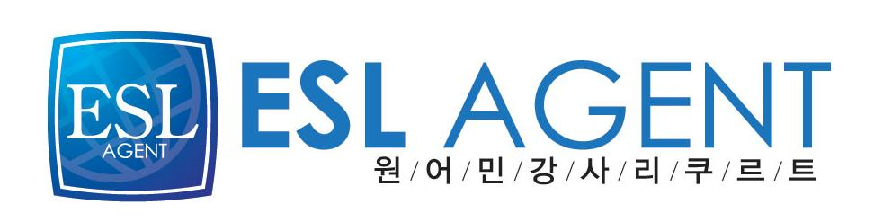
이에스엘 에이전트
김민수대리
02-2675-0582
017-569-6666
Marjanna Hynes

Education
2004 – 2008 Bachelor of Commerce
University Canada West
Victoria, British-Columbia

2000 – 2004 Secondary School Diploma
Cairine Wilson Secondary School
Ottawa, Ontario

Experience
02. 2009 – 02.2010 KJC Academy | Busan, South Korea
Teacher
- Taught English as a second language to elementary and middle school students.
- Integrated into a foreign culture and learned basic Hangeul language.

11. 2008 – 01.2009 The Ottawa Mission | Ottawa, Ontario
Fundraising Assistant (temp. position)
- Processed incoming donations, maintained donor relationships, and petitioned
corporate donors to support Ottawa’s primary homeless shelter.

10.2008 – 11.2008 Cirque de Soleil | Ottawa, Ontario
Office Assistant (temp. position)
- Communicated with employees, management, and clients directly, over the phone,
and through e-mail.
- Provided administrative support including data entry, photocopying, faxing,
laminating, scanning, filing, and fed-ex mail deliveries.
- Coordinated employee meetings and events.

09.2007 – 05.2008 Prism Lounge | Victoria, British-Columbia
Keyholder Bartender
- Opened and closed, trained new employees, and managed cash flows.

05.2007 - 08.2007 Minnewanka Boat Tours Ltd. | Banff National Park, Alberta
Boat Captain and Interpreter
- Captained 40-50 passenger vessels
- Lead engaging and interactive tours around the lake

09.2006 – 04.2007 The Hudson’s Bay Company | Ottawa, Ontario

09.2005 – 03.2006 Customer Service Representative
- Processed sales and completed a range of services including returns/refunds, credit
deposits, credit sales, cash opening, closing, and deposits.
- Continually achieved top credit card sales record in the point-of-sale department
and won a contest for being top seller in the Jewellery department.

05.2006 – 08.2006 Cyber Web Internet Café | Banff, Alberta
Service Representative
- Managed computer networks and databases, handled cash flows, prepared cash
sheets, opened and closed independently, trained new employees.
- Consulted and executed custom projects for clients including burning memory card
media to disk and creating local advertising flyers and business cards.

06.2005 – 09.2005 Johnston Canyon Resort | Banff, Alberta
Gift Shop Attendant
- Processed sales, maintained inventories, and handled cash.

Volunteer Work
02.2009 – 02.2010 FOVA: Foreigner Volunteer Association | Busan, South Korea
Cultural exchange facilitator
- Work with a group of low-income ladies every Saturday morning for two
hours, practising basic conversational English.

2006 – 2008 CHEO Telethon | Ottawa, Ontario
- Annually volunteer answering telephones and processing donations during
daylong children’s hospital fundraiser.

Achievements and Awards
- Speak fluent French
- Service Excellence Certificate
- Smart Serve Certificate
- NLS (National Lifesaving Society) Certificate
- CPR Level C Certificate
- Successfully completed a United-Nations sponsored
workshop on Water and the Oil Sands in Fort McMurray, Alberta
- Transport Canada Limited Masters and Restricted Engineer Certificate

