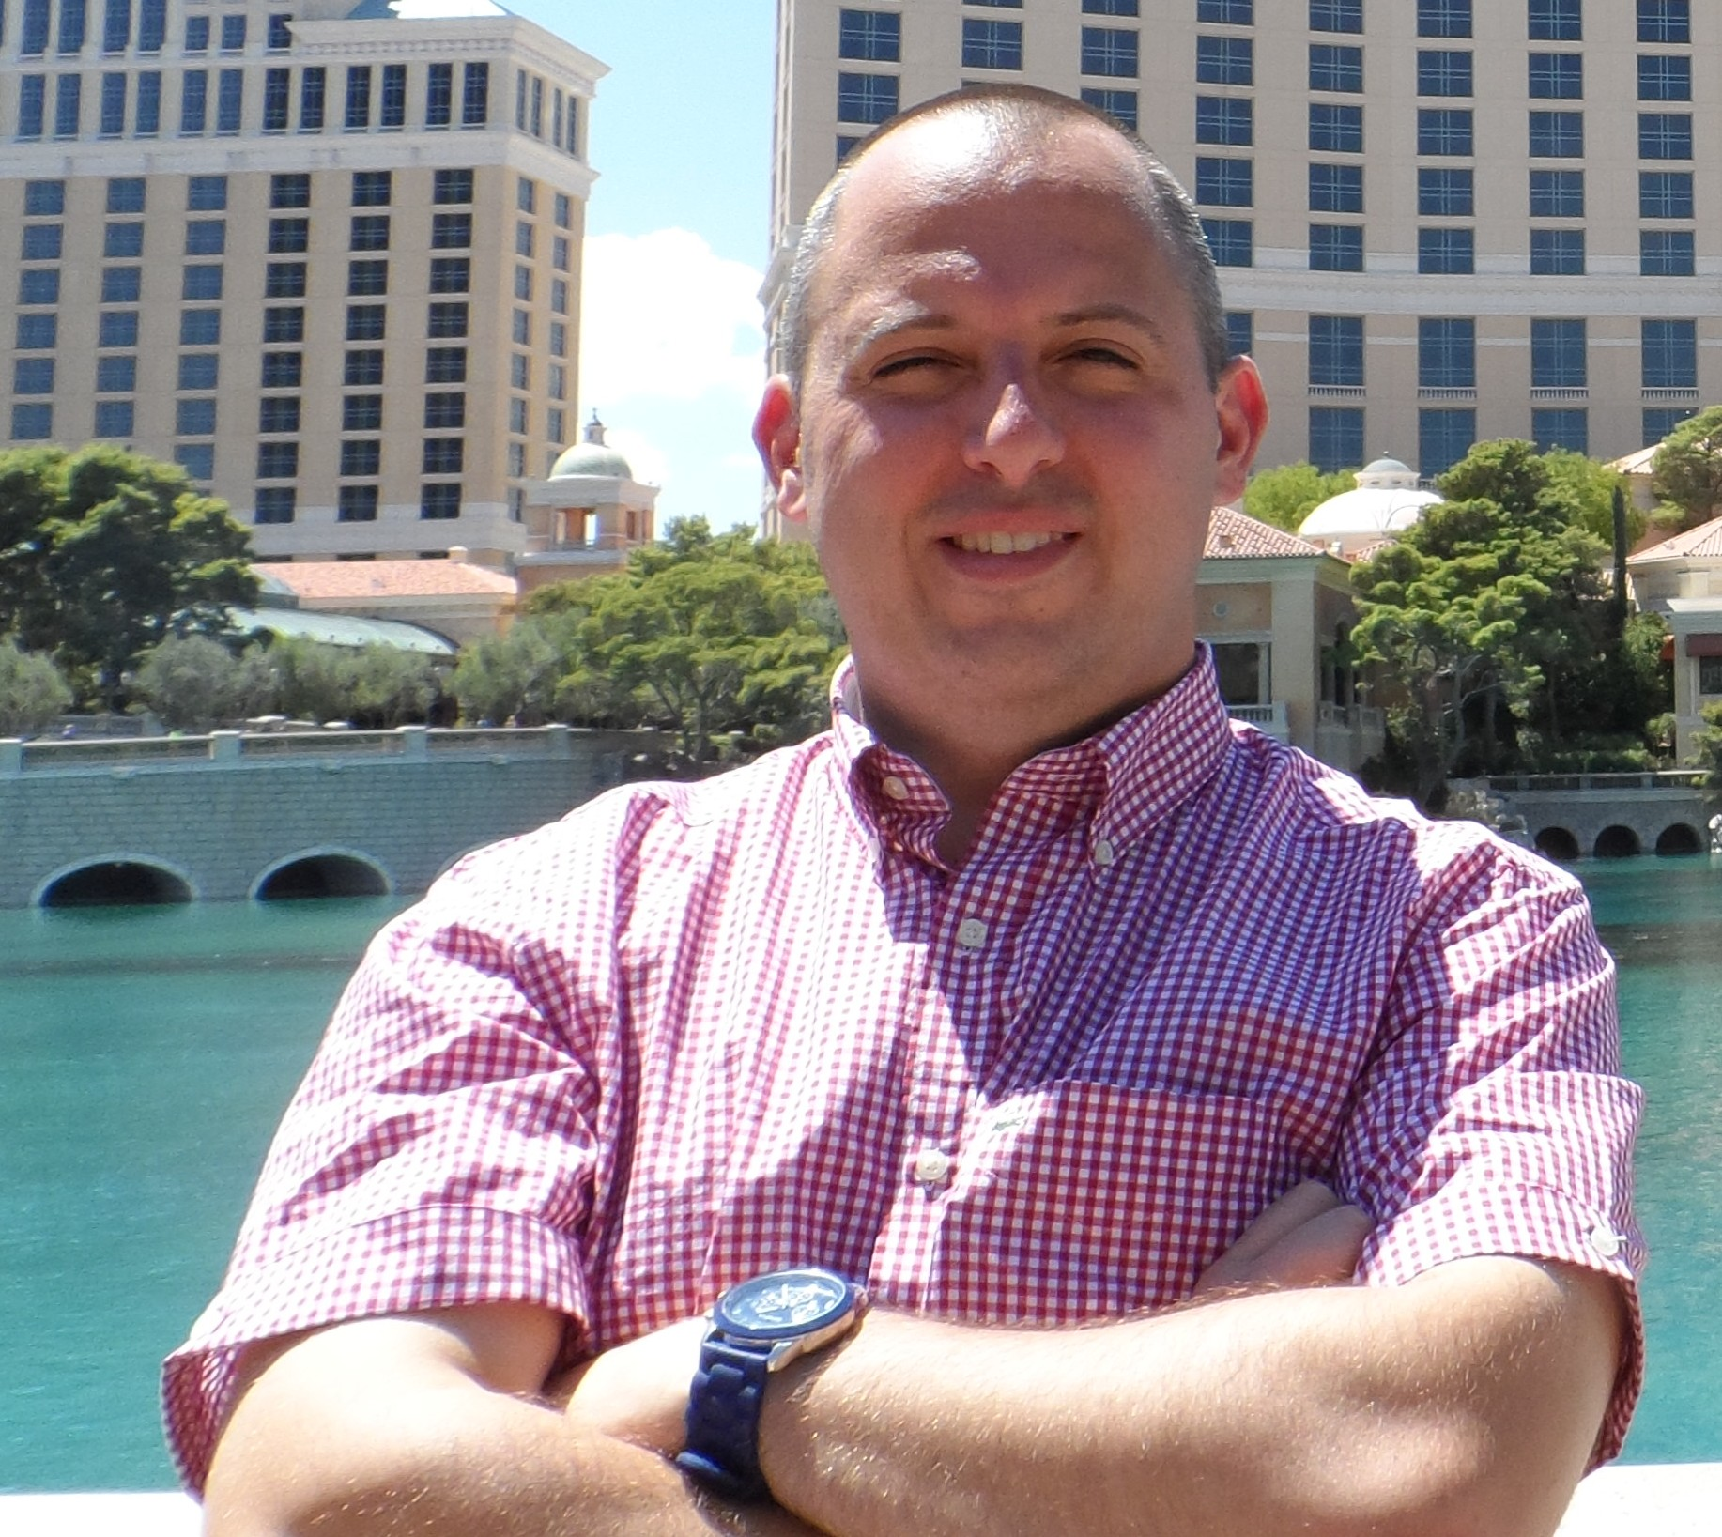

Mark Krajcar:

Nationality: Canadian

Contact Details: markkrajcar@hotmail.com, 82 10 3425 0656.

Current Residence: Busan Gwangan Dong, South Korea.

Experience:

1. Dong Hang Middle School, Busan City South Korea
March 2009 to Present: ESL Native Speaker Instructor
-taught conversational English to middle school boys and girls
-assisted Korean teachers
-prepared and administered speaking tests to the students
-prepared and carried out English camps during the breaks
2. Gyeongnam Girl’s Middle School, Busan City South Korea
April 2008 to February 2009: ESL Native Speaker Instructor
-taught conversational English to middle school girl’s
-assisted Korean teachers
-made and administered speaking tests to the students.
-prepared and administered English camps during vacation

3. English 20/20 and Wonderland Busan City South Korea.
January 2006 to March 2008. ESL Native Speaker Instructor/Foreign Teacher’s Supervisor/TOEFL Instructor.
-taught English to students aged 4 to 17
-guided and took care of the other foreign teacher’s in the school
-taught TOEFL speaking and writing to higher level students
-prepared lessons and corrected student’s writing
-attended seminars to improve teaching skills

4. LEE Byung Choil English Academy Jeonju City South Korea
October 2004 to October 2005. ESL Native Speaker Instructor
-taught English in History, Social Studies and Basic Science to students aged 8 to 17
-Assisted other teachers with editing
-Prepared and taught lessons
-Taught newspaper articles in English to the students.

5.Pioneer Youth Services. Kitchener, Ontario, Canada
February 2004 to August 2004 Child and Youth Worker/Caseworker
-provided day to day care of male teens who were high risk or possessed mental disorders
-caseworker for two of the residents in the home
-counseled the residents in the home
-non crisis intervention done when needed

6.Youth dale Treatment Center. Aurora, Ontario, Canada
December 2002 to December 2003 Child and Youth Worker/Caseworker
-provided day to day care in a co-ed residence of teens aged 14-18
-caseworker for one of the residents
-counseled and assisted the residents on a daily basis

Education:
1. Master's of Science Degree in Criminal Justice Ashworth College March 2013 to Present (Ongoing Project)
2. Bachelor of Arts Degree, Option in Criminology and Legal Studies. University of Waterloo 2002
3. Certificate in Entrustment Interviewing and Evaluating Students in ESL Speaking Busan Office of Education 2012
4.. ESL Certificate in Teaching Young Learners TITC 2013 (50 hours)
5. ESL Certificate in Teaching Business English TITC 2013 (50 hours)
6. TEFL Certificate. ITT International 2007 (120 hours)
7. TESOL Certificate College of Applied Linguistics 2001 (50 hours)
8. Diploma Psychology and Social Work Stratford Career Institute 2003

Skills:
-well organized
-computer oriented
-diligent and work well with others.

