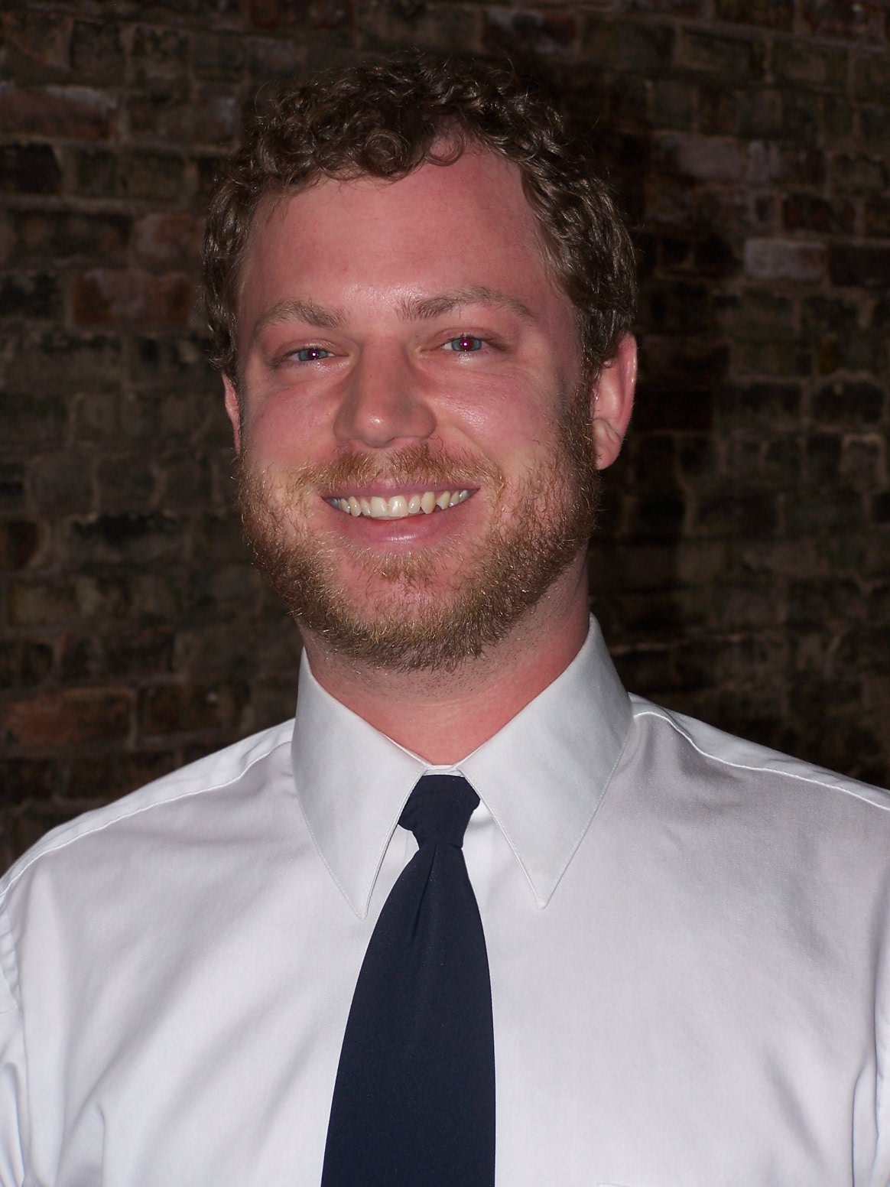
Matthew Forgy
email: mcforgy1@yahoo.com
2515 N. Stowell Ave., Milwaukee, WI 53211
Phone: (262) 853-7401

PERSONAL DETAILS___________________________________________________
Birth: U.S.A. 12/10/1976
Citizenship: American
Mother Tongue: English
Health: Excellent
EDUCATION___________________________________________________________
University of Wisconsin – Madison 1997 - 2000
Madison, WI, U.S.A.
- Bachelor of Science – Communication Arts

Milwaukee Area Technical College 2003 - 2005
Milwaukee, WI, U.S.A.
- Photography

TESOL / TEFL TRAINING_______________________________________________
Oxford Seminars 2009
Milwaukee, WI, U.S.A.
- Oxford Seminars TESOL / TEFL Certification

EXPERIENCE__________________________________________________________
Lift Products, Inc Manufacturing Company 2008 - Present
- Coordinate and assist the dealers that sell our products
- Sell material handling goods, including lift tables and motorized carts

Photography Assistant 2005 - 2008
- Responsible for all equipment including cameras and lights
- Responsible for lighting the sets and managing digital files

Private Tutor 2007
- Tutored university level Lithuanian student for mastery in reading comprehension

RELEVANT SKILLS & EXPERIENCE_____________________________________
Foreign Languages: French and Italian
Travel Experience: Germany, Czech Republic, Austria, and (22) U.S. states
Interests: photography, travel, cooking, reading

REFERENCES__________________________________________________________
Available upon request

