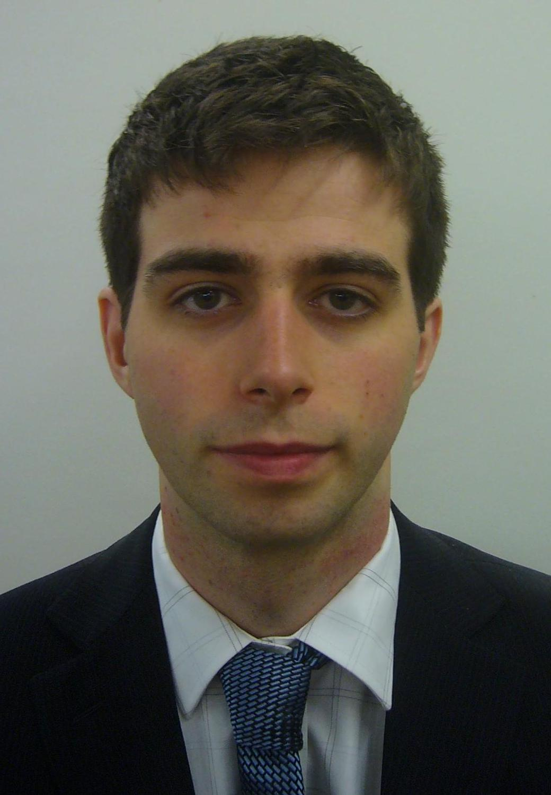
Matthew Lang

Date of Birth: 13th August 1989
Marital Status: Single, No Dependants
Nationality: British
Phone Number: (+44) 07553-319744 ( Available from 5pm – 10pm KST)
E-mail: matthewstamfordlang@gmail.com
Skype User Name: matt.langingo (Available from 5pm – 10pm KST)

Education

University of York, UK
October 2008 – July 2011 (3 years) York, North Yorkshire, England, United Kingdom

Bsc Economics. Honours: 2:2

Teaching experience

English as a Foreign Language Teacher

Pyeongtaek English Education Center
November 2011 – November 2012 Pyeongtaek, Gyeonggi-do, Korea

I taught English to numerous different age groups. These age groups included kindergarten, elementary, middle and adult. During this time period I created classroom tests, lessons and supplementary materials.

Teaching Qualification

I have a 100 hour TEFL course qualification from International TEFL and TESOL training.
Personal profile

I am an enthusiastic teacher and I hope to come back to Korea as soon as possible. If I am given the opportunity to teach again in Korea, I believe I can once again prove that I am both a willing and competent teacher of English as a foreign language.

References

Available upon request.

