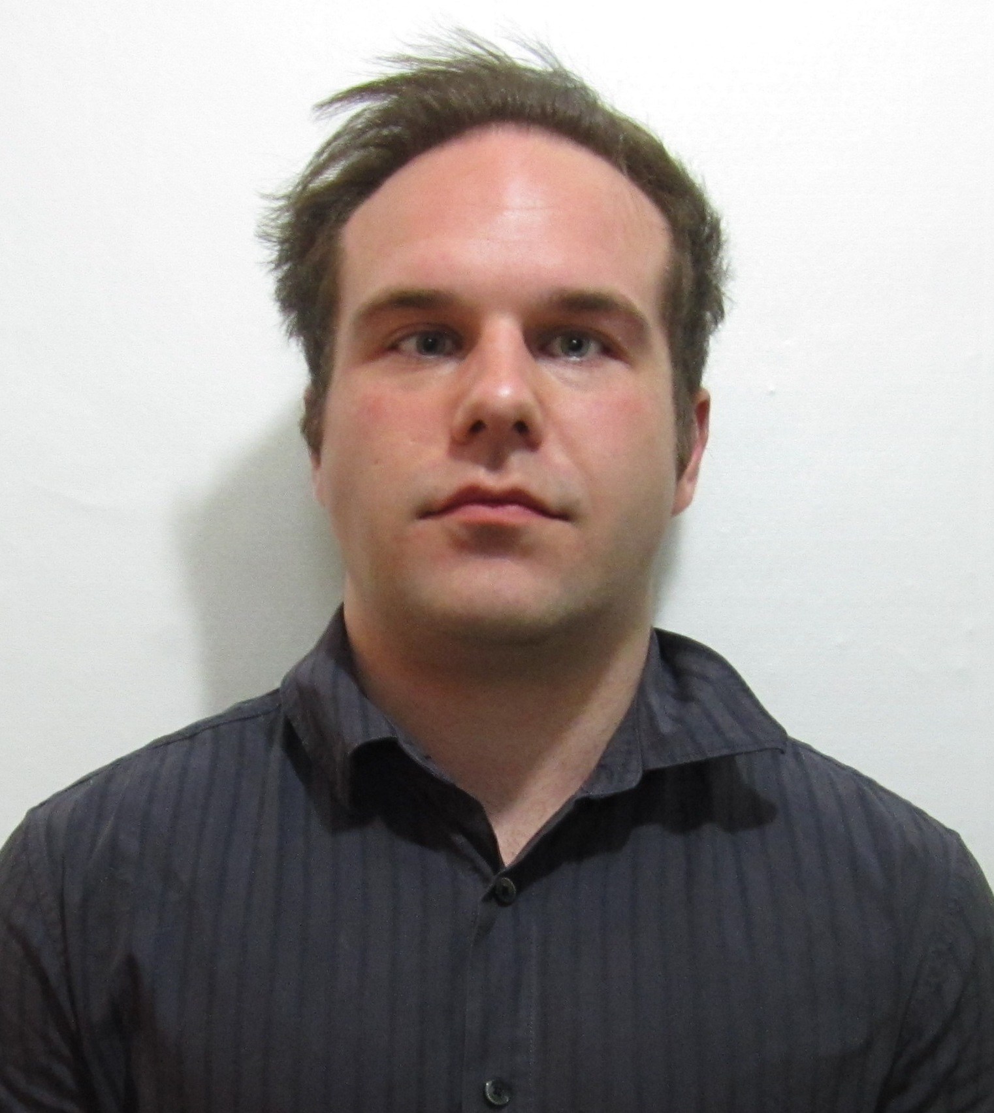

Philip Matthew Larson

CONTACT : Phone: 010-9435-1746
Email: Matt_larson87@yahoo.com

OBJECTIVE: To experience diversity and perspective through teaching

EDUCATION: Bachelor of Arts in History May 2010
Texas A&M University, College Station

WORK:
Head Foreign Teacher
Sullivan English School, September 2010 to Present
Pyeongtaek, South Korea
• Teach English to Korean students ranging from Kindergarten to Middle school and Adults.
•.Prepare lesson plans for the day which have the ability to captivate students with varying learning styles.
•Assist in conversation with upper level student using a wide array of topics.

Weight room Attendant
Texas A&M University Rec Center, December 2009 to May 2010
College Station, Tx
• Oversaw day to day activities of the weight room and assisted members with general question about health and fitness.
• Assisted in large scale weight room clean up i.e. dismantling various fitness equipment for deep cleaning and re-assembly.
• Maintained a professional atmosphere and excellent customer service.
• Received an Outstanding Employee award for my dedication to the weight room.

Maintenance Staff
The Heights Apartment Complex, May 2009 to August 2009
College Station, Tx
• Maintained the grounds for the summer of 2009.
• Oversaw all minor repairs to apartment complex ranging from toilet installation to re-caulking of bathtubs.

Trapper
American Shooting Centers, May 2005 to August 2008
Houston, Tx
• Assisted customers in proper gun safety
• Guided shooters through the various courses and assisted with game tactics.

REFERENCES:
Seo Jung Yeon
Sullivan English School
Pyeongtaek, South Korea
010-7652-1606

Bob Perez
Texas A&M Judo Coach, Rank: Sandan
Texas A&M University
Phone: 979-218-4582

Dr. Lee
Lee Dong Seok Clinic
Pyeongtaek, South Korea
Phone: 010-5668-1958

ACTIVITIES: • Vice President, Texas A&M Judo, 2008-2009
• Texas Judo Collegiate Champion – 73kg, 2009
• National Collegiate Judo Qualifier, 2009

