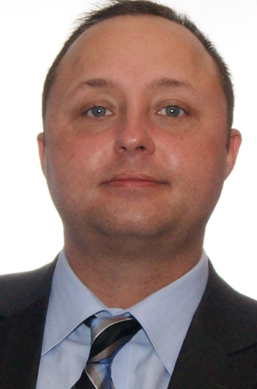

Matthew Owen
7 Enfield avenue, Toronto, Ontario, Canada, M8W 1T6

Self-motivated, dynamic management professional with diverse credentials which combine solid, tactical leadership and recruiting expertise with a strong educational instructor background, an ability to work collaboratively, and a commitment to achieving corporate goals. Analytical with a high degree of problem solving ability, able to excel in a client focused environment.

Core Competencies

Classroom Management | Course Creation
Problem solving | Level Evaluation
Cross cultural communication | Confidence-Building and Skills Validation
2011-2013 - Seoul, Republic of Korea  M-Poly Institute |  |  | Humanities Teacher
- 2000+ in-class lecture hours.
- Provided full cycle (proposal-implementation) course design. Course focus included world history, current events, debate and rhetoric, introduction to world politics, English literature.
- Creation of progress reports. Material selection and distribution to students. Evaluation and recommendation of student’s communication level.
- Interview and evaluation of prospective students to the M-Poly advanced education program.
- Provided feedback to Korean academic advisors with a focus on students’ overall progress

2009 - 2011 - Bucheon-si, Republic of Korea  Hankuk University of Foreign Studies  (Bucheon Campus) |  |  | Head E.S.L instructor
- Over 2500 in-class hours in a Korean environment teaching grades 1 through adult.
- Developed full semester courses. Course focuses included critical thinking, public speaking and confidence-building activities. Responsible for complete curriculum make up, including design and structure or courseware material with lesson plans.
- Taught standardized TOEFL material to all grade levels. Used a wide variety of material from different publishers.
- Conducted initial interview and recommendation for level placement of new students.
- Managing a staff of four ESL teachers. Provided employee progress and update reports to both staff and management.
- Creation of numerous grading and evaluation reports for students.

2008-2009 - Toronto, Canada  Self-employed (Consultant) |  | Research Writer
- Provided certified Immigration Consultants with research and writing material for eventual submission to the Canadian Immigration and Refugee Board (IRB).
- Focused on research material essential for Pre Removal Risk Assessments (PRRA) & Humanitarian and Compassionate (H&C) applications.
- Interviewed individuals for the purpose of creating a confidential assessment report regarding levels of persecution experienced by the individual.

Matthew Owen
Phone: 647.471.0962 Page 2 of 2 E-mail: owentoronto@hotmail.com

2006-2008 – Toronto, Canada  Winters Technical Staffing Service |  | Technical recruitment specialist / Expatriate support
- Recruitment of design and consultant Engineers for nuclear, petro-chemical and mining industries
- Screening and interviewing of potential candidates (in-person and/or phone)
- Prepared job posting information for internet and print media
- Client liaison for the purpose of ascertaining manpower requirement as well as salary structure
- Extensive resume screening
- Creation of employment letters of offer, employment confirmation etc
- Immigration and naturalization program: set-up to meet the needs of new overseas hires. Includes: (S.I.N. government documentation, banking and Visa requirements, hotel and dietary arrangements. Goal to reduce employee turnover by providing new hires with an accommodating environment. 100% success rate, no engineers returned home
- Knowledge and interpretation of: E.S.A (Employment Standards Act) IRPA (Immigration and Refugee Protection Act) and OH&S (Ontario Health and Safety Act)

Short-Term Employment
Innovative Workforce INC. - Current Position 2013
- Temporary staffing work

Blue Lime Enterprise (Toronto, Canada) – Two month contract 2009
Talent Acquisition Specialist

- Talent Acquisition Specialist, Marketing and Engineering division.
- Connected with potential candidates through use of social media (LinkedIn) and industry-specific websites
- Significant phone communication with an emphasis on confidence building communication.

Law Society of Upper Canada (Toronto, Canada) 2009 Exam Proctor
- Followed strict privacy guidelines while assuring candidate compliance with regulations set forth by the Law Society
- Provided exam proctor services in conjunction with the 2009 “Call to the Bar.”

Education and Qualifications (PLEASE SEE LINKEDIN PROFILE FOR ADDITIONAL INFORMATION)

McMaster University (2001-2005)
Hamilton, Ontario, Canada
Bachelors of Arts
Major: Political Science

Humber College (2006-2008)
Toronto, Ontario, Canada
Courses related to Marketing, Legal Research and Immigration Law

Red Cross (Standard First Aid) Level C (2013 – Currently Valid)
CPR / AED (Adult / Children)

