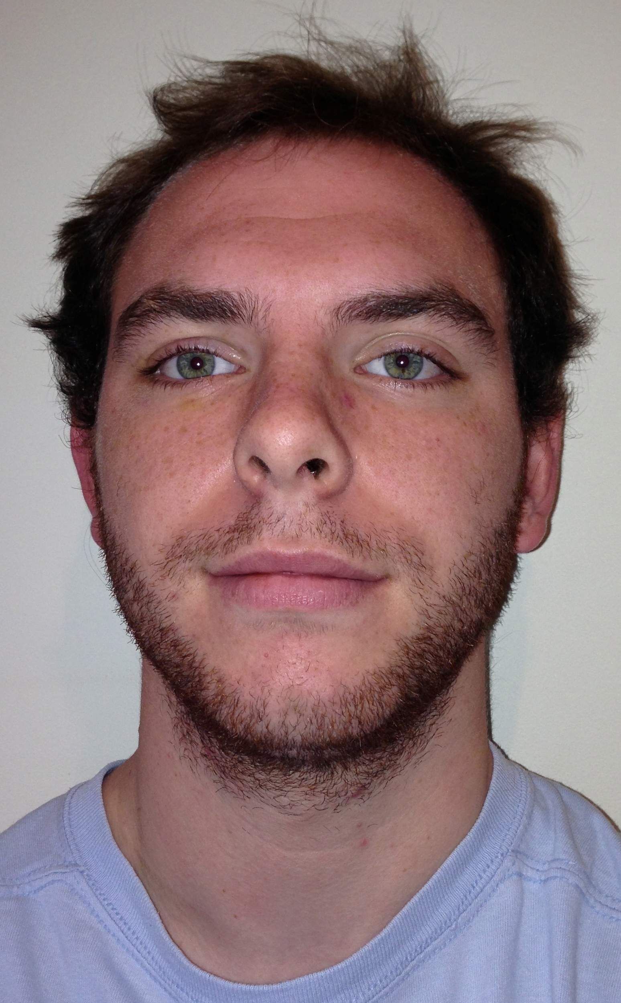
Curriculum Vitae

Matthew Pizer

D.O.B: 7th February 1989

Contact Details:

Personal Statement

I have a passionate interest in education. The catalyst for this was my good fortune in undertaking voluntary work in both Costa Rica and Nepal. This involved working within primary school care, teaching English and providing additional support for teaching and other staff. I found this extremely rewarding and it ignited my enthusiasm for this field of work.

Following graduation in my Philosophy degree, I decided to follow my career aspirations in teaching with a particular focus in studying Disability and SEN. In this respect, I studied for a Masters in this area of education, achieving a merit grade. Within this postgraduate degree I have specialised in the management and practise of teaching assistants, and teaching mathematics to children with learning difficulties.

Subsequently, I have applied this knowledge at a practical level via working as a Teaching Assistant in a London based primary school. Primarily, I supported the development of children with a statement of Special Educational Needs. I found this position greatly helped to develop my understanding and skills in teaching.

I now wish to travel, whilst continuing my professional development in teaching. Consequently, I passed the Certificate in English Language Teaching to Adults course (Celta). I believe the skills I have learnt will make me successful in teaching English to students in which it is not their native language.

Education and Qualifications:

St Bridget’s CE Primary School – 1993 - 2000

Calday Grange Grammar School – 2000 - 2007

A-levels - 2005 - 2007

A2 Law A

A2 Religious Studies B
A2 Drama C

AS English C

GCSE - 2005

Drama A*

D&T A
Religious Studies A
Dual Sciences BB

English Language B
English Literature B
Geography B

Mathematics C
Spanish C

Bar Mock Trial – Liverpool Crown Court – 2007

Leeds University

2008-2011

Philosophy - Honours Degree Course 2i

Within this course I studied the broad principles of philosophy. Modules that I found particularly interesting included environmental ethics, political philosophy, logic and meta-ethics. This degree enhanced my academic and analytical thinking. The course also helped me develop my writing skills and enabled me to become more articulate in presenting my ideas to my peers as it involved a lot of group work.

2011-2012 - Masters (MA) - Disability & Special Educational Needs – Merit classification

The opportunity to study for a Masters in Disability and SEN greatly developed my performance in academic writing. Additionally, as all the lessons involved group work, this course also helped me to develop my articulation in presenting ideas. Modules that I found particularly interesting included - Teaching children who experience mathematical difficulties and managing Teaching Assistants. A huge benefit of these modules was that they encouraged me to be creative in overcoming particular challenges that may be experienced in a classroom. I feel that these modules have provided me with skills and knowledge that I am confident in practically applying in a career in education.

2012-2013 - Teaching Assistant – Eastfield Primary school

I spent an academic year (November – July) working as a Teaching Assistant in a London based state primary school. Primarily, I worked with children who had a statement of Special Educational Needs. I also supported other children of varying ages who had a record of low attainment. My position focused on furthering the academic and social development of such children. Other roles included - lesson planning, student monitoring, student evaluation and assessment, behaviour management.

Furthermore, I also solely ran reading recovery lessons for low attaining students.

I feel that a number of the skills that I learnt in this role will aid me in teaching English as a foreign language.

Additional Teaching Experience

In 2008, I travelled to Costa Rica, a beautiful but poor country. I worked for several weeks in an orphanage, looking after and teaching young children.

In 2011, I visited Nepal for four weeks, another beautiful but resource-poor nation. During my trip, I worked in a rural village again teaching in a primary school.

Both trips provided an extremely rewarding experience and ignited my strong interest in teaching.

I have also recently completed a Celta course with a pass grade. This demanded that I teach and plan lessons for students of varying abilities. The course also required me to observe English lessons, whilst analysing and critiquing such lessons.

Employment and Work Experience

Paper Round – Waverley’s Newsagents, West Kirby – 2004/2005

Take Two video store - 2005-2007
Whilst at school, I worked part-time in a local video shop. This gave valuable work experience particularly in dealing with customers. I was later given responsibility in respect of working alone.

Birkenhead School - 2010 and 2011.
I worked for two summers at this independent school on the Wirral, principally for the Estates Department.

Extra-curricular activities

Sport
Rugby – Calday Rugby Club. 1990 – 1996.
Calday Grammar School team. Years 9 to 12.

Badminton – 1995 to 2005. West Kirby Junior Badminton Club. Multiple Titles.

Additional Skills

Driving – Full (clean) Driving Licence 2006

IT- I have competent IT skills. These include word processing using Microsoft word, PowerPoint presentations and exploring the Internet.

