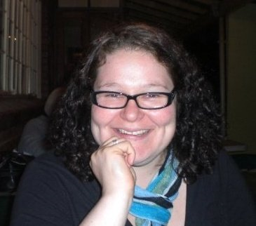
MEGAN FARRELL

메건 페럴

Date of Birth: 1982 – 11 - 20
Nationality: South African (남 아프리카 공화국)
objective
 | Application for a job as an English teacher.
work Experience
 | January 2011 – December 2011 Full-time Teacher  Selly Park Secondary School, Rustenburg – South Africa  Grade 8 – English  Grade 10 – English  (grammar, poetry, public speaking, literature, visual literacy, creative and transactional writing etc.)  October 2008 – October 2010 EFL Teacher  Brighton Junior English School, 부천  Full time kindergarten teacher (5,6,7 year olds)  Part time elementary school teacher (8-13 year olds)  July 2007 – May 2008 (school closed May 2008) Head Teacher  ENCT English Institute, 인천  Kindergarten and elementary school teaching  Curriculum development, resource creation & staff training  April 2006 – June 2007 Full-time Teacher  Ntaba Maria School, Grahamstown – South Africa  Grade 6 - Life Orientation  Grade 7 - English  Grade 8 - English, Arts & Culture and Life Orientation  Grade 9 - English, Arts & Culture, Life Orientation and Social Science  January – April 2006 Au Pair Johannesburg, South Africa  Full time, live-in au pair for a 10 month and a 6 year old.  July – October 2005 Student Teacher  Kingswood College - Grahamstown  Teaching Practice
EDUCATIOn
 | 2005 Rhodes University Grahamstown, South Africa  - Post Graduate Certificate in Education (PGCE)  Teaching Subjects:  - English First/Home Language: Grade 8 - Grade 12  - Arts and Culture: Grade 8 - Grade 10  2002 - 2004 Rhodes University Grahamstown, South Africa  - Bachelor of Arts Degree (BA)  - Majors in English Literature and Journalism & Media Studies  2001 Appleton West High School Appleton, Wisconsin, USA  2001 Renaissance School for the Arts Appleton, Wisconsin, USA  - Rotary International Long Term Youth Exchange Student  1989-2000 St. Conrad’s Brothers of Charity College Klerksdorp, South Africa  Grade 12 Subjects:  English, Afrikaans, Maths, History, Geography, Biology  - 2000 School Prefect  - 1999 Awarded Academic, Cultural and Merit School Honours  - 1999 Rotary Youth Leadership Award  - 1998 Member of Learner’s Representative Council
PERSONAL Interests
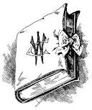 | Cooking, reading, theatre, travel, languages, writing, film, music and entertaining friends.

•e-mail• megz.farrell@gmail.com • Phone• + 27 82 591 9118•

