Dennis Melton

Years of Relevant Work Experience: 40
Years of International Work Experience: 21

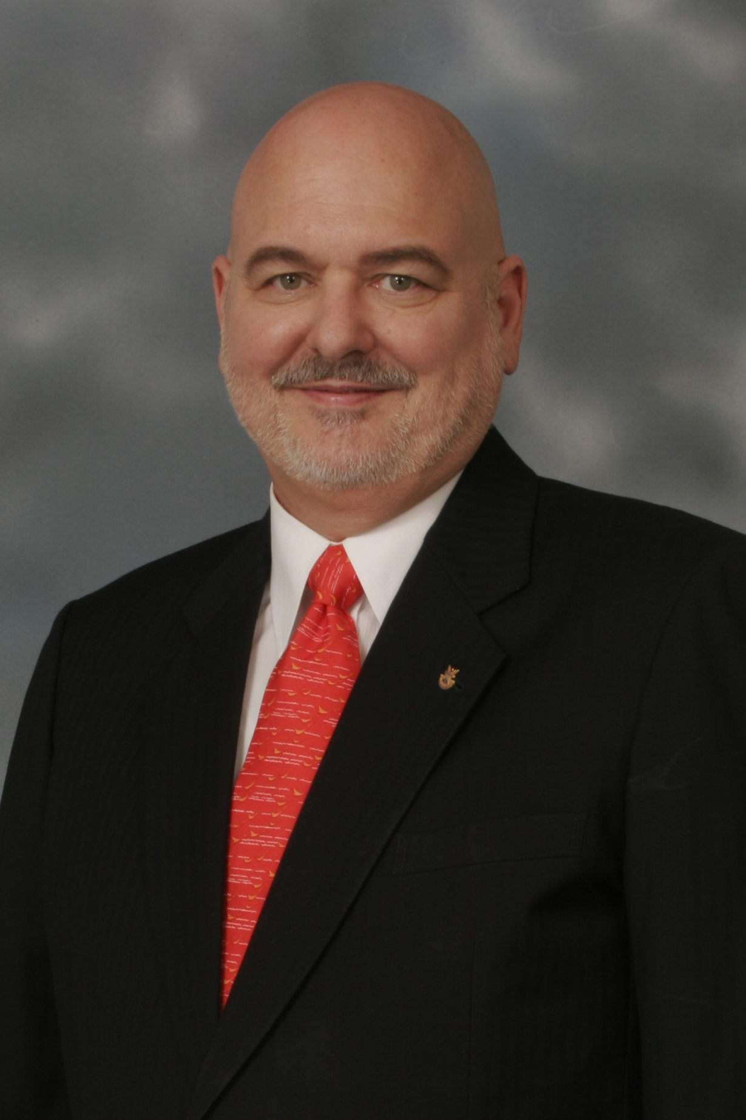
Key Qualifications:

Dennis Melton received his Cambridge CELTA certificate at Akcent International House in Prague, Czech Republic in May 2006.

He has over five years experience as an instructor in the United States Internal Revenue Service (IRS) and as a private consultant teaching a variety of managerial, strategic planning, and technical courses to adult, professionals over much of his 40 year career.

Since January 2009, Mr. Melton has been working in South Korea at Jungchul Language School teaching young learners from kindergarten through the sixth grade. His ESL career began in Thailand in October 2006 when Mr. Melton joined the staff of Panyasak School, teaching English conversation to all six primary grades in its English Language Program. This was a new teaching position requiring Mr. Melton to develop his own materials and lesson plans for each grade. Mr. Melton was very effective in creating interesting and challenging materials that were appropriate to each grade’s skill levels. Mr. Melton’s classroom skills allowed him to handle different age groups, class sizes, and English proficiencies very well.

In March 2007, Mr. Melton became the second grade English program teacher. He taught second grade for an entire school year and three “between semester” programs. He has proved to be an excellent teacher for young learners who has been very popular with the children. Mr. Melton has also related very well to his Thai and Filipino colleagues, who make up the majority of the school’s teaching staff.

Mr. Melton developed excellent lesson plans both as the conversation teacher and, later, for the second grade. He rigorously followed the set curriculum. Before the beginning of the 2007/2008 school year, he prepared the class syllabus and followed its schedule throughout the year. The school uses “English Time”, by Oxford University Press. The testing schedule is different from that suggested by the “English Time” teacher’s guide requiring Mr. Melton to adapt these materials to meet local requirements. His tests were well prepared and effectively measured the children’s progress.

Mr. Melton is a seasoned international expert with more than 40 years of experience in the IRS, and private consulting, including over eight years as Chief of Party leading technical assistance projects in Armenia, the Philippines, and from Washington, D.C. His technical areas of expertise include tax administration and policy, technical capacity building, and strategic planning and negotiation.

Working in the Philippines, Mr. Melton presented a series of Managerial courses to senior level Philippine tax administration managers. Each three-week course covered a range of managerial techniques. He presented the course ten times with each course having twenty students. Mr. Melton supervised a sub-contractor who developed a strategic planning course then he taught that material to senior management officials.

Working in Afghanistan, Mr. Melton wrote and presented three one-week courses on specific tax laws that were newly introduced into the country. Each course held from fifteen to twenty students. He also wrote a training course and trained tax identification number (TIN) registration personnel to accept forms and payments from taxpayers for new identification numbers. Students in the Philippines understood English but not as their native language, training in Afghanistan was accomplished through consecutive translation giving Mr. Melton an appreciation for teaching students who do not have English as their mother tongue.

As Chief of Party for the Armenia Tax Improvement Program, Mr. Melton accomplished various key milestones for the mobilization and set up of this project’s first year objectives including major Information Technology improvements, and drafting tax legislation.

In Afghanistan, Mr. Melton designed and implemented a nationwide Taxpayer Identification Number system for Afghanistan’s tax administration on an 18 month assignment.

As Chief of Party in the Philippines, Mr. Melton led a five-year, technical assistance project for the Philippine Bureau of Internal Revenue. This project introduced fundamental, systemic changes to enhance operational quality, broaden the tax base, increase the capacity to collect revenues, and improve operational integrity and transparency.

As Tax Attaché in Riyadh and Singapore, he led negotiations with U.S. bilateral tax treaty partners resolving issues that impacted U.S. direct foreign investment. Key negotiation counterparts included Ministers of Finance, Commissioners of Revenue and their senior staffs, major United States corporations, and U.S. Ambassadors. Earlier in his career, he held managerial roles in the IRS involving tax collection, audit, and taxpayer assistance functions.

Education:

M.B.A., Management, Georgia State University, 1971
B.B.A., Management, Georgia State University, 1970
CELTA, Akcent International House, Prague, Czech Republic, May 2006

Citizenship:

United States of America

Language(s):

English (native language); French and German (proficient)

Chronological Work History:

Jungchul Language School, Mokpo, South Korea, January 2009 to present
Panyasak School, ESL teacher, Bangkok, Thailand, October 2006 – April 2008
Booz Allen Hamilton, Chief of Party, Yerevan, Armenia, June 2005 – April 2006
BearingPoint, Inc., Senior Advisor, Kabul, Afghanistan, January 2003 - June 2004
Internal Revenue Service, Tax Attaché/Deputy Tax Attaché, May 1998 - January 2003
Internal Revenue Service, Chief of Party, August 1993 - December 1997
Internal Revenue Service, Chief International Projects June 1990 - July 1993
Internal Revenue Service, Tax Attaché, June 1987 - June 1990
Internal Revenue Service, Deputy Tax Attaché, January 1983 - June 1987
Internal Revenue Service, Revenue Agent, January 1981- December 1982
Internal Revenue Service, Group Manager Collection, January 1974 - December 1980
Internal Revenue Service, Revenue Officer - Atlanta District, August 1969 - December 1973

References

ESL Teaching References
Mr. Daniel Yoon  1728-3 Sanjung-dong  Mokpo, Junnam 530-350  Republic of Korea  011-9096-7959  danieljyy@naver.com | Mr. .Reuben Collier  Acting Head Teacher  Panyasak School (retired)  reubencollier@gmail.com  mobile (66) 87030 0453
Professional References
Dr. James Mudge  Economist  2500 Frances Dr.  Loveland CO 80537-6966  970 667-7720  (cell) 303 829-7626  jmudge179@yahoo.com |  | Ms. Teresa Petrocco  Senior Tax Administration Advisor  5238 Silver Star Road  Vernon, BC V1B3K4  teresa.petrocco@gmail.com  (250)542-0194
Mr. Richard (Dick) Teed  Director, Strategy, Research and Program Planning  Large and Mid-Sized Business Division, IRS (Retired)  Currently – Independent Consultant  58 Spofford St.  Newburyport, MA 01950  (978) 465-0898  rwteed@comcast.net |  | Mr. Stanley Beesley  Tax Attaché Tokyo, IRS (Retired)  Currently – Independent Consultant  2332 Condor Dr.  Redmond, OR 97756  stan_beesley@yahoo.com
Additional references upon request

A more detailed CV covering my previous work experience is also available upon request.

