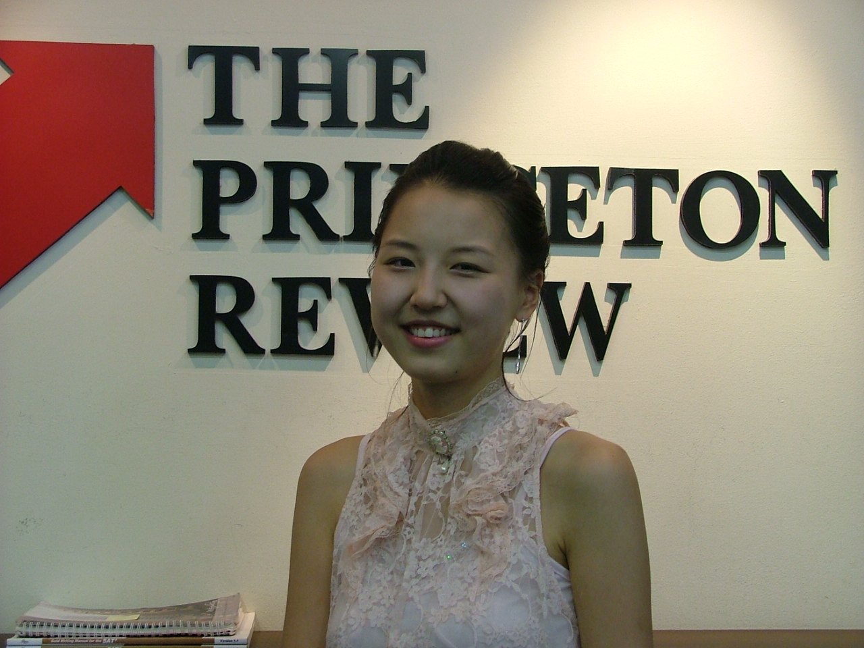 Miae Kim
Jamwon-dong, Seocho-gu, Seoul, Korea E-mail: jollybean@hanmail.net
(010) 4393-2232

EDUCATION
Korea University Graduate school of International Studies (March 2007 - Present)
Sahm yook University B.A. in Management Information Systems and English Literature (March 2001 - August 2006)
University of Sydney in Economics (March 2003 - July 2004)
Catonsville High School (September 1996 - May 2000)

EXPERIENCE
YBM ELS Jongro campus (Full-time, May 2008 – Dec 2008)
1 Responsible for TOEIC Speaking and OPIc class.
The Prinston Review Korea Daechi campus (Full-time, March 2007 - April 2008)
1 Responsible for Business conversation and TOEFL writing class.
Hynix co., Ltd (Part-time, October 2006- June 2007)
1 Responsible for Business English class to the employee.
Hyundai Click Festival (Part-time, 2004, 2005, 2006, 2007)
- Responsible for oral translation for international drivers.

SKILL
- Computer software: Microsoft Windows family.
- Fluent in both English and Korean language.

