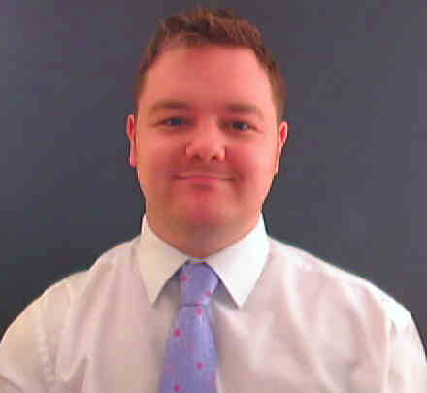

Michael McLaren
107 New Wokingham Road, Crowthorne, Berks, RG45 6JW, England
Telephone: +441344774421 (Home) +447546456358 (Cell)
Email: mike958@gmail.com

Birthday: 01/03/1986
Marital Status: Single
Nationality: British

Professional Profile

A positive, proactive and results-driven Music Industry Management graduate from Bucks New University possesses excellent interpersonal, communication skills and the ability to develop and maintain mutually beneficial internal and external relationships. Enjoys being part of a team and thrives in highly pressurized and challenging working environments now seeking next challenging and rewarding opportunity within a successful organization

Objective

To have the honor of working for a great school, teaching English as a second language.

Education and Qualifications

2009 International TEFL Teacher Training (20 Module Course)
100 Hours TEFL Certification

2005 - 2008 Bucks New University
BA Music Industry Management & Live Production
Modules Included:
- Strategic Management of Live Events
- Entertainment Law
- Global Distribution Networks
- Finance
- Marketing

Edgbarrow School, Crowthorne
A Levels 2002 - 2005
Business Studies B
I.C.T. B
Resistant Materials C

GCSEs 2002
11 GCSE passes all at B grade including English, Mathematics and Science

Career Summary

May 2009 - Oct 2009 English Teacher, CDI April (Full Time)
I worked in Mokdong, Seoul, South Korea teaching English to children grades 1-6.

2007 - 2008 Barman & Sound Engineer, The White Horse Pub (Part Time)
Worked as part of a team in a commercial environment under pressure, often using communication skills to listen and deal with difficult customers, whilst also understanding the customers’ needs and using this knowledge to improve the business by suggesting improvements to the management.
In addition to pub work I served as the sound engineer working with a number of difficult people in bands setting up and running equipment and audio levels.

2002 - 2006 Sound & Lighting Engineer, Stagerats (Casual Work)
Working unsociable, long hours and to tight deadlines helping to set-up and run equipment in unfamiliar environments around the UK. The job required high levels of planning, patience and a good sense of timing to help achieve the clients’ visions.

2002 - 2005 Food Service Assistant, Wellington College Kitchens (Part Time)
Served college students and worked with other staff in friendly & professional manner under very strict health and safety laws.

Skills

- Basic Korean & Japanese
- Full current clean driving license
- Excellent communication skills
- Good knowledge of several word processing packages including Word, Excel, Access and the Internet

Professional Development

Traveling – I believe that we only get one shot at life and so I aim to make the most of it. In my holidays I have traveled to many places in the world as I like to learn about other cultures and customs, the last place I visited was Thailand.
Sport – I enjoy and have trained in martial arts which require high levels of dedication and motivation. It has led me to achieve a high level of self discipline and respect for others.
Music – Playing musical instruments has been a hobby of mine. For the last five years I have been playing bass guitar both for fun and on/off in bands. I also enjoy listening to and engineering other peoples music as it also gives me great satisfaction.

