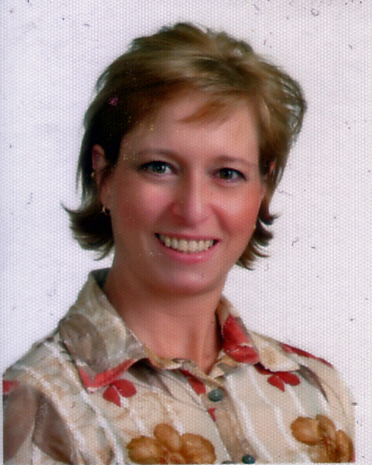

Michele Farley –

TEFL/TESOL Certified English Teacher

Professional Communicator
Member of KOTESOL
michelekorea@hotmail.com

Cell: 82 +10 7738-2753

Summary of candidacy:
Canadian Citizen. Native speaker. Experienced teacher. Professional Communicator. Computer literate. Professional, dedicated, enthusiastic, and very creative.
International TESOL certified and graduate in Communications and Industrial Relations. Several years practical work experience in many settings, including academic, business, NGOs, and government agencies. Hobbies include dance, photography, golf, tennis, travel.

Education:
Bachelor’s degree in Public Communications from the University of Ottawa (Canada)
Certificate in Industrial Relations from the Universite du Quebec a Hull (Canada)
Diploma Programmer Analyst from CDI College Ottawa (Canada)
Diploma in Multimedia Development from Algonquin College, Ottawa (Canada)
Certification Teacher of English as a Second (or Foreign) Language with specializations in Business, Computers, and Tourism.

Experience:

Teaching

Over five years teaching experience, more than four years teaching in Korea notably for Chun Ang University in Seoul, Woo Song University in Daejeon, the Korea Herald Language Institute, and for the Canadian Language Institute, Canadian Education Networks in Seoul catering to students of all ages notably Elementary and University level students. I have participated in numerous winter and summer camps helping develop and deliver the program of activities.

I have worked with university and college students, adult workers, in-company training and high level executives, as well as with children of all ages including kindergarten. Previously I was teaching adolescents and beginner and intermediate adults in Mexico in a private institute. In Canada I worked for a government contracted language school catering to public servants in large groups and one on one. My approach to teaching is dynamic and interactive. I take special attention to students needs and like to create innovative ways to teach and deliver the material prescribed by set curriculums, or developing my own. My expertise also lies in presentations, business writing and interview skills. I have been asked to participate in special workshops for university students.

Business and Communications
Many years experience working for private companies and government agencies in Canada, notably in the areas of public relations and media relations, proposal technical writing, report and analysis, marketing, strategic communications planning, project management, special events (trade show and conference) coordination, and web site development. I have also done radio and television interviews of behalf of various organizations and been involved in multi- disciplinary committee work for private companies and the government of Canada. I have been commended for my analytical and writing skills.

Computers and Technology
Employed by high technology companies as a proposal technical writer, course developer and trainer, web site developer, coordinator, and performed communications needs analysis for various Canadian Government clients in the fields of training, web site development, and policy development related to computers and communications.
Knowledgeable and proficient using office software programs: MS Word, Excel, PowerPoint, Access, MS Project, and various multimedia tools.

