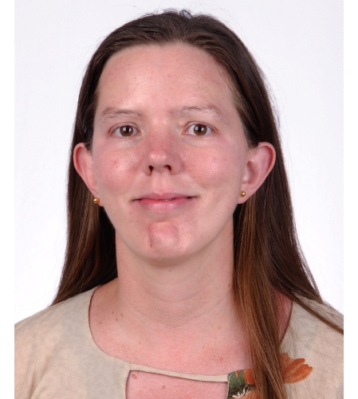

Monica Mc Kelvy
nikkimckelvy@gmail.com

Profile
 | Master’s in psychology. Experienced in managing projects from conception to completion. Excellent team building skills.

Education
 | Master of Arts, Psychology  Canyon College |  |  |  | 2006
 | GPA 3.63.
 | Bachelor of Arts, Psychology  Stephens College |  |  |  | 2000

Qualifications
More than ten years experience as an English as a Foreign Language Instructor.
Experienced in conducting research and have done so for 6 years.
Familiar with SPSS and able to learn statistical programming easily.
Excellent computer skills.
Fluent in English and Spanish and conversant in Chinese. I can get by in about a dozen languages.
I love reading, learning, researching, and writing, and I am good at taking notes and am excellent in statistical analysis.

Relevent Experience
 | Curriculum Coordinator at Greenhill International Language Consortium |  |  | Feb. 2012-Sept.2012
Powerlong Mall, 4th floor
- Worked with every level from preschool to adults
- Taught all levels from basic to advanced
- Taught English and Spanish as a foreign language
.
 | English Lecturer at Busan Catholic University |  |  | Sept. 2010-Sept.2011
Bugok3dong, Kumjung-gu, Busan / Phone : 82-51-515-5811~5 Fax : 82-51-514-1576
- Lectured English at the university level.
- Learned I loved working with university and adult students.
- Developed tests and curriculum for my students
- Started study groups for my students
- Built strong relationships inside the school
- Started learning Korean
.
 | Counselor for St. Paul’s Preparatory Academy |  |  | Aug. 2009-Aug. 2010
B-dong, HeeKyung Bldg. 206-1 Yangjae-dong, Seocho-gu, Seoul, Korea Tel: 02-3462-8850Fax: 02-3462-8881
- Asked to help set up the counseling department for SPPA-Korea
- Taught Psychology at the university level
- Taught Spanish
- Helped to establish the school in the international market
- Handled difficult students
- Frequently worked overtime
- Worked to establish a good working environment with everyone at the school.
 | Head Counselor | Nov 2006- Aug.2009
Bahrain Counseling Center Villa 2141 Street 2432 Juffair, Manama Bahrain
- Created the center from nothing into a profit making business.
- Was able to build strong and trusting relationships
- Treated people with all problems from addictions to learning disorders to depression.
- Worked under very stressful and difficult circumstances
- Helped people change their lives a little bit every day.
- Oversaw my own staff
- Learned about life in the Middle East
 | English Teacher |  |  | 2004-6
Sogang Language Program, Joyup 2 Dong. Ilsan, Ku, Kyungki, Do, Goyang Shi, South Korea 011-82-031-916-1230 http://ilsan.slp.ac.kr/

- Taught my way through my Master’s degree.
- Gained the trust of the Korean faculty.
- Possessed one of the highest return rates in the school.
- Was able to build strong and trustful relationships with the most difficult of people.
 | English Teacher | 2004
Sacred Heart School, 166 Hsin Dian Rd. Keelung, Taiwan 886-2-24282454 http://www.shsh.kl.edu.tw
- Trained other teachers in how to teach English as a foreign language.
- Helped teachers adapt to the local culture.
- Encouraged thinking and leadership in difficult students.
 | Head Counselor |  | 2002-3
Dominican International School, 76 Dah Chih St. Taipei Taiwan 886-2-2533-8451 www.dishs.tp.edu.tw
- Hired to create the Counseling Department from the ground up, including testing materials, college and career counseling, and guidance.
- Helped the school in the accreditation process.
- Oversaw a staff of four.
- Taught classes on the college level (Spanish and Comparative Religions).
- Set up the entire college and career guidance programs.
- Increased communication between all levels of the school.
- Encouraged multicultural attitudes and assembled curriculum.
- Tested children for disabilities.
- Trained others in counseling procedures.
 | Head Counselor |  | 2000-1
Escuela de las Americas- Atras de Cada, Avenida Intercomunal, El Tigre, Anzoategui Venezuela 011-58-0283-2412467
- Set up the entire counseling program from scratch.
- Counseled children and teenagers in Latin America.
- Created programs for the entire school and set the standard for the programs.
- Helped diagnose and treat some of the more difficult students.
- Increased communication both within the school and in parent/teacher interactions.
- Encouraged multicultural attitudes.
- Taught Psychology and Health.
- Frequently was asked to do all of this under very strenuous conditions, including no electricity, earthquakes, and kidnappings.
- Developed proficiency with children, teenagers, and adults.

