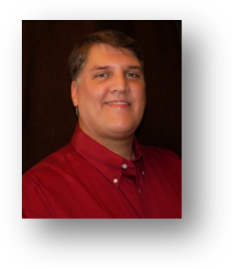
Monte Reed
11622 - 42nd Dr SE • Everett • WA • 98208 • USA
Email: mqreed@gmail.com • Mobile: 425-239-3010 • Home: 425-493-4484
Birthday • April 9, 1963
Marital Status • Single
Nationality • USA

Objective

The opportunity to teach E.S.L. in Korea

Education

1989 - 1996
Embry-Riddle Aeronautical University, Daytona Beach, Florida
Bachelor of Science
• Major in Professional Aeronautics
• GPA: 3.9

1981 - 1983
Everett Community College, Everett, Washington
Associate in Arts and Sciences
• Major in General Education

Teaching Related Experience

April, 1995 – May, 1996
Hughes Technical Services, Flight Simulator Instructor/Operator
• Taught small groups and individuals in both a classroom setting and in the cockpit
• Taught and evaluated critical skills to ensure safety and that all FAA regulations were understood and met
• Taught instructors how to operate the Flight Simulator

June, 1993 – April, 1995
US Army, Instructor Pilot
• Taught all aspects of flight training, as a platform instructor to larger groups, small group instruction, and individual training/evaluation in the classroom and in the cockpit
• Developed and taught the non-rated crewmember training program that the U.S. Army later adopted
• Ensured all assigned crewmembers were fully trained to FAA and D.A. standards

Recent Work Experience

August, 2006 – November, 2008
The Rock, Assistant General Manager
• Mentored and coached team members to develop their quality and consistency skills
• Primary employee trainer both on the dining room floor and in the bar. Taught extensive custom drink menu to new bartenders
• Developed team members to maximize effectiveness and achieve organizational goals

Awards/Certificates Received

1985
• Commercial Instrument Rotary-Wing License

1993
• Instructor Pilot Certification

Language Skills

• Basic Spanish

Travel Experience

• Egypt, 7 months (also Israel, Jordan)
• Central America, 6 months (also Honduras, Belize, El Salvador, Guatemala)
• Korea, 13 months
• Australia, 6 weeks
• Mexico (multiple trips)
• Canada (multiple trips)

References

Available upon request

