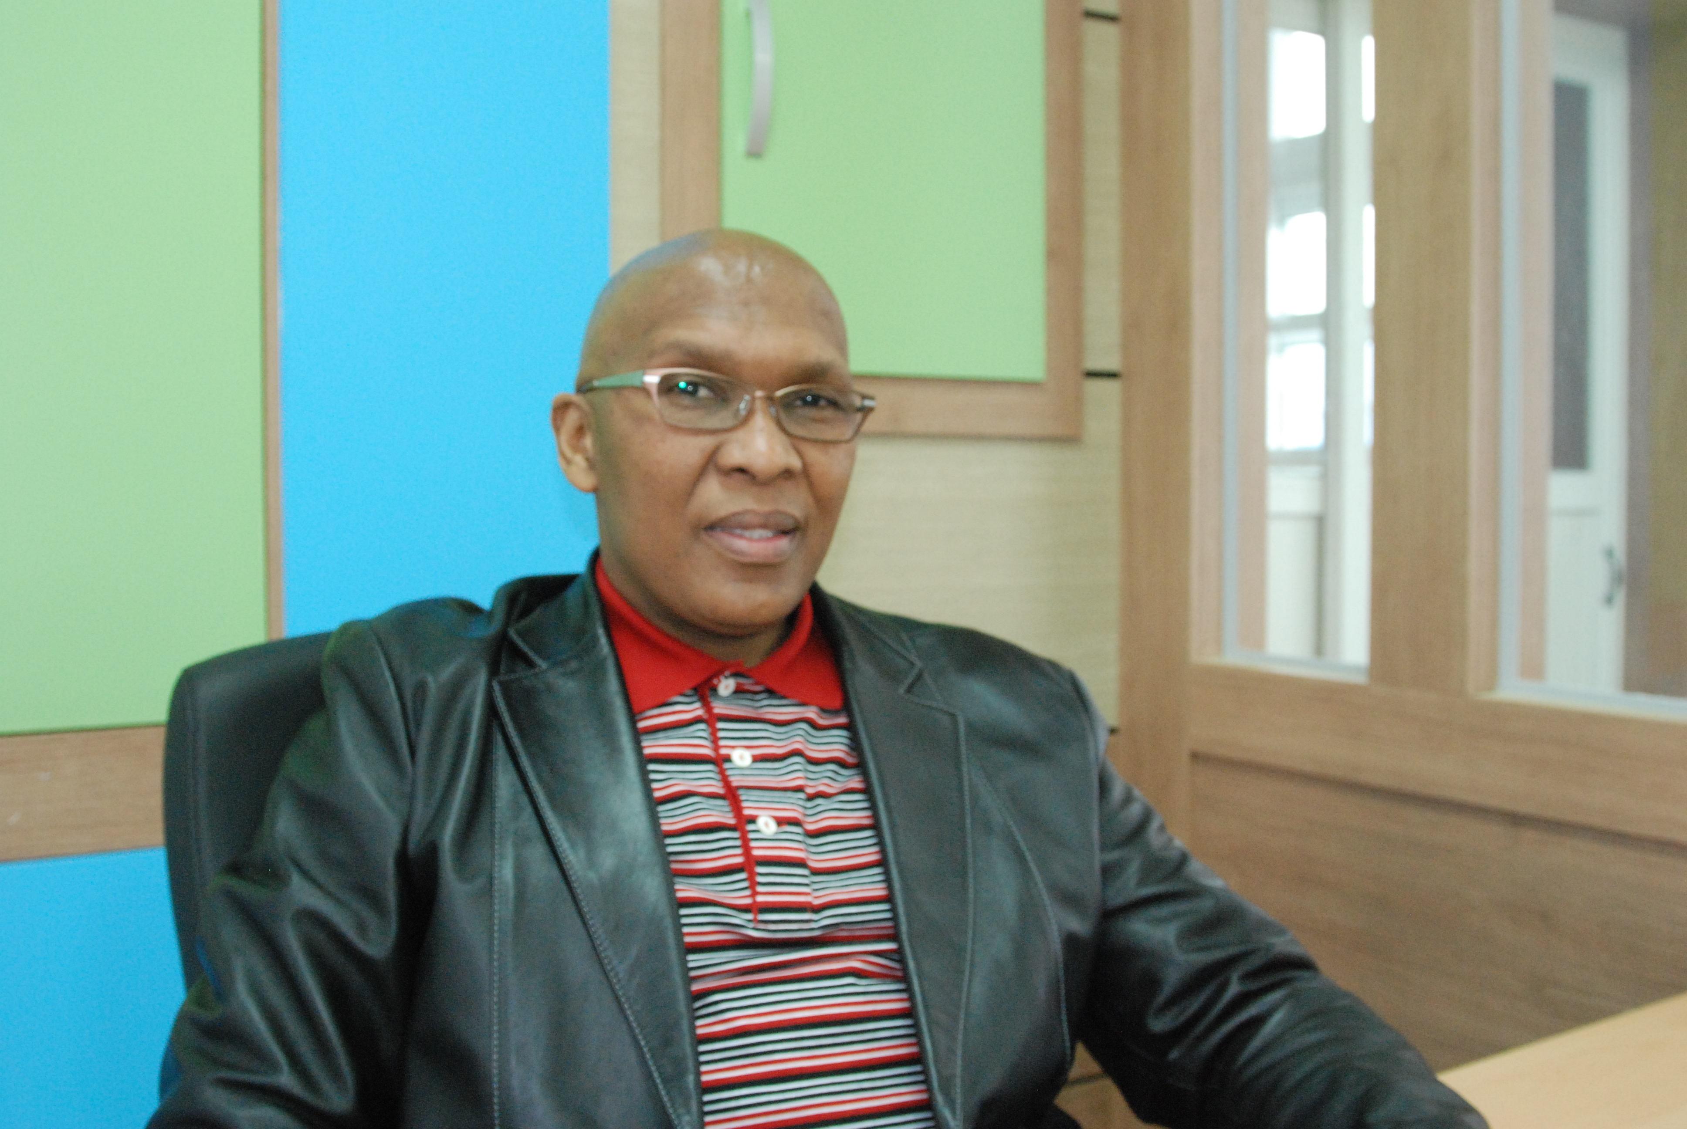 3rd Floor, 23 Sungnae 1 Ri Punggi, Yeong-Ju 750-809
Nnena Thabo Cell # 82 01 8108 4551; Home # 82 70 8221 4551
Email: nnenathabo@gmail.com ; Skype ID tnnena
Qualifications Profile
An enthusiastic professional poised to leverage education and experience; towards a successful career as an English Teacher with an educational institution committed to supporting the institutions objectives.
- Teaching: Elementary and / or Middle School students English listening, speaking, reading and writing skills.
- Communication & Presentation: Exceptional interpersonal skills. Handle sensitive matters with tact, poise and diplomacy. Communicate well with individuals at all levels.
- Computers & Administration: Proficiencies include Microsoft Office ( Word, Excel, Power-point ) Internet Research and applications.
Education
- Bachelor of Commerce Degree ( Information Systems, Business Management ) 11/2007
University of South Africa – Pretoria ; South Africa
- TESOL Certificate ( 100 Hours ) 08/2009
Linguaedge College – California; United States of America
Professional Experience
- Technical College of South Africa – Randburg ; Johannesburg ; South Africa
Computer Practice Tutor ( March 2005 – 2006 )
Tutoring College students Microsoft Word, Excel, Access and Power-point.
- SDA Language Institute
- January 2008 – April 2009 SDA Institute
- Bonghyeon, Angjeong and Bonghyeon Sebu Elementary Schools
- 1st May 2009 – Present (Contract expires April 30 2010)
Personal Details
- Alien registration number : 620520-5760290
- Marital status : Engaged
- Health : Good
- Criminal record : No criminal record. Police report in order
- Date of Birth : 20th May 1962
- Hobbies : Cycling, Playing soccer and Photography

