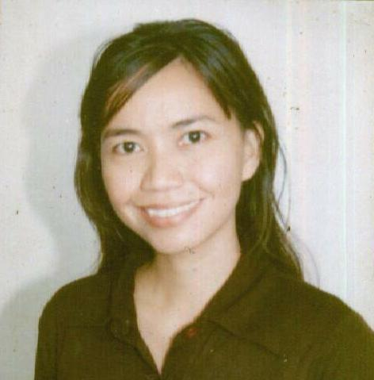
MA. NOAHMI U. ESTRADA
English Instructor

B2 L3 Cardinal Village I
Dasmarinas, Cavite
4114 Philippines

Mobile No: +639154455088
Email Address: noahmi556@yahoo.com

Career Objective: To assist students in learning the English Language in the simplest possible way from basic conversation to grammar that will help them get through with their day to day encounter.
QUALIFICATIONS:
- TOEFL/TSE/TWE passer.
- Has been teaching the English language in the Philippines for 2 years now in a classroom and on one-on-one setting(Topics: Grammar, Parts of speech, Business Writing, Job Interview, Speeches). Furthermore, assisted students with their IELTS review.
- Excellent in English communication skills on both written and oral form. With fair communication skills in Arabic and Spanish..
- Authored an English Proficiency curriculum for the Power Skills Technical Center which is registered by TESDA in the Philippines.
- Conducted workshops for different age groups.
- Commendable leadership skills with good students rapport.
- Proficient in Computer applications.
- Imbued with good moral character and dedication to work.
- Member of the Toastmasters International (public speaking club).

WORKING EXPERIENCE:
SCHOOL | POSITION | YEAR
Power Skills Technical Center Imus, Cavite Philippines | English Instructor | Aug. 2006- Present

EXAMINATION TAKEN/EDUCATIONAL BACKGROUND:
LEVEL OF EDUCATION/LICENSURE | UNIVERSITY/SCHOOL/ADDRESS | YEAR GRADUATED/ LICENSURE EXAM
TOEFL/TSE/TWE |  | 2006
PTRP (Philippines PT Licensed) | PRC, Manila, Philippines | 2000
Bachelor of Science in Physical Therapy *** | De La Salle University-Health Sciences Campus Dasmarinas, Cavite, Philippines 4114 | 1993-1998
Secondary Education | Binmaley Catholic High School, Inc.  Binmaley, Pangasinan, Philippines | 1989-1993
Primary Education | Don Gregorio Evangelista Memorial School Zamboanga City, Philippines | 1983-1989

