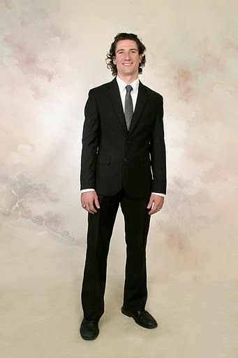
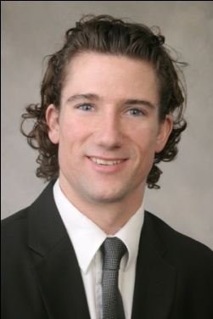
Nathaniel M. Norman

Current address
Gangdong gu, Cheonho 2 dong
Ssangyong Platinum River Apt. 716
Seoul, South Korea 134-874
Mobile phone # 82 (0)10-3944-9789
Email address – nathanielmarcusnorman@gmail.com

Objective
My objective is obtaining a position at your school where I can use my educational and employment background, personal skills, and travel experiences to best serve your interests. I will help the students realize their potential and instill in them a passion for perfection in all areas.

Education
B.A. in International Studies
Certificate in Asian Studies

1. University of South Florida (Tampa, FL) January 2004 – August 2006
References: Dajin Peng, peng@chuma1.cas.usf.edu
Eric Wolters, ewolters@cas.usf.edu

2. Clearwater Christian College (Clearwater, FL) August 2002 – December 2004

3. Georgetown University’s Junior Statesmen Summer School (Washington D.C.) July 1999 and July 2001

4. Calvary Christian Academy (Saipan, MP – Northern Mariana Islands) August 1998 – May 2002
Reference: Vanessa Pritchard, holly_jollyvkp@hotmail.com

Employment from 2000-2010
- Lingua Songpa: Seoul, South Korea, July 2009 – Present English Teacher
I began working with a group of amazing teachers. After 6 months a completely new staff was hired. I personally recruited 2 foreign teachers. During the transition I trained the new staff and developed a dramatically altered curriculum. I am now the head foreign teacher coordinator. I teach students from the ages of 4 to 11. I have learned a lot about early childhood development from teaching the youngest students.
- Modern English Studio: Seoul, South Korea, July 2008 – July 2009 English Teacher
Reference: Natalie-Jane Howard, natauzjhoward@hotmail.com
Mobile 010-5592-8899
I contributed to textbook development and student placement in this private academy. I taught 14 adult classes conversational English. Aside from teaching the textbook and leading class discussions, I graded or revised my student’s writing assignments every day. Managing this hectic schedule took dedication and focus every minute of the day.
- Bahama Breeze: Tampa, Florida, June 2005 – September 2006: Server
Reference: Jeannie Lafever and Ray Atwood PH # 1 813 289 7922
I supervised closing the restaurant most nights. This included checking other people’s closing work, putting the restaurant back in order, and writing shift reports about other’s performance. I was entrusted to collect cash from the other employees. I dealt with about $5,000 or more every night.
- Pacific Islands Club: Saipan, April 2000 – June 2002: Lifeguard
Reference: Cole Pritchard, seaexec@picsaipan.com
This was my first job. When I was 16 years old, I lifeguarded after school and on the weekends. I also instructed guests at the resort in archery, golf, windsurfing, and volleyball.

Other experiences
- Volunteer teaching underprivileged children in southwest Seoul, January 2009 – June 2009
- Participated in Beijing’s Tsingua University Poverty Alleviation Program by teaching English for a month in the province of Ghuizhou, China from July to August 2006.
- Led a successful study abroad scholarship fundraiser for the University of South Florida’s International Studies Department in August 2005.
- Counseled and taught juvenile delinquents at the Hillsborough West Juvenile Detention Center in Tampa from September 2002 to September 2003.
- Won the regional championship for the speech organization National Forensics League in 2001 and 2002. In 2001 I went to the National competition in Norman, Oklahoma. In 2002 I went to the national championship in Charlotte, NC.

All references
Lingua
- Mr. Park - 82 10 9168 3318
- Jenny Choi - 1124jenny@naver.com 82 10 6396 6648
Modern English Studio
- Natalie-Jane Howard - natauzjhoward@hotmail.com 82 10 5592 8899
Talkster English
- Christine Lee – softyuna@gmail.com 82 10 4172 1975
Bahama Breeze
- Ray Atwood – 1-813-289-7922
- Jeannie Lafever – lafevertampa@aol.com
Pacific Islands Club
- Cole Pritchard – manager, seaexec@picsaipan.com
University of South Florida
- Eric Wolters – academic advisor. ewolters@cas.usf.edu
- Dajin Peng – International studies professor. peng@chuma1.cas.usf.edu
- Adriana Novoa – Latin studies professor. Ph. 1-813-974-9375. Email – ainovoa@shell.cas.usf.edu
- Earl Conteh-Morgan – International studies professor. conteh-m@chuma1.cas.usf.edu
- Joan Newcomb – International studies advisor. jnewcomb@tampabay.rr.com
- Naoko Komura-Birtwell － Japanese Professor. naokokomurabirtwell@yahoo.com
- Taketo Ohtani － Japanese Professor. tohtani@msn.com
High school
- Vanessa Pritchard, Calvary Christian Academy – holly_jollyvkp@hotmail.com
- Cole Pritchard, Saipan, PIC – seaexec@picsaipan.com

