Lisa O’Neill | June 28  2008
This document includes;  Cover Letter, Resume and all  documents needed to work in  Korea |  | PLEASE NOTE:  Available to begin anytime after August 25, 2008
Dear Sir or Madam,

I recently moved to Bucheon City, Korea and I plan to reside here long term. I am interested in a position near my home starting late August 2008.

I am interested in working at a public school, university or reputable company and would like a salary of 3.5 (+) million won per month. Although, it is negotiable depending on the position, hours and preparation time per week.

I am the best candidate for your position because of my roots in Korea yet I am a native English speaker. I currently hold an F-2 visa and have the qualifications to get an E2 visa (you can see an old copy of my E2 visa in the attached document on page 5 of 6).

Since my husband is Korean I have a better understanding of Korea than most other westerners. If you hire me, you will see I am extremely professional and independent. I will not be a problem for the school like someone new to Korea. I will not need housing, airline ticket, medical insurance or assistance that inexperienced teachers need.

The majority of my private lessons in Korea have been long term. I have visited the same Korean homes for years. They have been so pleased with my teaching and manners that I have had some of the same classes for 5 to 7 years.

I hope you consider me for your position, and if you are genuinely interested in me and my conditions, please email me at lmtoneill@hotmail.com Afterwards, I will send my telephone number or arrange an interview at your earliest convenience.

I have attached all the necessary information for employment in Korea. Although, I have not lived in Canada for quite some time, I can supply you with a criminal check if it is required.

- Resume pg. 1 to 3
- Copy of F2 Visa pg. 4
- Copy of old E2 pg. 4
- Copy of current passport pg. 5
- Advertising giving my class special recognition t Hyundai Department Store.

Sincerely,
Lisa O’Neill

Lisa O’Neill
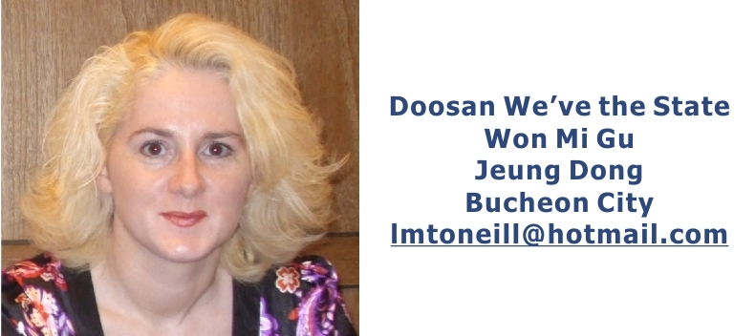

Specializing in teaching ESL in Korea for over 10 years
Goal

Professional and motivated with excellent communication skills. Capable of managing all kinds of classrooms situations. Looking for a part time or full time position in a professional teaching environment. Taught some of the same students for 5 to 7 years and I am a F2 Visa holder.

Skills

Interpersonal
- Creative, efficient and energetic individual
- Excellent communication skills (written and verbal)
- Works extremely well with students and patient in resolving any classroom situation
- Ability to create a mutual teacher-student respect in the classroom
- Highly adaptable and manages situations quickly and calmly
- Strong understanding of cultures and its sensitivities, especially Korean

Technical
- Advanced use of computer graphics software such as Corel Draw and Adobe
- Thorough knowledge of Microsoft Office, Excel and Word.
- Learns most computer and internet related skills faster than the average user

Extracurricular Activities

- Sports: Workout daily, walking, hiking, inline-skating, badminton, ice skating and hockey
- Travel: Traveled to over 20 countries. Europe, North America, Mexico and Asia
- Reading: All kinds of books, news and current events
Page 1 of 6

Education
1988 - 1992 Cabot College St. John’s, NL. Canada
B. A. Business Administration
1986 - 1988 Memorial University St. John’s, NL. Canada
General Studies

Relevant Work Experience

Present ~ 03/08 Hyundai Department Store Bucheon City
ESL Teacher
- ESL Teacher at Hyundai Department Store’s Cultural Center
- Got special recognition in Hyundai’s magazine for their summer semester ESL classes Included Hyundai Department stores ad as JPEG on Page 6 of 6

2008~2003 East2West Connections Asia Seoul, Korea
Recruiter
- Recruiting Korean students for camps at Memorial University, St. John’s NL
- Recruiting for short and long term programs with the Newfoundland Government’s International Students Educational Program (Canada)

2002~2003 Bambini Edu-Center Seoul, Korea
ESL Teacher
- Taught ESL to Kindergarten Students
- The students at this school studied all subjects in English
2003 Hyundai Training Center Paju, Kyung Ki Do

ESL Teacher
- Taught ESL to Hyundai and Kia Employees
- Prepared employees for G-TelpTesting and improvement of conversational skills for English in the workplace

1998 – 2002 Formerly, Dae Moe Kindergarten Ilwon Dong, Seoul
ESL Teacher
- Taught ESL to kindergarten students
- Designed the school’s entire English curriculum for over 4 years
Page 2 of 6

1999 – 2000 Kyungwon University Songnam City
ESL Instructor
- Taught ESL to first year university students
- Designed the curriculum for this class

1997 – 1998 Kwak’s English School Mok Dong, Seoul
ESL Teacher
- Taught ESL to students of all ages including morning business class and morning classes for women
- Helped design school curriculum

References Available upon Request

Page 3 of 6

Present F-2 Visa

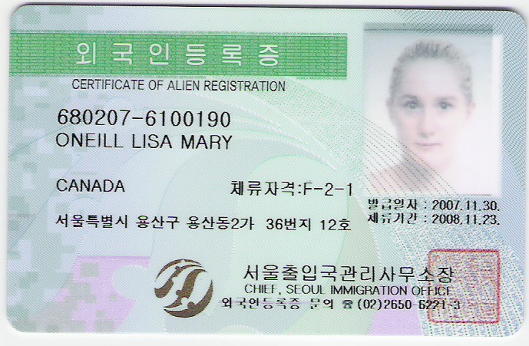

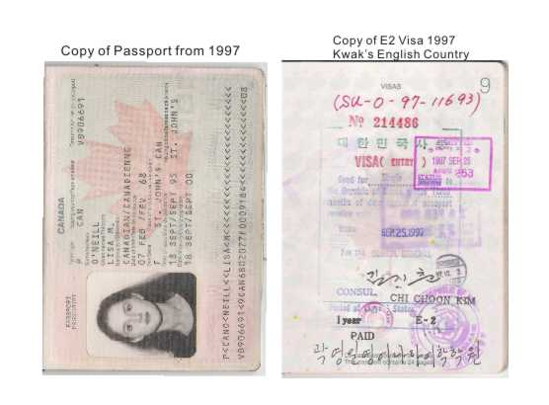
Page 4 of 6
Present Passport Copy

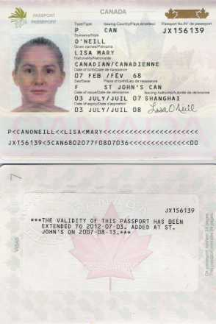

Page 5 of 6
Ad from Hyundai Department Store where I presently teaching

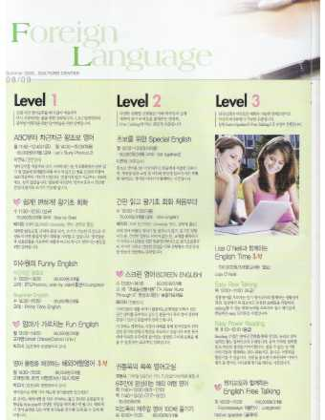
Page 6 of 6

