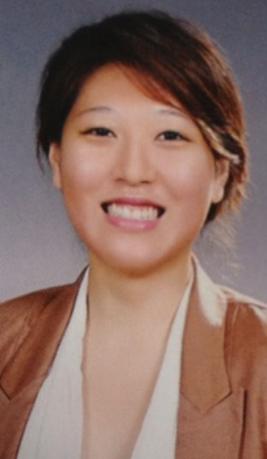
Curriculum Vitae

[Name : Nicole Seo]
[Age: 26]

EDUCATION
Rangitoto College, Auckland, NZ
High School | 2004-2006
University of Auckland, Auckland, NZ
-Bachelor of performance in  Jazz major | 2007-2009
- honors degree (on suspension) 2010
Site
http://www.myspace.com/shj-jazzpi25
http://www.soundcloud.com/shj-jazzpi25
Certificate
Associated board of the royal schools of Music theory exam Grade 5
The Professional Bar School Certificate.
Tesol certificate (+120hours)
Musical experiences

-1st keyboardist gospel band (4yrs)
-Church service choir pianist (6yrs)
-Conductor for junior choir (2yrs)
-Jazz composer and arranger with recording projects. (6yrs)
- Experienced playing gigs at the many different atmospheres (more than 7yrs)
-Performed for national NZ police celebration ceremony
-performed for event company advertisement music video

work experiences

- Sandwich & coffee cafe
Took customer orders, handled customer complaints. ( 2002-2004)
Skill gained (team work, confidence with customer and solving problem)

- Assistant at hair design.(2004) Skill gained ( communication, team work, interpersonal)

- Teach the music ( 2006- 2012) (to develop my skill and communication skills through meeting a variety of people)

- Teach English at the elementary public school (2012June-2013June)

- Teach English kids at the libraries in the Gyongido province (2013July-current)

