Resume  Teaching Skills:  Education  Relevant English Teaching Highlights:  Work History  Workplace:  Responsibilities:  Workplace:  Responsibilities:  Workplace:  Responsibilities:  Workplace:  Responsibilities:  Workplace:  Responsibilities:  Referees: | 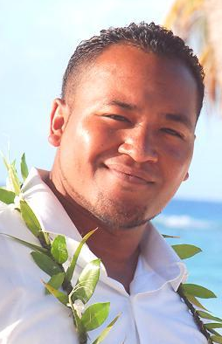  Joseph Noel Carmel Fe’ao  Cell +82 10 9271 5679   noel.feao@gmail.com   Date of Birth 25:12:80   New Zealander   Gender: Male  Qualified and registered New Zealand teacher.  - Experience in New Zealand and South Korea.  - Managerial Experience.  - Relevant experience with youth literacy.  - Experience in teaching a variety of subjects.  - Experience in caring and teaching students aged 3 to 18.  - Diverse background in working well with others.  The University of Auckland 2000 - 2003   Bachelor of Education (Teaching)  Tupu Dawson Road Library  2008 - 2009  Manager   Management of literacy resources, programs and staff.  Tupu Dawson Road Library  2007 - 2008  Youth Literacy Coordinator   Promoting and connecting local youth with books.   Students aged 3 – 18 years.  Wiri Central Primary School  2006 - 2007  Teacher, Sports Coordinator  Students aged 5 – 13 years.   Implementing Physical education programs.  Koru Primary School  2006 – 2007  Teacher   Students aged 5 – 13 years.   English, mathematics, science, social studies, physical education, arts.  Kedgley Intermediate School  2004 - 2006  Teacher   Students aged 10 – 13 years.   English, mathematics, physical education, creative arts.  Albert Matamu  TEACHER  Tokyo  Japan  Telephone: (+81) 803 528 31 67  Email: alby@paradise.net.nz  Pelu Leaupepe  DEPUTY PRINCIPAL  Papatoetoe Central Primary School  Auckland  New Zealand  Telephone: (+64) 215 862 32  Email: pelul@pcs.school.nz
  Kedgley Intermediate School | Teacher, Creative Arts, Physical Education. | 2004 - 2006
  Koru Primary School | Teacher | 2006
  Wiri Central School | Teacher, Sports Coordinator | 2006 - 2007
  Tupu Dawson Road Youth Library | Youth Literacy Coordinator | 2007 - 2008
  Tupu Dawson Road Youth Library | Manager | 2008 - 2009
  TLBU Global School | Teacher | 2009 - Current

