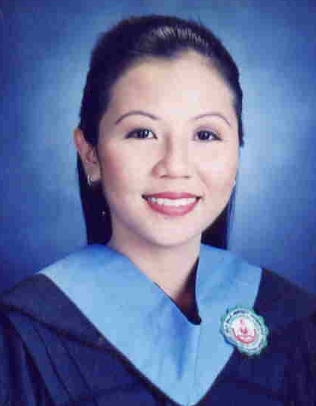

OLIVE GAY D. HERMOSO
Bachelor of Secondary Education
Major in English
Blk 10 L8 Duhat St. Mutual Homes
Muntinlupa, City 1770
Philippines

Mobile # 0906-2582504
(02) 809-6647

WORK EXPERIENCE

May 7, 2008- present English Teacher, South Mansfield College
(Southville International School Supervised)
Roman Cruz Soldiers Hills Muntinlupa City

June 2004 –April 2007 English Teacher, St. Augustine International School
AMA Biñan Campus, Km.32 Nat’l Highway, Canlalay Biñan, Laguna
Plans and conducts classes for Elementary and High School Students

June 2003-March 2004 English Teacher, SouthernsideMontessori School
Camella Homes IV, Poblacion Muntinlupa City
Plans and conducts classes for Elementary Students
( Grades Three, Five and Six )

EDUCATIONAL ATTAINMENT

On-Going Master of Arts in Teaching- English (Academic Units)
De La Salle University – Dasmariñas
Dasmariñas, Cavite

1999 – 2003 Bachelor of Secondary Education
De La Salle University – Dasmariñas
Dasmariñas, Cavite

1995 – 1999 Cavite National Science High School
Maragondon, Cavite

SEMINARS ATTENDED

May 7-28, 2008 LIP Training and English Proficiency
Southville International School

April 19-21, 2007 Promoting Technology in Education, Culture, History and Sciences: Envisioning a Culture of Peace
Hotel Supreme, Baguio City

January 20, 2007 National Conference on Language and Literature
Language and Literature Teaching: A Multidisciplinary Perspective
De La Salle University- Dasmariñas

September 16, 2006 Revitalizing the Language and Literature Classroom
De La Salle University- Dasmariñas

July 8, 2006 Seminar on Plagiarism and APA Format
De La Salle University- Dasmariñas

August 29-30, 2005 Faculty and Development Training
AMA-Biñan Campus, Km. 32 Canlalay, Biñan Laguna

March 1, 2005 Strategies and Methods of Teaching
AMA-Biñan Campus, Km. 32 Canlalay, Biñan Laguna

February 10, 2005 Personality Development and Individual Effectiveness for Teachers
AMA-Biñan Campus, Km. 32 Canlalay, Biñan Laguna

June 7-10, 2004 Faculty Workshop – Great Explorations in
Math and Science
AMA Education System, St. Augustine International School Project. 8, Quezon City

EXAM TAKEN
Licensure Examination for Teachers

RESEARCH PAPER PREPARED

March 2002 Effects of Late Marriage to Teachers
A research conducted to find out if late marriage affects teaching profession.

PERSONAL BACKGROUND
Born on the 11th day of February, 1983 in Cavite, Philippines. Proficient in English and Filipino. Has knowledge in Microsoft Office ( Word, Excel and PowerPoint ). Interests: surfing the internet and reading novels. Flexible, Self -motivated, Reliable, Accepts Criticisms and Team Leader. Enjoys sharing/imparting knowledge to students.

CHARACTER REFERENCES

Mr. Leslie Gerard Alvarillo, Jr.
Area Director- St. Augustine International School
39 Panay Avenue, Quezon City
Tel.No. 3733901 loc.8265

Ms. Leslie U. Noman
School Director – St. Augustine International School-Biñan
AMA-Biñan Campus, Km. 32 Canlalay, Biñan Laguna
Tel.No. 02-698-63-12

Merlyn V. Lee, PhD
Director, CLA Graduate Studies
De La Salle University -Dasmariñas
Tel.No. 046- 416-4531

