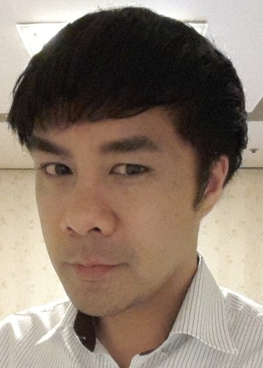
Parker Ernest Brooks
Experience
Sang Seung Academy Siheung-si, Gyeonggi-do, South Korea Feb 2012-present
English Teacher
- Taught mainly elementary students and some middle school students.
- Schedule consisted of three to five 50-minute classes a day, five days a week.
- Corrected homework, gave out grades, and prepared material for classes.
Academic Chess San Francisco, California, USA 2011-Feb 2012
Class Instructor
- Taught classes of 10-30 students from grade levels kindergarten to fifth.
- Worked at ten different after school programs, both public and private.
- Classes consisted of a 35 minute lesson with 25 minutes of supervised playtime.
EXOM.net Web Design San Francisco, California, USA 2005-2011
Freelance Web Designer
- Handled marketing, accounting, and customer service as a self-employed business.
- Designed websites, logos, Flash animations, and leaflets.
- Clients were generally business owners, lawyers, real estate agents, and educators.
Tall Chair, Inc. San Francisco, California, USA 2010
3D Modeler and Texture Artist
- Worked with a team of artists to produce video game art.
- Participated in weekly team meetings.
- Illustrated concepts for game assets.

Education
Academy of Art University San Francisco, California, USA 2011
Bachelor of Fine Arts
Other
- Born October 6, 1982.
- American national currently on an E-2 visa.
- Experience tutoring adults through language exchange.
- Beginner-intermediate level of the Korean language.

