Yoonsun Ahn
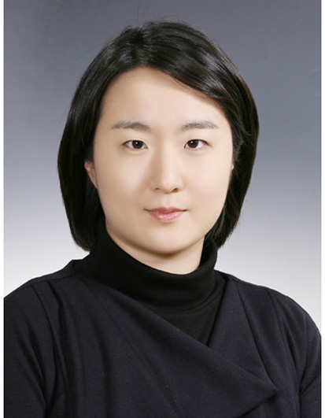
Citizenship: Canada
Visa Status: F4

My name is Patricia Yoonsun Ahn, and I'm currently looking for a new place where I can continue to teach and work with young students. I am writing to see if there is an opening at your institution and I would like to briefly introduce myself to you.

I was born in Seoul, Korea, and when I was 9 years old, my family immigrated to Canada. It is there that I spent my childhood, youth and my early adult hood.

I have graduated from University of Toronto, studying music which has always been my passion. Throughout my years as a university student (and even in high school), I have taught violin to many young students between the ages of 5 to 20.

I also had an opportunity to teach English and Canadian Culture to young kids who have just moved from Korea. It was my job to help their transition to the new country as smooth as possible by showing them the culture, playing the children games, and teaching English.

However, when I moved back to Korea 4 years ago, I spent 3 years working for Kumho Company. In 2011, I decided to change my career and took the i-Tesol Course from Sookmyung University. From March of 2012, I taught for a full year I taught at a private English kindergarten ‘Mount Pisgah’ in Bundang, Korea. I was the homeroom teacher for the 7.3 class where I am in charge of 17 students, immersing them in English and stimulating their growth in language, social and motor skills.

I am currently looking to finding a new workplace where I can continue to work with young children as they immerse themselves in learning.

Education

SC-i TESOL Certificate June 2011 – October 2011
Sookmyung Women’s University
Graduate School of Tesol
Seoul, Korea

Masters of Arts [Music Performance – Violin] September 2004 – May 2006
University of Toronto, Canada
Faculty of Music
- Ginny Medland Green Graduate Fellowship
- Sylvia Schwartz Fellowship

Bachelor of Arts [Music Performance – Violin] September 2000 – May 2004
University of Toronto, Canada
Faculty of Music
- Felix Galimir Award
- University of Toronto Fellowship

Earl Haig Secondary School September 1996 – June 2000
Toronto [North York], Canada
Claude Watson Arts Program - Music
- Musician of the Year Award

Cummer Valley Middle School September 1993 – June 1996
Toronto [North York], Canada

McKee Public School February 1992 – June 1993
Toronto [North York], Canada

Professional Strength
- Possess an ability to learn quickly and adapt to stressful work environments
- Insightful and reliable professionalism with clear understanding of both Eastern and Western values
- Ability to work across diversified cultural and organizational environment with outstanding coordination and communicative skills
- Fluent speaker in English(Native) and Korean(conversational)

Professional Experience
MapleBear Korea 2013- present
Full time Teacher
- Introduce the language to beginner levels
- Provide children with individual attention and establish relationship among the class
- Demonstrate and encourage social skills to create a friendly classroom environment
- Plan lessons and activities that immerse students in English and stimulate growth in language, social and motor skills

Mount Pisgah Korea (Bundang, Korea) 2012-2013
7 Year-old (3rd year) Homeroom Teacher
- Provide children with individual attention and establish relationship among the class
- Demonstrate and encourage social skills to create a friendly classroom environment.
- Plan and implement lessons and activities that immerse students in English and stimulate growth in language, social and motor skills
- Monitor and record progress of individual students throughout the year.
- Maintain an ongoing communication with parents regarding children’s activities, behavior, and development, and responded to all parents concerns as they arise

Kumho Asiana Cultural Foundation (Seoul, Korea) July 2008– 2012
Concert Planning and Artist Management
Responsibilities
- Creating various concert series’ for season, and controlling budget for each series.
- Contacting suitable artists for each concert and negotiating contract details.
- Keeping liaisons with both national and international artists, handing over press interviews, managing their Kumho concert related schedules such as flight schedule, in-Seoul transportation, and accommodation.
Kumho Instrument Bank
Responsibilities
Kumho Instrument Bank Audition
- Organizing audition materials, contacting possible adjudicators and coordinating their requests, handling other minor responsibilities during the audition process.
- Preparing for the award ceremony, contacting winners and their parents, as well as checking final conditions of each instrument.

Instrument Insurance
- Contacting instrument insurance companies for yearly payments and alerting each of the companies of their payment dates, and checking their deposits.
- Reporting any incidents involving instrumental damage.

Other Responsibilities
Marketing
- Collaborate with marketing representative for creating and organizing various events for concert promotions.
- Sponsorship proposals for Orchestra Series
VIP Meetings
- In charge of international guest invitations for concerts and events.
- Translating for the executive vice president and international ambassadors’ during their meetings.

Reference: Available upon request

