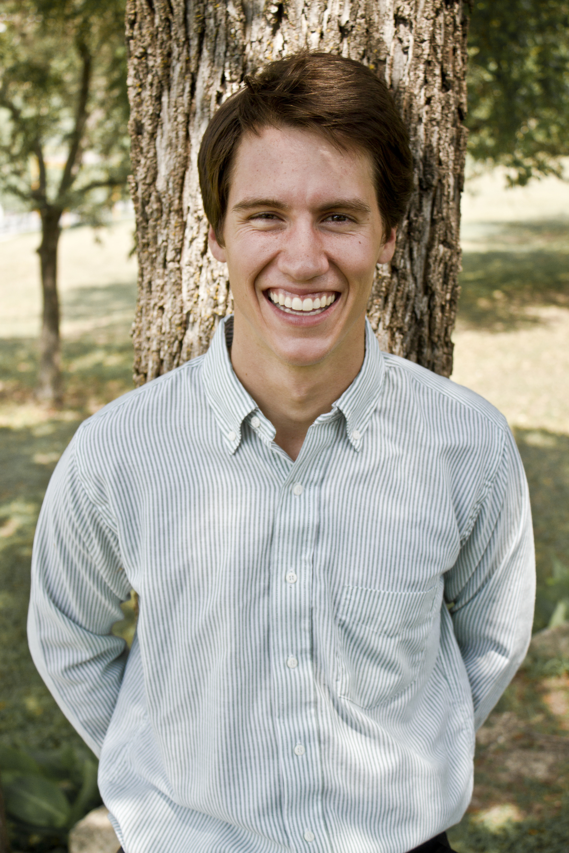

Patrick A. ripley biffle

511 carriage trail 214-543-1215
rockwall, Texas 75087 pbiffle@gmail.com

ESL Instructor

PROFILE

Recent college graduate seeks international position teaching English as a second language. Academic and practical experience in second language study at all education levels learning Spanish. From a family that engages in linguistic pursuits. Father is a professional writer. Mother is a bilingual teacher. Uncle speaks five languages and works in international business. Some teaching experience assisting mother in her bilingual classroom and working as a volunteer in Ecuador. Excellent communicator. Positive attitude. Quick learner. Punctual. Strong work ethic. Bring additional skills developed in the course of study at the university and through work experience: Ability to assist school with any digital media employed (i.e. video editing, social media networking, etc.). Strong troubleshooting skills. Aptitude for analytical thought. Ability to meet strict deadlines. Academic experience in preparing marketing strategies. Possess computer skills in: Final Cut Pro 7, Motion, Compressor, MS Power Point, DVD Studio Pro, MS Excel, MS PowerPoint, Adobe Photoshop, MS Word, After Effects. Languages: Bilingual in English and Spanish.

INTERNATIONAL STUDIES

Supplemental Spanish studies—Antigua, Guatemala, Summer 2004; Barcelona and Valencia, Spain, Summer, 2007; School of the World, Playa Jaco, Costa Rica---September, 2007

VOLUNTEER PROGRAMS

Yanapuma, Quito, Ecuador –Aided in the development of local settlements---October-December, 2007
- La Chimba- Worked as Teacher’s assistant in the local school and also helped children and teachers in repainting the school; Renovated an old hacienda; Worked with host family to replant garden and collect milk.
- Tena- Engaged in daily languages lessons with the community children---they taught me Spanish and Quichua and I taught them English; Cleared brush and marked medicinal plants; Built new enclosure for an Ocelot.

EDUCATION

Bachelor of Business Administration, Major: Digital Media Management, St. Edward’s University, Austin, Texas

AWARDS
St. Edward’s University Scholar Award and Grant Recipient

PROFESSIONAL WORK HISTORY

GnB English School, Incheon, Korea January 2012-2013
English Teacher: Taught English to students ages 6 to 16; levels of instruction encompassed the basics, such as the alphabet and animal names, through more intricate language concepts and tasks, like advanced science vocabulary and essay writing.

EBITDA International, Austin, TX May, 2011-2012
Content Manager: Promoted brand image by aiding design team in the creation, organization and publishing of both the website and the content within using Joomla editor.

Jeffrey’s Restaurant, Austin, TX May, 2010-2012
Valet: Parked/Retrieved patrons’ cars. This basic customer-facing role sets the first and last service impressions for Jeffrey’s. Moreover, the quality of my service is incentivized by tips, which I used to offset my education expenses.

AVI-SPL, Houston, TX June 2009-August 2009
Set-up Assistant: Supported exhibition marketing team in the setting up product displays, marketing related “Audio Visual” equipment; contributed to product placement decisions and assisted in the set-up of the main control areas.

Blue Lens Studios, Dallas, TX May 2007-August 2007
Photo Assistant: Responsible for the set-up and break down of equipment; captured and logged footage, video editing.

Tyco Plastics & Adhesives, Frankfurt, Germany July 2005-August 2005
Marketing Admin Internship: Organized marketing data files and performed routine marketing support tasks.

