Personal Details_______________________________________
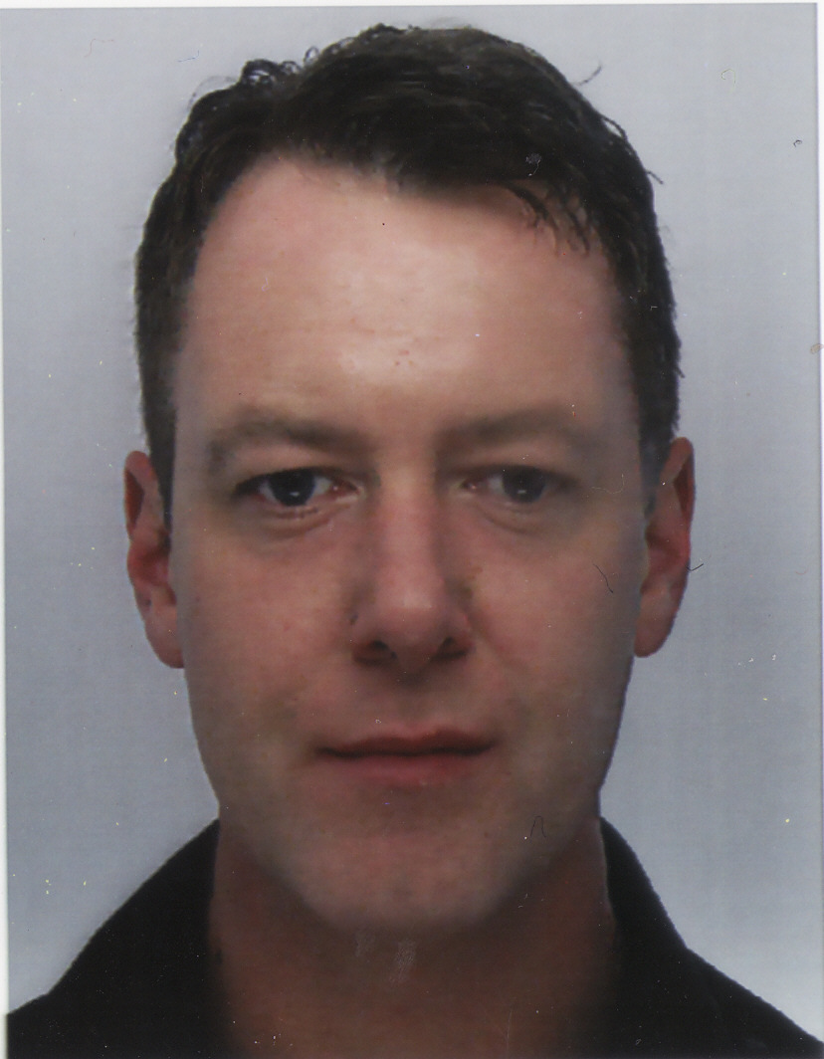

Name: Patrick Harty

Date of Birth: 3rd May 1970

Gender: Male

Nationality: Irish

Address: 154 The Court, Dunboyne, County Meath, Ireland

Phone: +353 85 7850119

Skype: patrickharty

Email: path765@yahoo.co.uk

Personal Statement____________________________________

I’m a conscientious and diligent person with a can-do attitude looking for experience in teaching English as a foreign language in Seoul. I enjoy working with people and consider myself to be a good communicator. I’ve a wide range of work experience and am capable of working off my own initiative or as part of a team. I’m a quick learner and feel that I can quickly add value to your organisation. I’m available for interview at any time and should you require any further information please do not hesitate to contact me.

Education____________________________________________

(1993) Bachelor of Arts (Honours) in Politics and Philosophy, University College Dublin, Belfield, Dublin 4.

(July 2009) Cambridge CELTA, Grade Pass, International House, Camden Street, Dublin 2.

Employment History___________________________________

(1998 – 2009) Contract IT Technical Support Engineer

Since 1998 I’ve worked as a Contract IT Technical Support Engineer and have worked on numerous projects. I have strong IT skills that include:-

MS Windows desktop and server operating systems.

Networking and networking equipment.

Desktop and server hardware and software applications including MS Office, email, Internet browsers.

Asset Management and Documentation.

Mentoring and training of new employees.

(1993 – 1998) Various roles including:-

Logistics, Security, Catering, Manufacturing.

Language Skills_______________________________________

English – proficiency

French – basic knowledge

Spanish – beginner

Interests and Activities_________________________________

Soccer, Reading, Socialising.
.
References___________________________________________

References are available upon request.

