PERSONAL RESUME
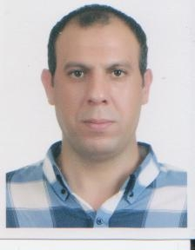

Full NAME: Gary John
Nationality: Canadian.
Address: Sangbong dong .29_41 Bd Seoul .
Phone: 01072650287

Email:gary_john_john@yahoo.comEmail:

Short Description:

I am an Open –minded, friendly and active person. Have been working as an English Teacher in Korea, Japan and China for few years. I know that Teaching is not just job but it also a responsibility to help the kids of today learns things, to be open-mind, open to foreign people as they are the future of tomorrow. I love kids too much and I treat them just like a family member. Have a good ability to be adapted with different situations, as I always promise to do my best to meet the institute's expectations and take care of the kids the perfect way.
It would be a pleasure to get the chance to work for you and contribute to the children development.

Qualifications:

Bachelor of economy university of Alberta

Work Experience:
Feb,2006¬May,2007: English teacher at Shanghai Great kids kinder garten Shanghai china .
June 2008¬Feb 2009 : English teacher at kinder garten Tokyo, Japan.
June 2008-Feb 2009 : English teacher at Daejon, Korea.
March 2009-Dec2009 :English teacher at English Education,Seoul,korea

Beside those mentioned position, I also had done many different part time jobs in various locations, especially in and around Seoul.

I have been to France, Italy, United Kingdom, China, Japan and Thailand

