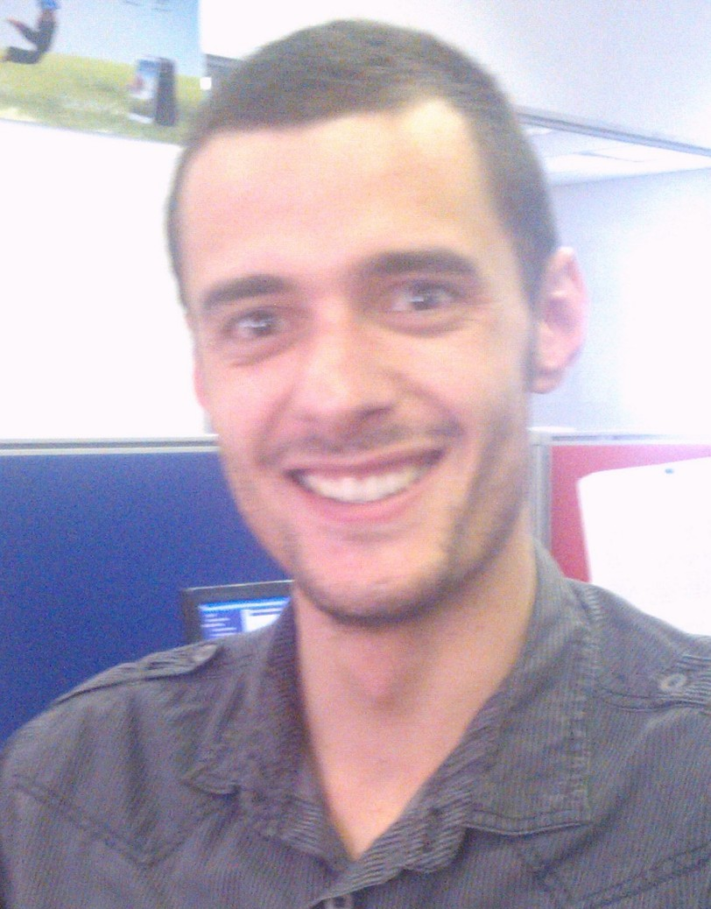
Petros (Peter) Demetriades

1. PERSONAL INFORMATION

Name: Petros (Peter) Demetriades

Date of Birth: 5 April 1985

Health: Excellent

Languages: English, Afrikaans, Greek

2. EDUCATIONAL BACKGROUND

2.1 SECONDARY EDUCATION:

Highest grade passed: Grade 12, Senior Certificate, 2002

School attended: Grey College
BLOEMFONTEIN

Subjects: English
Afrikaans
Business Economics
History
Geography
Biology

2.2 TERTIARY EDUCATION

Institution attended: University of the Free State
Year: 2006 - 2008
Degree: B.A. (Integrated Marketing Communication)
Major Subjects: Business English I
Introduction to Public Relations
Advanced Public Relations
Introduction to Advertising
Applied Advertising
Advanced Advertising
Advertising Copy-Writing
Internet Marketing
Integrated Marketing Communication
Advanced Marketing Management
Mass Media Research Principles
Applied Mass Media Research
Introduction to Journalism
Intercultural Communication
Introduction to Organisational Communication
Advanced Organisational Communication
Persuasive Communication
Political Communication
Computer Literacy (MS Word, PowerPoint, Excel)
Communication Law
Criminal Law I – II
Legal Practice I – II
Introduction to Legal Science I

3. EMPLOYMENT HISTORY

1)2002: Waiter at House of Coffees

2)2005 – 2009: Waiter at Mexican Restaurant (while studying)

3) Promotional work for Empilweni Solutions – Brutal Fruit promotion at Stones.
Promotion for Jay Jay’s Clothing at UFS Student Centre.

4) Waiter / Barman for Leopards and Lace (catering business), and waiter for Olive Ranch Catering.

5) Previously employed at OK Furniture Bloemfontein (started on 25th May 2009 until 14th October 2010) as trainee manager and have completed the following training departments:

a) Stock clerk:

Involving:
Ordering and receiving of stock from other branches, suppliers, and customers.
Dealing with customer complaints and customer repairs.
Conducting daily stock-checks (sectional stock-checks), and full stock-checks (every 4 months).
Daily checks on all stock moving in and out of the warehouse.

b) Cashier:

Involving:
Receiving Payments in cash, card and cheques
RICA registrations
Petty cash withdrawals and allocations
Refunds i.e. cash and carry refunds, cash delivery refunds and deposit refunds
Cheque clearances

c) Salesperson:

Involving:

Capturing cash deals
Capturing credit agreements
Advising customers on purchasing the right products
Advising customers on buying on cash or credit
After-sale service

d) Supervisor and Admin Manager:

Involving:

Price overrides
Daily banking i.e. recording the daily cash deposits
Weekly banking i.e. checking daily cash deposits on record
Monthly banking i.e. checking weekly banking totals on record
Cashiers’ overs and shorts
Petty cash withdrawals and refund records
Refund authorisation
RICA registrations
Maintenance of staff attendance registers
Sales and resource management
Television license confirmations
Processing ITC and credit applications
Checking incoming and outgoing stock

Training courses that I have attended and completed at OK Furniture:

1. Manual Procedures (to be followed when power failure occurs),
2. Stocktaking procedures (guidelines for effective stocktaking),
3. Receiving and Despatching (processing of incoming and outgoing stock),
4. Branch Insurance claims (procedures for insurance claims),
5. HP and Cash Office (administration),
6. General Ledger and Income Statement (monitoring profit and loss),
7. Customer Care,
8. RICA (processing of cellular phone sales),
9. Occupational Health and Safety Act,
10. Project Goldstar (manager training course to assist in improving efficiency of the manager and sales force and to manage resources more effectively),
11. Open Office Spreadsheet,
12. Outlook Express and Email,
13. Prospecting and Salesperson Activity Calendar (monitoring salespersons’ sales activity and efficiency).

6) 2011(April 1st) – 2012:

I am currently working at Nashua Mobile as a call centre agent, which involves assisting clients telephonically with:

a) Increasing and decreasing call limits,
b) Adding and removing value added services such as: call limit monitors, data bundles, Blackberry internet services, airtime transfers, sms bundles, sim card insurance, etc.
c) Advising on upgrades,
d) Advising on new contracts,
e) Assisting clients with queries on monthly statements received,
f) Handling and escalating customer complaints.
g) Terminating services,
h) Receiving payments from clients in arrears,
g) Unlocking previously arrears accounts,
h) Data support,
i) Migrating clients from a higher to lower package and vice versa,
j) Passing credits on accounts,
k) Refunding clients for incorrect charges on accounts,

4. ACHIEVEMENTS

2001 and 2002: Prize for top scholar in History – end of grade 11 and 12

2008 - Completed my above mentioned degree at UFS in 2 years and not the prescribed 3 year period.

5. INTERESTS

Enjoy playing social soccer, cricket, squash, and reading.

6. Currently

Studying towards the achievement of an LL.B degree through UNISA and have completed the following subjects:

1) Criminal Law (Specific Crimes)

2) General Principles of Criminal Law

3) End-User Computing

4) Origins of South African Law

5) Foundations of South African Law

6) Introduction to Law

7) Interpretation of Statutes

8) Law of Persons

9) Family Law

10) Constitutional Law

11) English for Law

12) Law of Succession

13) Skills Course for Law Students

14) Fundamental Rights

15) Entrepreneurial Law

7. REFERENCES

Mr S. Watson
Proprietor
Mexican Restaurant
19 Second Avenue
Tel: (051) 430 4526

Deon Olivier
Branch manager
OK Furniture Bloemfontein
Tel: (051) 410 1560

Charmaine Weber
Manager
Nashua Mobile
Cell: 0787167816
****************************

