Profile
I have a passion for teaching. For 37 months, I taught in an English academy in South Korea. I thoroughly enjoyed the experience and wish to teach more.

Experience

English Instructor, DYB Choisun Academy; Seoul, South Korea -- 2009-2012
- Taught elementary and middle school students.
- Prepared lessons daily/weekly using worksheets, activities, and PowerPoint.
- Actively promoted the best interest of the company to students and other co-workers.

Retailer, J’s Mega Mart; Knoxville, TN -- 1994 - 2009
- Performed store operations.
- Sold and advertised products.
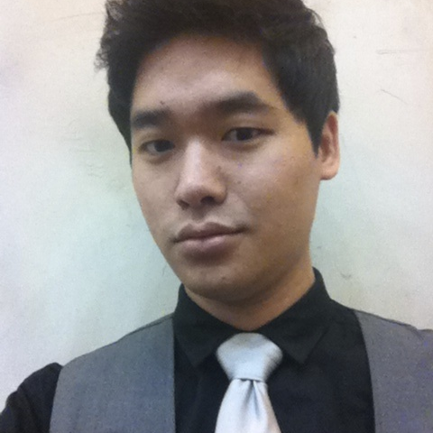

- Assisted in customer service.

Peter Nguyen
English Instructor

Manager, P & JB Knives; Knoxville, TN -- 2005-2007
- Firsthand experience in entrepreneurship.
- Operated as co-owners in a business venture
- Traveled to different flea markets, knife shows and gun shows.

Education
University of Tennessee, Knoxville
- Bachelor of Science in Business Administration
- Major: Enterprise Management
- Collateral: International Business

Skills
Computer skills with Windows, Mac OS, the Internet, networking, Microsoft Word, Excel, and PowerPoint.
Other skills: quick to learn and adapt; work well individually and with others

