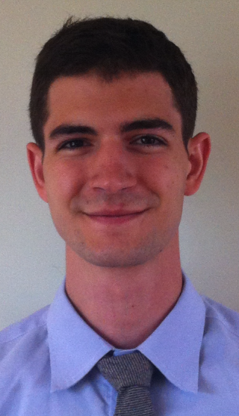

Phillip DelTorto

ESL Teacher
Career Objectives:
- As a professional educator it is my goal to pass on my love of learning. I will be a good, positive role model for my students in all aspects of life both in and out of the classroom.

Education and Credentials:
Keystone College
- Graduated in May 2010
- Bachelors Degree: Secondary Mathematics Education
- GPA of 3.67 Cum Laude
- 2010 Outstanding Graduate for Mathematics Education
- Certified Teacher (mathematics grades 7-12)
High School
- Scranton Preparatory School, class of 2006.

Professional Experience:

Daechi Wonderland (Seoul) August 2010-July 2013
- Promoted to Head Foreign Teacher Supervisor
- Taught ESL students, ages 5-10
- Lesson planning, field trips and activity days
- Interviewed, hired and trained new foreign teachers

Old Forge High School (PA)
- Spring 2010 completed student teaching
- Taught 8th grade honors algebra, 8th grade PSSA prep, 9th grade algebra, 9th-11th grade basic math, and 12th grade honor calculus. Class sizes ranged from 8 students to 30.
- Attended subject area and and school faculty meetings
- Participated in parent teacher conferences
- Prepared study guides, reviews and assessments for all classes
- Created long term and daily lesson plans to achieve PA State standards
Tunkhannock Area Middle School (PA)
- Spring 2010 completed student teaching
- Taught 6th grade math, five sections approximately 20 students in each class.
- Attended subject area and and school faculty meetings
- Created long term and daily lesson plans to achieve PA State standards
- Design interactive bulletin boards

Interests and Technology:
- Experience teaching with Smart Board and Promethean Board technology
- Fully competent with computer and technology use including PowerPoint, slide shows, and interactive activities
- Lived and studied in Barcelona, Spain in the summer of 2009
- 4 year member and 3 year President of MCASA, Multicultural Affairs Student Association. MCASA is a organization that recognizes and supports diversity and cultures, on and off Keystone College campus.

*References upon Request
Korea and American schools

