12th May 2013
Application for a teaching position .FAO: THE PRINCIPAL
Dear Sir / Madam,
I wish to apply for a teaching position in your school. I am able to start immediately as I recently moved to Cambodia from Vietnam.

Please find attached my CV. I am British,32 years old and an art graduate I have a BA Hons Fine Art and Photography Degree. I completed my studies in the UK at Central St Martin’s School of Art and Design and at Sir John Cass School of Art and Design, part of London Met University.
I have travelled widely since graduating and recently worked in Vietnam after moving from Busan in S Korea where I was teaching English as a foreign language for 2 years. I taught adults and children general and conversational English.
I also worked as a teaching assistant in the Art dept at the Island school in Hong Kong, one of the prestigious ESF schools. I am therefore used to the classroom environment and after my experiences in S. Korea and Hong Kong, I would be very happy to work in a school environment once again.
At Island school in Hong Kong , my duties included hands on support for the teaching staff, setting up the art rooms for particular projects, sourcing art materials, assisting the art teachers during classes, workshops and practicals.
I also worked in the sports and hospitality industry as I spent some time in Costa Rica as Deputy Manager of a yoga and surf centre. I subsequently also worked as a ski guide in the French Alps for one season. I have excellent people skills and speak French and also intermediate Spanish.
Thank you for considering my application and please do not hesitate to email me or phone if you have any further questions.
Yours sincerely,
Philip Young

Philip Young’s CV
• Nationality: British
• Age: 32
• Place of Birth: UK
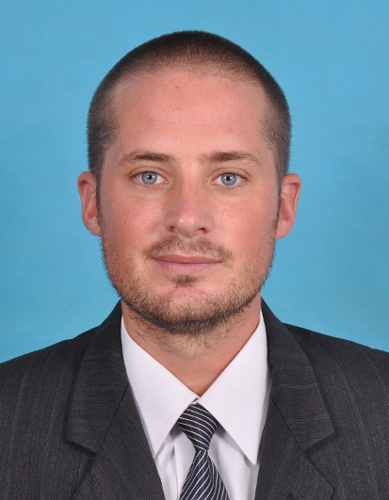
June 2012- present day Traveling Australia, Vietnam and Cambodia.
Traveling the east coast of Australia. Traveled the east cost of Vietnam and the south cost of Cambodia.

Employment

June 2011 - May 2012 Avalon English School Busan South Korea
http://english.avalon.co.kr/
English Teacher: teaching English to Korea children. Age 10-17.

Nov 2010 - may 2011 Feinshcule English school South Korea.
http://www.feinschule.co.kr
English Teacher
Teaching English to kinder-garden kids and elementary students.

Nov 09 - Oct 2010 Kagyu Samye Ling Monastery Scotland UK.
http://www.samyeling.org
I spent the summer helping out the monks and nuns. i volunteered in the kitchen and the coffee shop. It was an en lighting experience.

June 09- OCT 09 http://playanegrayoga.com/ Cost Rica
Setting up a yoga center in coast Rica. Gaining over a Million Dollars’ worth of business. Working worth some amazing yoga teachers.

Sept/2001 to June/2002 Island School Hong Kong Hong Kong
www.island.edu.hk/
Educational Assistant.
As an educational assistant in the art department.

Education or Qualifications/Training

Sept/2004 to June/2007 London Metropolitan University London
http://www.londonmet.ac.uk/
BA Fine Art.
Bachelor of Arts, Lower second class with Honors.

Sept/1993 to June/2000 Seaford College West Sussex.
http://www.seaford.org
A ‘levels
• Fine art: A Photography: A Design and Technology: C
GCSE’S’s
11 GCSE’s: five A*, five B’s and one C
REFERENCES:
Reference for Philip Young
To whom it may concern.
I worked with Philip for one year and he was a well organize teacher. Philip is a good teacher and a good friend. He works hard and brings a lot of happiness and joy to the class room. I found him to be kind and caring. He was always on time for work and worked well with colleagues. He always prepared hiss lessons and had great ideas for all the lessons.
I wish him and yourself all the best
Dean Smith.
Head teacher off English, Avalon. Busan.
deanmathewsmith123@gmail.com

To whom it may concern.
Philip was employed at Playa Negara Yoga center, Playa Negara, Costa Rica as the Deputy Director at the Playa Negara Yoga center and Surf center. His duties included meeting and welcoming guests at the airport, planning yoga and surf schedules, organizing trips and excursions, assisting with advertising and liaising with visiting guest yoga teachers.

Philip has excellent organizational skills; he works well with the general public and has an eye for detail. He has excellent and varied IT skills. He is very flexible and adaptable plus he regularly has imaginative ideas for serving the public.
He is punctual, hardworking and well organized. He is a good team player. I can strongly recommend Philip and feel that he would be an asset to your team.
Please do not hesitate to contact me if you require further information.
Yours sincerely
Pamela Price
Email: yorklangs@gmail.com

